MIAMI VALLEY HOSPTIAL
MEDICAL STAFF GRAND ROUNDS
presents
Candida auris: an emerging pathogen within hospitals

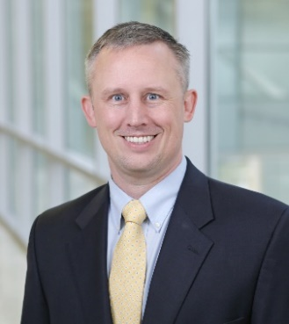
Steven Burdette, MD, FIDSA
  - Professor of Medicine and Chief of Infectious Disease for Wright State University Boonshoft School of Medicine
  - Medical Director of Infection Prevention for Miami Valley Hospital, Miami Valley Hospital South, Miami Valley Hospital North

Thursday, June 8, 2023
12:00 – 1:00 PM

Miami Valley Hospital, Bieser Auditorium or Teams Live Event

Register using the link or QR code below to share which venue you will be joining
as a lunch will be provided for those attending in-person.

In-person registration deadline, Friday, June 2nd.

CLICK HERE TO REGISTER

Meeting invites and more information for both in-person and
Teams link will be sent a week prior to the event.

For more information or questions please contact Lakmali Ranathunga, MD – President, Miami Valley Medical Staff lcranathun@premierhealth.com or Dana Mackert, Internal Physician Relations Manager dlmackert@premierhealth.com

