Bio Department Seminar
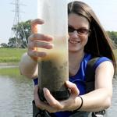

Speaker: Silvia Newell

Title: “Nutrient Reduction via H2Ohio wetlands”
Date: January 23, 2023
Time: 1:25 pm
Location: 165 Brehm Lab
WebEx Link:
