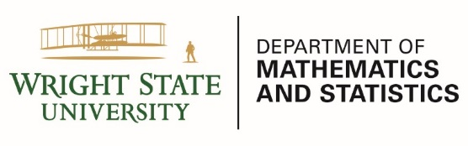
COLLOQUIUM

Speaker: Dr Sivaguru Sritharan, Applied Optimization

Title: Geometric and Topological Methods for Applications in Data Science, Machine Learning and Complex Systems

Date: Friday, December 4, 2020

Room/Time: Meet-n-Greet: 2:30 p.m.
Talk: 3:00 p.m.
https://wright.webex.com/wright/j.php?MTID=m6d1e9d09d10005ffead03a9ee5dbef39

Host: Dr. Qingbo Huang

ABSTRACT:

In this talk we will discuss some of the major developments in real and complex geometry and topology in the past century such as Weyl and Minkowski embedding, Nash embedding, Poincare conjecture and geometrization, generalized Poincare conjecture, real and complex Monge-Ampere equations, mean curvature flows and varifolds, geometric evolutions (Ricci flow, Harmonic mapping flow, Calabi flow, etc), and optimal mass transport, in a thought provoking manner to seek possible applications. The goal is to seek possible applications and insight in big data science, machine learning and complex system modeling utilizing these benchmark results in geometry and topology.

SPEAKER BIO:

Dr. Sivaguru S. Sritharan has held numerous leadership and faculty positions in U. S. Defense Department and in civilian universities in the U. S. and also internationally. His research areas are nonlinear partial differential equations, stochastic analysis, functional analysis, fluid dynamics and control theory. His research has been funded by a number of agencies including ONR, AFOSR, ARMY, and DARPA. He has given over three hundred invited colloquia world-wide.

