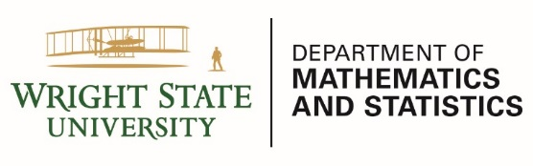
COLLOQUIUM

Speaker: Dr. Alex Gutman, 84.51°

Title: Data Science, Here and Aboard: My Path After WSU

Date: Friday, February 28th, 2020

Room/Time: Meet-n-Greet: 2:30 p.m. Room 222 MM
Talk: 3:00 p.m. Room 224 MM

Host: Dr. Ayşe Şahin

ABSTRACT:

In this talk, I’ll share my thoughts and answer your questions about careers in Math, Statistics, and Data Science based on my experience in government and industry after graduating from Wright State University. I’ll also share lessons learned from my recent trip as a Fulbright Specialist to Bishkek, Kyrgyzstan, where I spent a month leading a project titled, “Artificial Intelligence for All” for the High Technology Park of the Kyrgyz Republic, a government-led hub that hopes to boost the country's technology sector.

SPEAKER BIO:

Alex Gutman, PhD, is a Data Scientist, Corporate Trainer, and Accredited Professional Statistician® with expertise in statistical & machine learning and experience working as a Data Scientist for two Fortune 50 companies. At Procter & Gamble, Alex supported the Data Science and Artificial Intelligence team where he taught courses on open-source software and machine learning. He also implemented several machine learning and Natural Language Processing (NLP) techniques to improve the safety of P&G products. In his current role at 84.51°- a data science company owned by Kroger -Alex enables, empowers, and encourages other data scientists to use machine learning by developing & delivering training on open-source & state-of-the-art proprietary tools and by consulting on supervised, unsupervised, NLP, & time-series projects. He also enjoys teaching a wide variety of data science topics to non-technical audiences.
Alex received his BS and MS in Mathematics from Wright State University and PhD in Applied Mathematics from the Air Force Institute of Technology (AFIT). He’s a member of the American Statistical Association and serves as an Adjunct Professor in the Department of Operational Sciences at AFIT.

