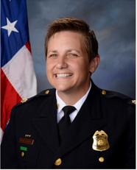

Sponsored by: The Department of Sociology & Anthropology, Crime & Justice Studies, Applied Behavioral Science, and CLASS

November 5th at 5:30pm

in the Millett Atrium

with

Major Wendy Stiver

from the

Dayton Police Department

**EVIDENCE-BASED POLICING**