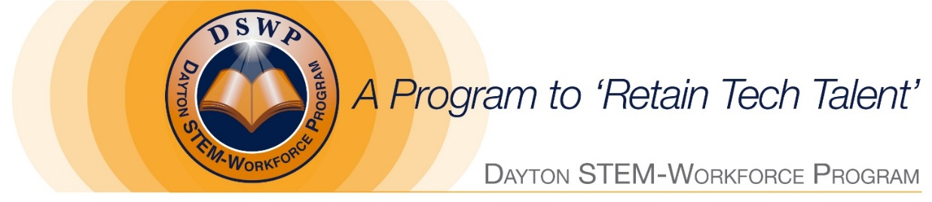
2019 Dayton STEM-Workforce Scholarship

Wright State University
Bachelor Degree - Annual Amount - $1,000

​Note: Scholarship application period will begin January 21, 2019
and must be received no later than April 5, 2019.

GUIDELINES
Bachelor Degree: Students are eligible to apply in their sophomore or junior year for one of the following STEM majors with a GPA of 3.0 or better. (Note: Nursing students pursing Bachelor or Master’s degree are eligible)
• Accounting • Geographic Information Systems
• Aerospace Engineering • Geospatial Technology
• Business Economics • Health Communications & Information Technology
• Computer Science • IT (Web development, Analytics, Programmer
• Computer Engineering • Management Information Systems (MIS)
• Core Sciences (Biology, Chemistry) • Marketing & Management
• Cyber Security • Mathematics, Statistics
• Engineering – Biomed, Electrical & Mechanical • Nursing (Bachelor & Master of Science)
• Finance • Supply Chain Management

Renewable Scholarships: Students who received our STEM scholarship going into their junior year, and who maintain their academic standing, will be eligible to apply for a Renewable scholarship going into their senior year. Note: Students currently in their senior year are not eligible to apply.
Workforce ‘Angel’ program: All student applicants will automatically become enrolled in our Workforce ‘Angel’ program and be connected to our many high growth local business partners for internship opportunities or job interviews. Go to website for list of business partners.

List of DSWP business partners Short video about Workforce ‘Angel’ Program
www.DaytonSTEM-Workforce.org

