  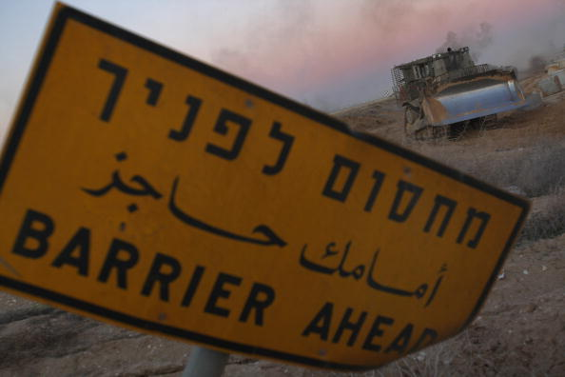
    - “Bethlehem”
  “Bethlehem” is a documentary produced by Dan Bracken, media producer for Ginghamsburg Church in Tipp City, Ohio, in partnership with United Methodists for Kairos Response. Dan will present his film about Christians living in Palestine, who refer to themselves as "the living stones". Their unique story reinvigorates healthy dialogue about the conflict in the Middle East, and their invitation is simple: "Come, and see."
  Discussion to follow with Susan Brogden, who lived for three months in Bethlehem as a volunteer with the Ecumenical Accompaniment Program in Palestine & Israel (EAPPI). She served with a team of internationals from a dozen countries, providing a protective presence for vulnerable Palestinian communities, monitoring and reporting on human rights abuses, and learning about the conflict from both Israeli and Palestinian sources.
  Heading 1
  To get started right away, just tap any placeholder text (such as this) and start typing to replace it with your own. Want to insert a picture from your files or add a shape, text box, or table? You got it! On the Insert tab of the ribbon, just tap the option you need.
  Monday April 15
  7:00 pm
  Rike hall 020
  free and open to the public
  sponsored by the Middle Eastern and Islamic Studies Lecture Program
  Contact: Dr. Awad Halabi
  Departments of History and Religion
  Co-ordinator of the Minor in Middle Eastern and Islamic Studies
  awad.halabi@wright.edu

