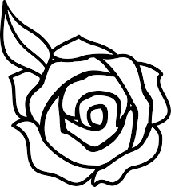
Wright State University
Department of English
Visiting Writers Series
presents

An Evening with Dayton Poets
April 11, 5 p.m.-7 p.m. in the Stein Galleries
in the Creative Arts Center

Free and open to the public!

Featuring:
Rita Coleman Cathy Essinger
David Garrison Gary Pacernick
David Petreman Mary Jo White

Please join us for readings and discussion, and to meet the poets.

