Wright State University Statistical Consulting Center Presents:
Introductory Programming
Friday, December 1, 2017 10am-12pm
R is quickly becoming one of the most popular kinds of statistical software and it can be downloaded, free of charge, by anyone who would like to use it. The Statistical Consulting Center is offering an introductory hands-on tutorial using version 3.1 of R for Windows. This 2 hour tutorial has no prerequisites and assumes no prior knowledge of R. Topics include:

- Creating and reading in data sets
- Generating descriptive statistics
- Creating plots
- Correlation
- Simple linear regression
- Contingency tables
- Chi-square test
- Reformatting data sets
- Installing packages
- Using R as a calculator

Introductory SAS Programming
Friday, December 8, 2017 10am-12pm
SAS (Statistical Analysis System) is a software suite developed by SAS Institute for Advanced Analytics. This 2 hour tutorial has no prerequisites and assumes no prior experience with SAS. Topics include:

- Creating, sorting data, and formatting data sets
- Writing output to a Word document
- Generating descriptive statistics
- Creating histograms, scatterplots, bar charts
- Paired t-test
- Correlations
- Reading data in from text documents & excel files
- Linear Regression
- “Do” loops
- Creating contingency tables
- Chi-square test, One-Way ANOVA, Tukey’s Studentized Range test
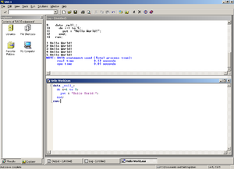

These tutorials are free of charge to faculty, staff, and grad students. Registration is limited to 12 per class.
You must be able to log onto WINGS using your WSU Username and Password.
To register, or if you have questions,
Call: (937)775-4205 or Email: jennifer.schmidt@wright.edu

