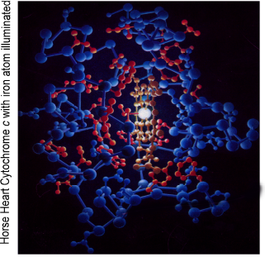
Seminar Notice
Department of Biochemistry
and Molecular Biology

ALL Seminars are held in 125 Medical Sciences
Spring Semester 2017
Date | Speaker | Topic
Thursday, January 19, 2017  Host: Madhavi Kadakia | Ashish Lal, Ph.D.  Center for Cancer Research National Cancer Institute | Regulating the Master Regulator: Long non-coding RNAs in the p53 network
Thursday, January 26, 2017
Host:
Thursday, February 2, 2017  Host: Madhavi Kadakia | Loren Friedman  Director of Clinical Trials  Wright State University and Premier Health Clinical Trials Research Alliance | Investigator-Initiated Studies Funded by Industry: Both Basic Science and Translational
Thursday, February 9, 2017  Host: Madhavi Kadakia | Matthew Stratton – Faculty Candidate | Regulation of cardiac hypertrophy and fibrosis by the chromatin reader BRD4.
Thursday, February 16, 2017  Host: Weiwen Long | Erhu Cao  Assistant Professor  Department of Biochemistry  University of Utah | Structures and mechanisms of the polycystic kidney disease channel PKD2
Thursday, February 23, 2017  Host: Madhavi Kadakia | Eric Bennett  Chair and Professor  Neuroscience, Cell Biology & Physiology  WSU | “Does sugar make the heart beat stronger?”
Thursday, March 2, 2017  Host: | Spring Break!
Thursday, March 9, 2017  Host: Weiwen Long | Oleg Paliy, Ph.D.  Associate Professor  WSU | " We are what we eat: associations between human diet and gut microbiota"
Thursday, March 16, 2017  Host: Hongmei Ren | Wen-xing Ding, Ph.D.  Associate Professor Department of Pharmacology, Toxicology and Therapeutics The University of Kansas Medical Center | Mechanisms Regulating Mitochondria Homeostasis
Thursday, March 23, 2017  Host: Nicholas Reo | Martin Myers, M.D., Ph.D.  Marilyn H. Vincent Professor of Diabetes Research  Department of Internal Medicine and Molecular & Integrative Physiology  University of Michigan
Thursday, March 30, 2017  Host: Julian Cambronero | Dipak Panigraphy  Asst. Professor of Pathology  Harvard Medical School | Pathophysiology of autacoids in cancer
Thursday, April 6, 2017  Host: Julian Cambronero | George Carman, Ph.D.  Board of Governors Professor  Institute of Food, Nutrition, and Health  Rutgers University | Regulation of lipid metabolism by phosphorylation
Thursday, April 13, 2017  Host: Madhavi Kadakia | Rumela Chakrabarti, Ph.D.  Assistant Professor  Department of Biomedical Sciences  University of Pennsylvania School of Veterinary Medicine | "Cell fate regulators in breast cancer"
Thursday, April 20, 2017  Host: Chad Campbell | Christopher Kasbek  Admera Health Company | “The Era of Personalized Medicine and Non-Invasive Cancer Testing”
Please Post! http://www.med.wright.edu/bmb

