WRIGHT STATE UNIVERSITY
STATISTICAL CONSULTING CENTER
PRESENTS
u
SPSS TUTORIAL I
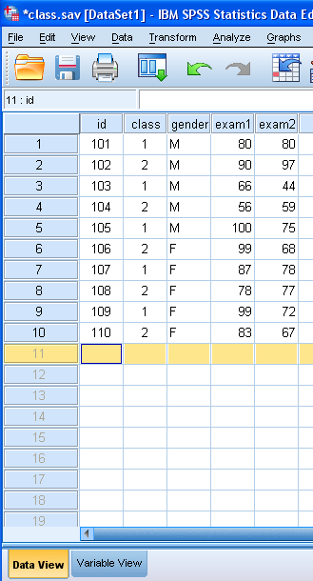
The Statistical Package for the Social Sciences (SPSS) is one of the most popular statistical packages used at Wright State. The Statistical Consulting Center is offering an introductory hands-on tutorial using version 21 of SPSS for windows. This 2 hour tutorial has no prerequisites and assumes no prior experience with SPSS. The tutorial is offered free-of-charge. We will cover:
- Data entry
- Descriptive statistics
- Correlation
- Crosstabs
- Importing spreadsheets
- Independent samples t-test
- Merging files
- Paired comparison t-test
- Linear Regression
- ANOVA
Registration is limited to 12 per class. You must be able to log onto WINGS using your WSU Username and Password. Please call the SCC and register today for one of these upcoming tutorials. The tutorial will be offered on the following days and times:
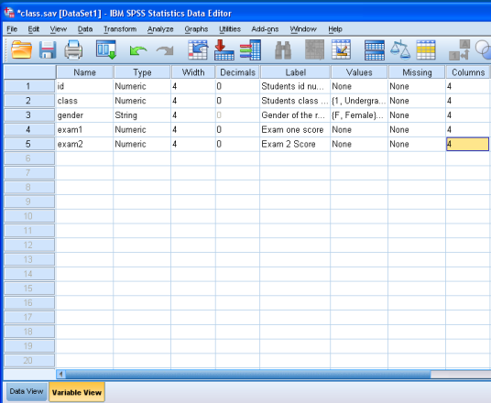
October 7, 2016 10:00 AM - 12:00 PM
October 14, 2016 3:00 PM - 5:00 PM
October 21, 2016 10:00 AM - 12:00 PM
October 28, 2016 3:00 PM - 5:00 PM
November 4, 2016 10:00 AM - 12:00 PM
November 18, 2016 3:00 PM - 5:00 PM

170 Math & Micro Bldg.

To register, or if you have questions,
Call: (937)775-4205
or
Email: melissa.deshurko@wright.edu

