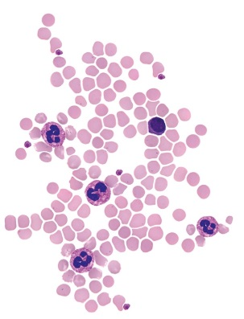
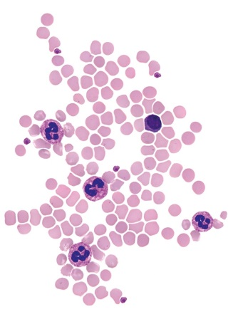
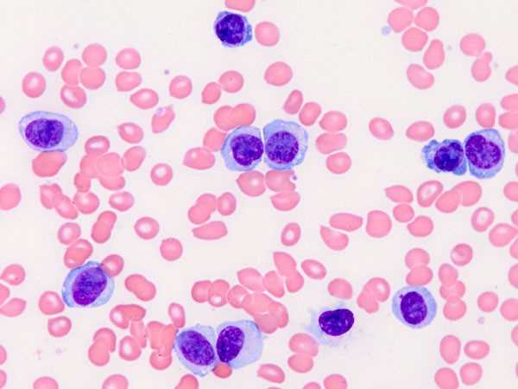
Clinical/Medical Laboratory Science’s
Hematology Poster Presentation
The Clinical/Medical Laboratory Science (MLS) students will be hosting a Hematology Poster Presentation. Join us in the Diggs Atrium to learn more about their current projects and discoveries. This event is open to all who are interested.
When: Friday, November 18
From 11:30 to 1PM
Where: Diggs Laboratory Atrium
(First floor)
Light refreshments will be served.

