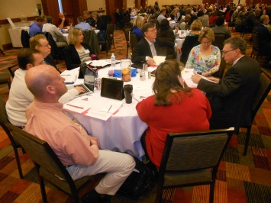
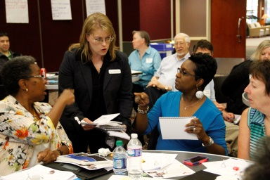
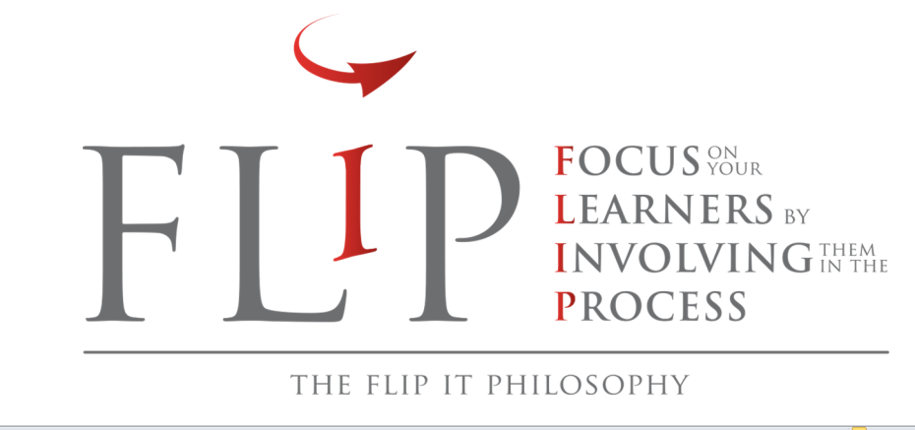

Join us for a day of engaging workshops and conversations to spark your creativity, increase student engagement, and improve learning!

“The concepts associated with “flipping” as a philosophy of teaching rather than as a teaching gimmick were well articulated. Dr. Honeycutt provided good responses to participant questions and concerns so that the atmosphere was very supportive.” –Workshop Participant, Teaching Professor Conference, 2014

Part 1: Create an Engaging Learning Environment: FLIP a Lesson!
When you FLIP, you reversing the way you design the learning environment so students are engaging in activities, applying concepts, and focusing on higher level learning outcomes during class time. This workshop will be flipped to allow you to experience a flipped learning environment for yourself. You will create a plan for a flipped lesson and explore the current research, models, and best practices. Bring a lesson you’d like to FLIP!
Part 2: Learning Styles and Preferences in the Flipped Classroom
An important part of moving towards a flipped paradigm involves knowing how to structure your lesson, create new activities, and assess learning. However, it’s also important to go a step further and raise your awareness of the different learning styles and preferences that exist in your learning environment. In this workshop, we will use a learning styles framework to increase your awareness of how students approach learning and communicating to allow you to design strategies to enhance student success. You can use your lesson plan from Part 1, and we’ll discuss strategies to integrate into the plan to increase engagement.
Part 3: Becoming a Facilitator of Learning
Through guided reflection and discussion, you will develop a plan or series of next steps to continue your professional development to create successful flipped learning environments. We will conclude with “The Reveal” which is a signature of Dr. Honeycutt’s workshops. All of the flipped strategies used throughout the day will be discussed and analyzed as you reflect on your experience as a learner in this environment and how to will adapt the flipped experience to align with your teaching style.



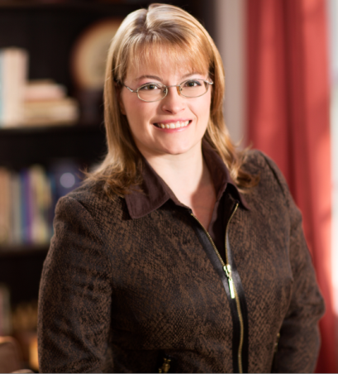
Meet the Facilitator!
Dr. Barbi Honeycutt is a speaker, scholar, and author. Throughout the past 16 years, she has facilitated more than 3,000 professional development events for more than 10,000 faculty, graduate students, and postdocs. Dr. Honeycutt is the founder of FLIP It Consulting in Raleigh, NC, and an adjunct professor at North Carolina State University. She facilitates workshops, shares strategies, and creates resources to support educators who want to develop learning environments that involve students, increase engagement, and improve learning. Dr. Honeycutt’s work has been featured in Faculty Focus, The Teaching Professor Conferences, The Teaching Professor Technology Conferences, and Magna Publications.
Email: barbi@flipitconsulting.com
More info: flipitconsulting.com

