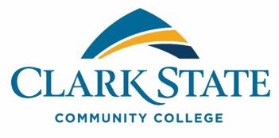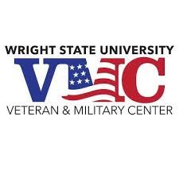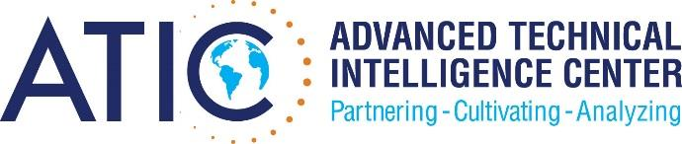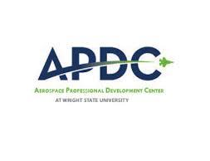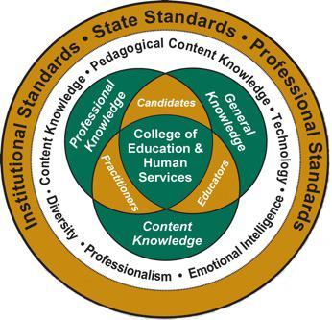

**Wright State University’s Aerospace Professional Development Center**

**&**

**College of Education and Human Services cordially invite you to a**

**Federal Resume Class hosted by WPAFB Personnel**

**Wednesday, June 1st, 2016**

**11:00 – 3:00 p.m. Location:**

**WSU Student Union Discovery Room To R.S.V.P. www.atichcd.org/events**

**Intended Audiences**

**Students desiring greater understanding of the federal resume writing and submission process & Career Services Personnel interested in gaining training insight and materials to pass along to their student populations**

APDC thanks and recognizes key partners for their support!