WRIGHT STATE UNIVERSITY
STATISTICAL CONSULTING CENTER
PRESENTS
APPLIED STATISTICS: AN OVERVIEW
FRIDAY, JANUARY 8, 2016
The science of statistics is used to design experiments and to summarize, analyze, and interpret data. This course will give you an overview of what questions must be considered when seeking to answer a research question using quantitative analysis. Everything in the course will be illustrated by examples; most of these examples will come from actual projects at the Statistical Consulting Center. We will cover:

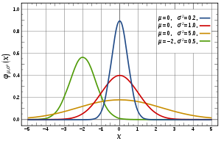
- Levels of Measurement
- Variable Structures
- Descriptive Statistics
- Classification of Statistical Methods
- Sample Size Determination
- p-value
- t-test and ANOVA
- Multiple Regression
- Logistic Regression
- Experimental Design

Date: January 8, 2016
Time: 8:30 AM – 5:00 PM
Location: 202 M&M (Math & Micro Building)
Presenters: Dr. DeAnne French & Michael Bottomley
Cost: $400 per participant ($100 with WSU fee waiver; grad students $100)
$200 for K-12 Educators with proof of employment
Continuing Education: Authorized for 0.8 CEUs

Continental breakfast, lunch and snacks provided.

Registration: CALL (937) 775-4205 OR EMAIL mary.alspaugh@wright.edu
Registration deadline is 12/22/15

Payment (by January 2, 2016): Check or credit card (and fee waiver, if applicable)

Checks should be made out to: Wright State University
Mail checks to: Statistical Consulting Center – 130 MM
Wright State University
Dayton, OH 45435

