

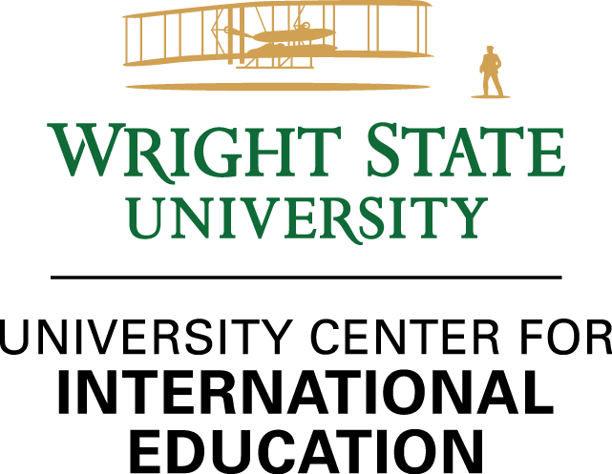

|  |  |
| --- | --- |
|  | Agent Manual |
|  | 2023 - 2024 |
|  |  |

## Welcome!

Wright State University is thrilled to have you as part of our network of international agents recruiting international students to our campus. Our university was one of the founding members of the American International Recruitment Council (AIRC) and has had an agent network in place since 2008. We currently enroll over 1,000 international students from over 50 countries and look forward to partnering with you to fulfill the academic dreams of many new students in the future.

The work you do to find the best fit for students to study abroad is a critical component of our mission in the University Center for International Education. This manual is designed to serve as a resource for you to advise students in considering Wright State as an option, support your advisors as they work with applicants to apply to our university, tracking commission and preparing your invoices, and keeping up to date on our programs, processes, and communications with our staff. If you ever need assistance or have questions beyond what is available in this manual, please do not hesitate to contact me or Jesse Makowski, our International Recruitment Partnership Coordinator, at jesse.makowski@wright.edu.

Thank you for your partnership. We look forward to working with you to help students succeed!



Michelle Streeter-Ferrari

Director,

University Center for International Education

# Partnership with You

As a recruiting partner of Wright State University, we want to develop a relationship with you that is long-lasting and beneficial for all parties. Students form the foundation of that relationship, and it is our desire to make sure that their needs are met, first and foremost.

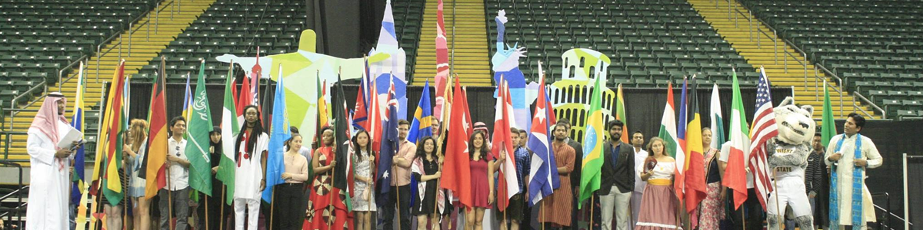

## What our Agent Partners can expect from us:

* We promise to communicate with you regularly about policies, processes, programs, scholarship   
  opportunities, and any updates that may affect both parties.
* We commit to responding to your inquiries in a timely manner. These include inquiries regarding students, applications, invoices, procedures and policies.
* We will provide initial training at the beginning of each new contract term. This ensures you have the knowledge and tools to successfully promote Wright State University to your students.
* We will continue to provide training upon request via our in-state representatives or through video-conference.

## What we expect of our Agent Partners:

* To promote WSU in a truthful manner
* To provide the students’ needs first
* To abide by all terms and conditions of our contract at all times
* To notify us immediately of any company changes such as agency name changes, address, point of contact, banking account, or any other company changes as they relate to recruitment to WSU.
* To keep up-to-date with information on WSU’s website: [www.wright.edu](http://www.wright.edu), and UCIE’s website [www.wright.edu/international-education](http://www.wright.edu/international-education)
* To communicate with WSU representatives, international admissions, and international partnership coordinator regarding recruitment activities, and when you have any questions or concerns.
* To inform students on a student via that they must have the primary purpose of studying, and must study on a full-time basis.

# Why Wright State University?

## A global campus

More than 1,043 international students attend WSU from 59 different countries.

## Affordable and Quality Education

Wright State University is a national public university in Dayton, Ohio with more than 10,000 students. Offering 315 degree programs, the university is made up of six colleges, a medical school, and a branch campus in Celina, Ohio. Named for the Wright brothers, Wright State University offers an exceptional, affordable education.

## Rankings

Wright State University was ranked in the **top 6.4%** out of 20,531 universities worldwide in the 2023 edition of the Global 2000 list by the Center for World University Rankings. *May 15, 2023*

U.S. News ranks Wright State **graduate programs among best** in the nation. *April 25, 2023*

Princeton Review ranks Wright State’s **entrepreneurship program in top 50**. *December 7, 2022*

Wright State ranked among **top undergraduate nursing programs** in the Midwest. *June 30, 2022*

School of Nursing, Kinesiology, and Health Sciences **ranked No. 3** among NursingProcess.org’s 10 Best Accredited Nursing Schools in Ohio. *May 9, 2022*

Raj Soin College of Business earns **two high rankings** for entrepreneurship and graduate information systems programs. *April 13, 2022*

“Best undergraduate engineering programs,” U.S. News & World Report, 2022

And many more!

## Safety and welcoming city

Wright State University takes pride in its beautiful 557-acre campus, which includes lush forests and a biology preserve. The university’s state-of-the-art facilities include 32 academic and academic support buildings, 33 student residential buildings, and a world-class entertainment and athletics venue. Underground tunnels connect 20 of 22 buildings in the academic section of campus, shielding students and employees from any adverse weather and adding to the university’s national reputation for accessibility for those with disabilities.

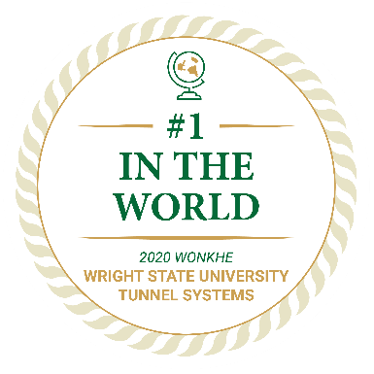

Located in the Miami Valley region of southwestern Ohio, Dayton is a **mid-sized city** surrounded by a diverse metropolitan area of almost a million residents. **Dayton ranked No. 2 on Livability’s list of the Best Affordable Places to Live.** “The real bargain that comes from living in Dayton is the high quality of life residents enjoy,” according to Livability.com. “Dayton offers a rich assortment of things to do, from outdoor recreation that includes canoeing and ice skating to cultural amenities, like the Dayton Philharmonic Orchestra and the Benjamin and Marian Schuster Performing Arts Center.”

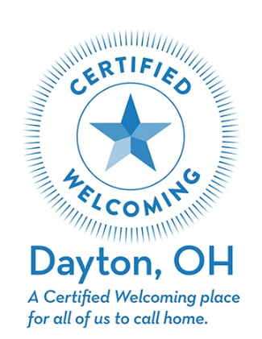

## Scholarships for international students

Wright State University offers a merit scholarship for both undergraduate and graduate students. This scholarship is based on the student’s GPA. Find more information about undergraduate scholarships here: <https://www.wright.edu/raiderconnect/financial-aid/international-undergraduate-student-scholarships>

and graduate scholarships here: <https://www.wright.edu/admissions/international/graduate-student-scholarships>

## On-campus work opportunities

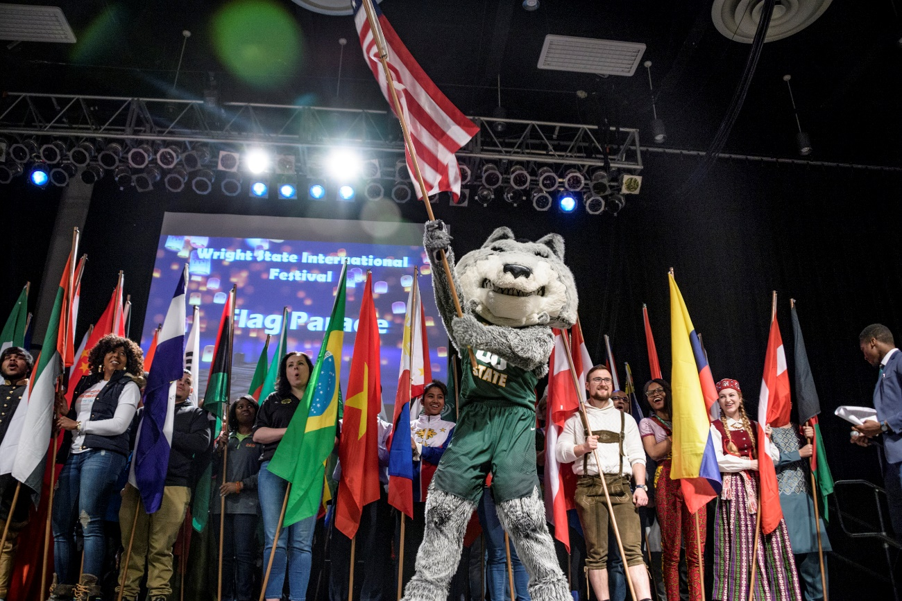Wright State international students may work on campus up to 20 hours per week during the academic terms, and 28 hours per week during breaks. Students have to apply for available on-campus jobs through Handshake https://www.wright.edu/student-success/career-and-academic-advising/handshake-login-guide

# The Application Process

## Application deadlines

Undergraduate: Please see <https://www.wright.edu/admissions/international/international-application-deadlines>

Graduate: Varies by program- see <https://www.wright.edu/admissions/international/graduate-programs>

## Submitting an application

You will find our online applications for undergraduate and graduate programs on our international admissions page, along with instructions and requirements: <https://www.wright.edu/admissions/international>

Supporting documents can be uploaded to the application. Please have your official IELTS, TOEFL, Duolingo or PTE results sent directly from the organization to Wright State University. Wright State's school code is 1179. It is the same school code for both graduate and undergraduate applicants.

Applicants from the following countries are required to have their transcript evaluated through an international credential evaluation service: Afghanistan, Bangladesh, Gambia, Liberia, Libya, Nigeria, Pakistan, Kazakhstan, Tajikistan, Turkmenistan, Uzbekistan, Iran, and Iraq.

Please review ALL of the information regarding transcripts at <https://www.wright.edu/admissions/international/international-transcripts>

## Admission requirements and English proficiency

Undergraduate:

* Please visit - <https://www.wright.edu/admissions/international/undergraduate-admission-requirements> for all undergraduate admission requirements including English proficiency requirements.

Graduate:

* Please visit - <https://www.wright.edu/admissions/international/graduate-admission-requirements> for all graduate admission requirements including English proficiency requirements.

Please have your official IELTS, TOEFL, Duolingo or PTE result sent directly from the organization to Wright State University. Wright State's school code is 1179. It is the same school code for both graduate and undergraduate applicants.

## Tips to expedite the application

* Application forms are complete and accurate
* Application fee has been paid
* All required supporting documents are uploaded
* Documents are correctly certified (where required)
* Documents are translated (where required)
* The student provides their **own permanent address** and **own email address** in their country of origin (this may NOT be the agent’s addresses)
* Your agent name is on the application, to ensure you are credited for the recruitment of the student. For both undergraduate and graduate-level applications, please choose the agent name from the drop-down menu. If the agency name is not included, please choose “My agent is not listed” and provide the agency name in the comments. Also, email [international-admissions@wright.edu](mailto:international-admissions@wright.edu) so that we can add the agency name to the list.

## The processing of applications may be delayed if:

* The application is incomplete
* Insufficient documentation is provided
* The application fee is not included
* A student changes program mid-assessment, or has selected a program which is not available for their chosen semester
* A student applies in a peak period (6-8 weeks prior to the start of the semester)

It is important to send **completed** individual applications as you receive them. Please do not collect applications and submit them only when you have a number of them. This is especially important during peak periods just before the semester starts.

# Tracking your student’s applications

* Email international-admissions@wright.edu, citing the student’s full name, date of birth, and/or WSU student UID number. This email is monitored daily, and our Admissions staff travel frequently, so it is important that you direct all inquiries to this email rather than to an individual’s email address.
* Students are encouraged to text our WhatsApp number at +1-937-231-4230. This number is ONLY **for application status checks** and not for other inquiries. This phone number is monitored daily.
* The intended response time for such enquiries is 2 working days. If, however, you do not receive a response *within 5 working days*, please email the International Admissions team at [international-admissions@wright.edu](mailto:international-admissions@wright.edu).

# Commission Payment

## Basis of Commission

Commission amounts are paid based on the terms of our contract.

Commission is paid on a per student basis, a maximum of two payments for an academic year, as determined by:

1. Whether the student is enrolled
2. Whether the enrollment status is “full-time”
3. Whether the contract is valid during the time of enrollment
4. The program of study is undergraduate or graduate level
5. A valid invoice has been sent within the required deadline for the semester being involved

## Processing Commission Payments

For the fastest processing, please follow these steps:

1. As soon as possible after the 15th day following the start of the semester, email a list of students for whom you are requesting commission to the International Recruitment Partnership Coordinator, Jesse Makowski. To determine eligibility, please include in the email the following information:
   1. Term of entry (semester)
   2. Student’s full name
   3. Student’s date of birth
   4. Student’s UID
   5. Student’s program/degree
2. The International Recruitment Partnership Coordinator, Jesse Makowski, will respond with confirmation of eligibility and commission due for each student.
3. Create an invoice with the updated information and send a completed, legible, and valid invoice back to the International Recruitment Partnership Coordinator.

## Valid Invoice

In order to be processed for payment, your invoice must be submitted within the following date window.

* No sooner than 15 days after the start of the semester being invoiced
* No later than the invoice deadline for the semester of enrollment

Your invoice should include all the following:

* Prepared on a company letterhead, with complete contact and address information
* Invoice number and date
* Correct information, including eligible student’s name, date of birth, WSU student UID number, student’s level and program of study, and the correct commission amount.
* The mandatory statement regarding the students’ location: *“I certify that recruitment services occurred while all students listed above were outside the United States.”*
* Your complete current banking information, which must match the banking information in our payment system. In you change bank accounts, please notify us immediately. The banking information on your invoice should include the following:
  + Bank name
  + Bank address
  + BIC/SWIFT Code or routing number, if a U.S. account
  + IBAN/Account number
  + Account name (name on the corporate account, not an individual’s name)
  + Account type: Checking or savings, if a U.S. account

Any invoice that does not have the complete and correct information will be returned to the agency for correction and will result in payment delays.

## Payment

Our goal is to process all correct, complete invoices as soon as they are received; however, staffing and workflow do not always allow that to happen; please allow up to 30 days for payments to be processed.

Payments to bank accounts outside the United States will be paid via wire transfer. Your agency must have a valid W-8 and W-9 on file. The W-8 is required by U.S. tax authorities and is valid for 3 years. The W-9 is required by Wright State University, regardless if the agency is outside the United States.

Payments to bank accounts in the United States can be paid via check or ACH electronic funds transfer. If your bank is in the U.S., please specify which method you prefer.

# Agent Assessment

We view our relationship with you as a long-term commitment with the understanding that building

institutional branding and marketing can take time. We understand that the nature of recruiting

markets can vary greatly by country and region. One of the factors we evaluate in assessing our Agent

Partners’ success is the number of students recruited, but that it certainly not the only factor. We

appreciate the value you bring in evaluating your students fully to determine which of them will be the

best fit for Wright State University, and we know that means that the numbers do not tell the full story.

Factors that we will use in assessing your performance are:

* Overall number of enrollments
* Conversion rate from applicants to enrollments
* Quality of your student applicants
* Communication
* Responsiveness
* Professionalism
* Reliability
* Honesty
* Integrity
* Compliance with WSU’s and students’ requests

# Your Wright State University Team

Your primary point of contact for all contract management matters, invoice processing questions and general issues relating to our policies and procedures should be directed to Jesse Makowski, our International Recruitment Partnership Coordinator, at jesse.makowski@wright.edu. Communication regarding the application or admissions process should be sent to us at international-admissions@wright.edu. And if you’d like to speak to us in person, we can arrange an online meeting or you can call 937-775-5745. If you plan to be traveling in or near Ohio, we will be happy to see you and arrange faculty meetings and a tour of our campus. Our physical address is:

Student Union  
3640 Colonel Glenn Hwy.  
Dayton, OH 45435 USA

The following link is a complete list of our UCIE staff and contact information:

<https://www.wright.edu/international-education/about/staff>

# **Agent Marketing Toolkit**

## **Video Links:**

You can subscribe to Wright State’s Youtube Channel here: <https://www.youtube.com/@WrightStateU>

You can invite your students and their parents to take a virtual tour of our campus: <https://www.wright.edu/virtual>

Campus life information: <https://www.wright.edu/campus-life>

Campus housing tour: <https://youtu.be/6ewQwD5KxCo>

Activities around Dayton, Ohio: <https://youtu.be/gbvrilOQC4I>

## **Connect with us on social media**

WSU UCIE FaceBook page: <https://www.facebook.com/WSU.UCIE>

WSU International Admissions FaceBook page: <https://facebook.com/internationalwsu>

WSU UCIE Instagram Page: <https://www.instagram.com/wsu.ucie>

## **Other useful links**

WSU University Center of International Education (UCIE) page: https://www.wright.edu/international-education

Dayton, OH Chamber of Commerce website: <https://daytonchamber.org/>

WSU international admissions: <https://www.wright.edu/admissions/international>

WSU tuition and aid: <https://www.wright.edu/tuition-and-aid>

WSU degrees and programs: <https://www.wright.edu/degrees-and-programs>

Student involvement and organizations: <https://www.wright.edu/student-affairs/student-involvement-and-leadership>

Application deadlines: <https://www.wright.edu/admissions/international/international-application-deadlines>

International Undergraduate Scholarships: <https://www.wright.edu/raiderconnect/financial-aid/international-undergraduate-student-scholarships>

International Graduate Scholarships: <https://www.wright.edu/raiderconnect/financial-aid/international-graduate-student-scholarships>