Student AIM Instructions
Contents
Logging into AIM 1
E-Agreements 3
Scheduling Tests 5
Communication Access- Custom Request 10
Alternative Format 17
Request an Appointment 19

Logging into AIM
- Go to https://www.wright.edu/disability-services
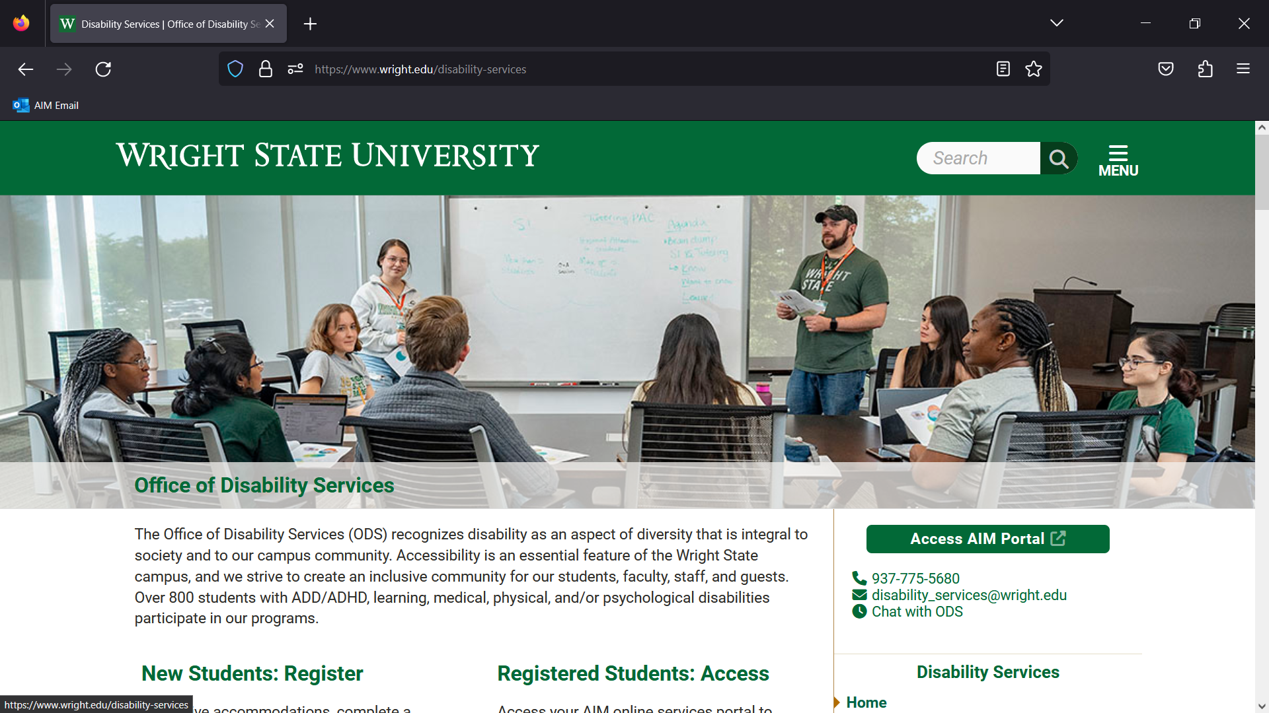

- Click Access AIM Portal button
0
- Enter your Wright State credentials (W# and password)
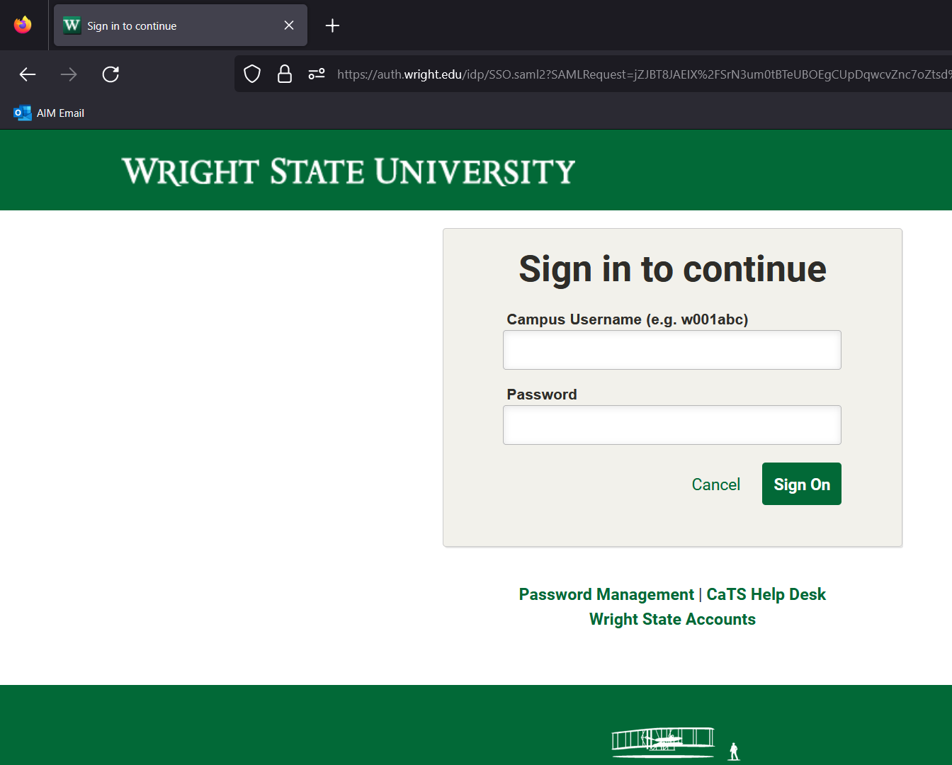
- You will fine yourself on the welcome screen. You may have to sign E-agreements before you can continue further.
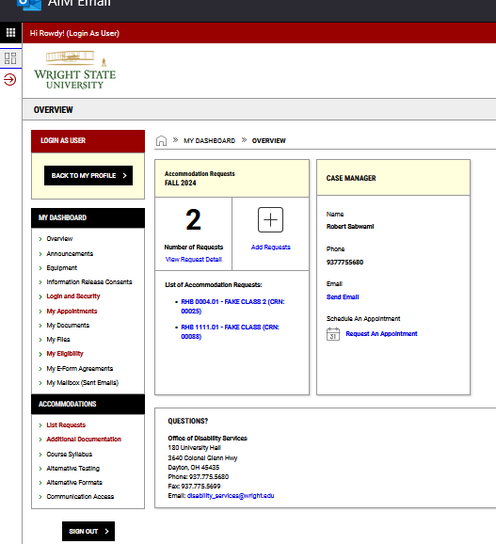

E-Agreements
1. If you have E-agreements to sign, they will populate first when you log into AIM.
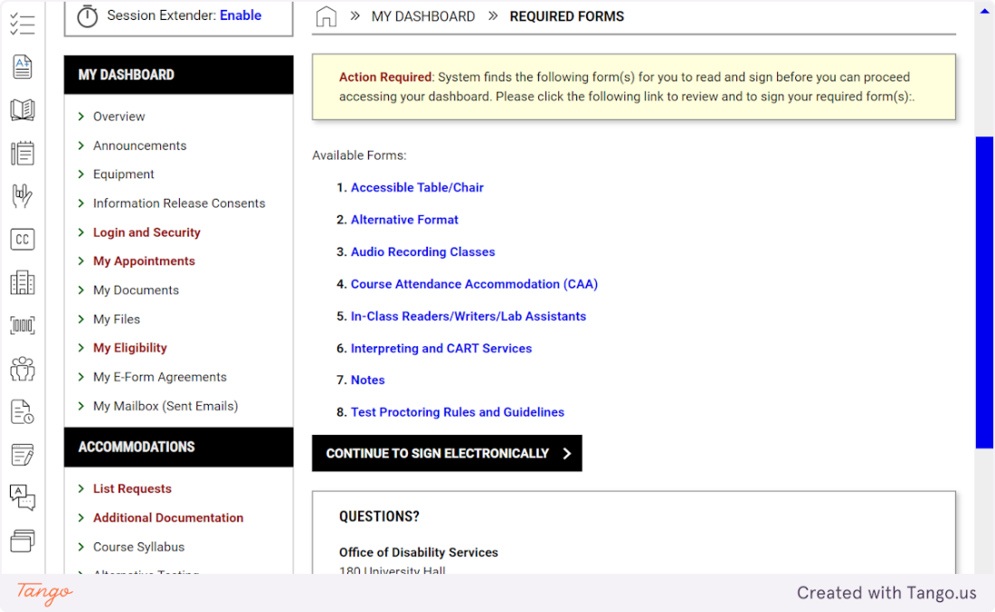
2. Click on CONTINUE TO SIGN ELECTRONICALLY
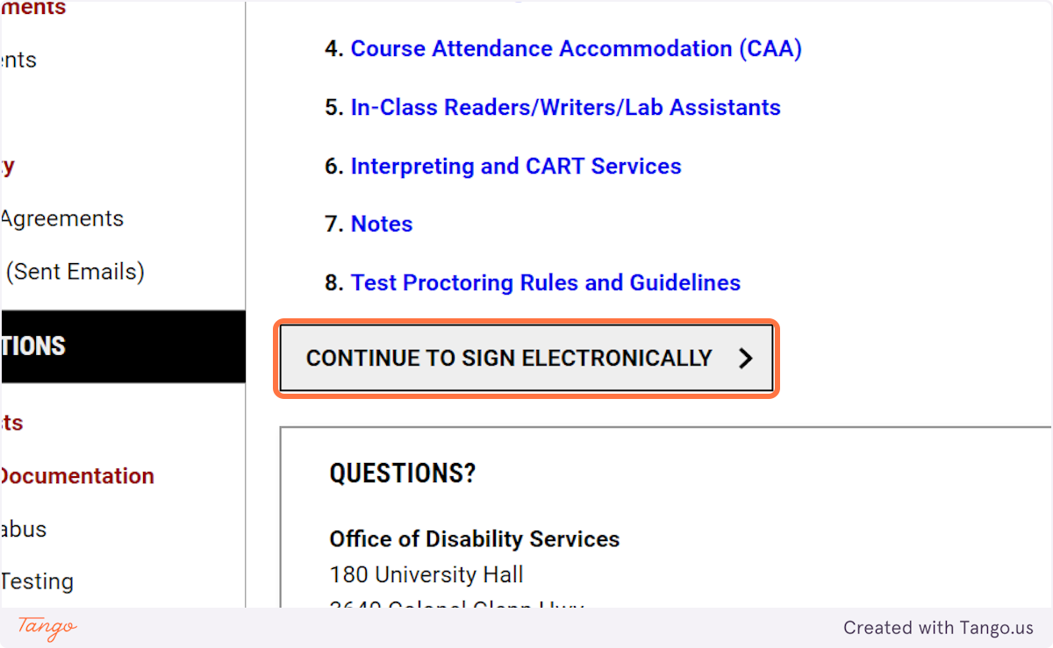
3. That will open the E-agreements and you can read them all before signing your name at the bottom.
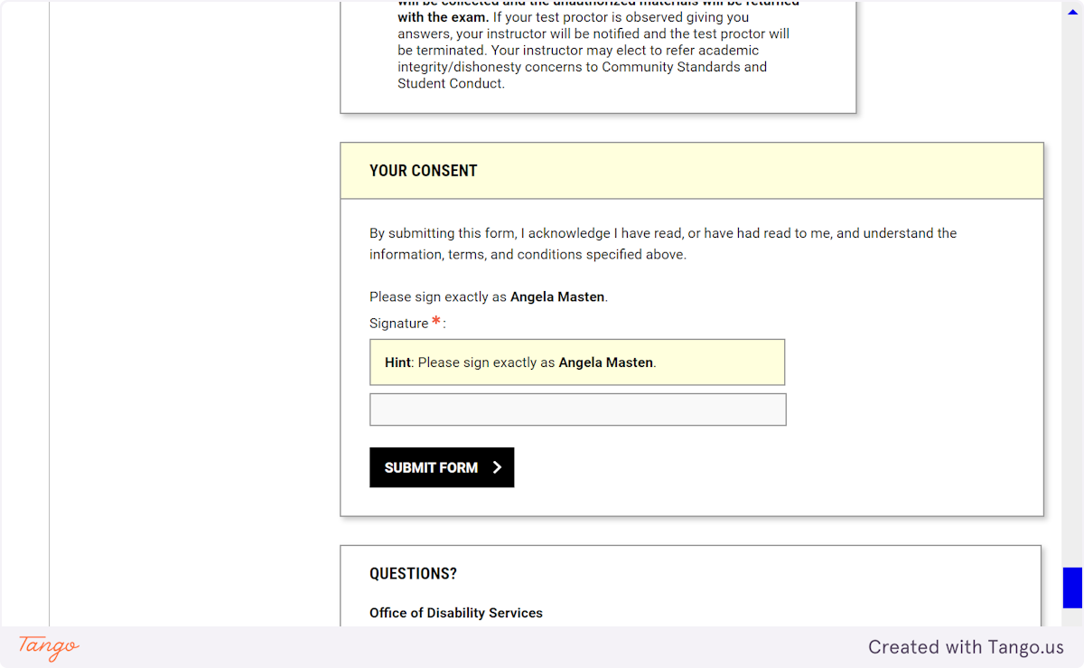
4. Type your name in the signature bar
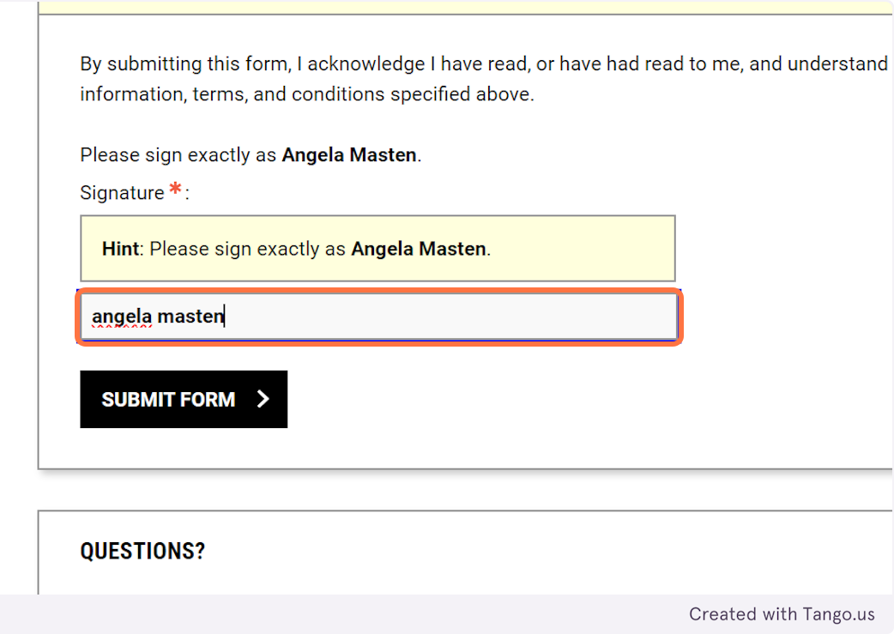
5. Click on SUBMIT FORM
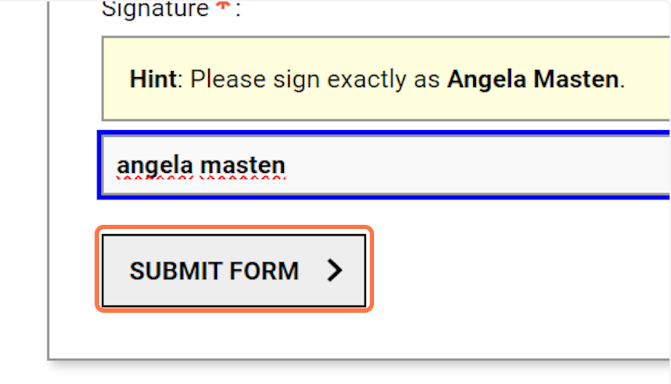

Created with Tango.us

Scheduling Tests
1. Click on Alternative Testing
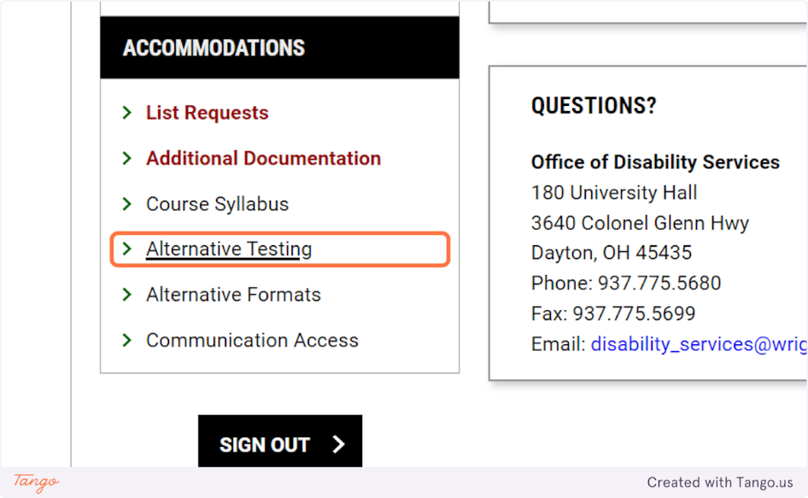
2. Choose your the class you are scheduling for.
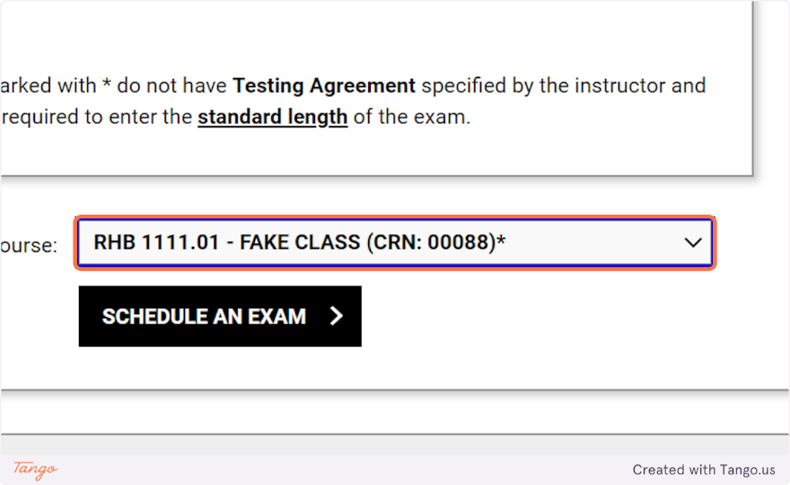
3. Click on SCHEDULE AN EXAM
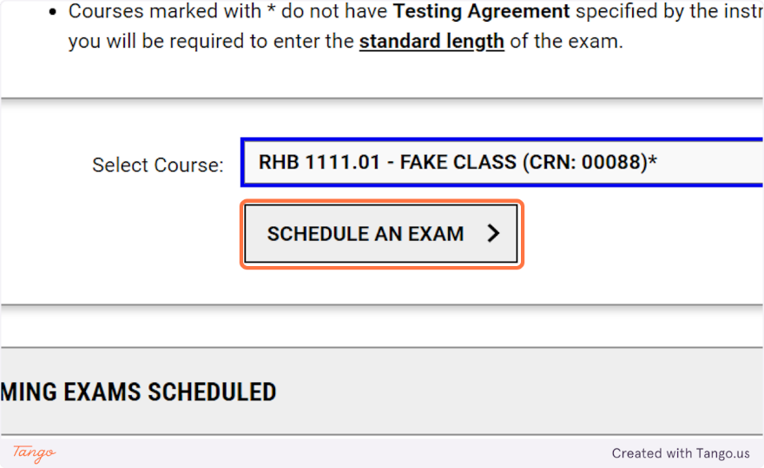
4. Select the type of item you need to schedule from the Exam Type dropdown menu.
Finals in week 16 should be scheduled as such. Finals in week 15 or earlier should be scheduled as a regular test.
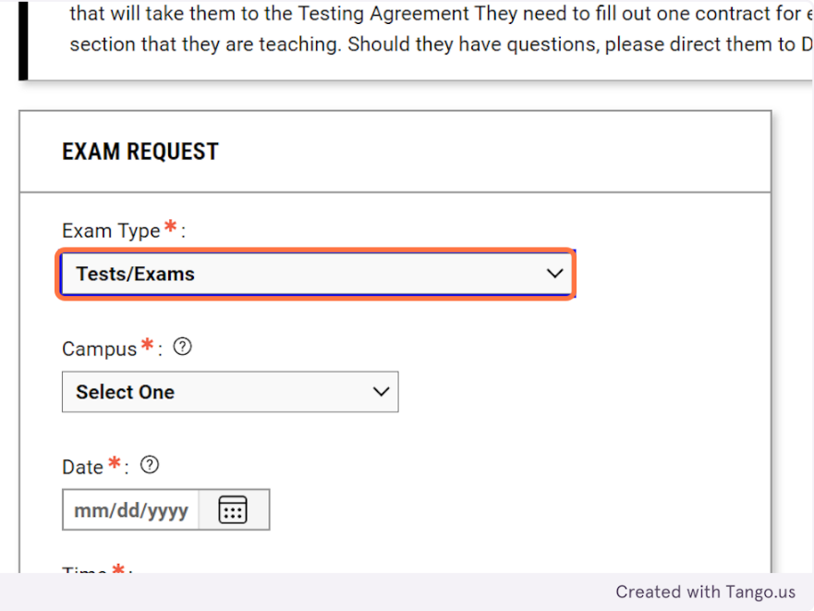
5. Select the Campus you will take the test at.
Dayton Campus or Lake Campus in Celina, OH
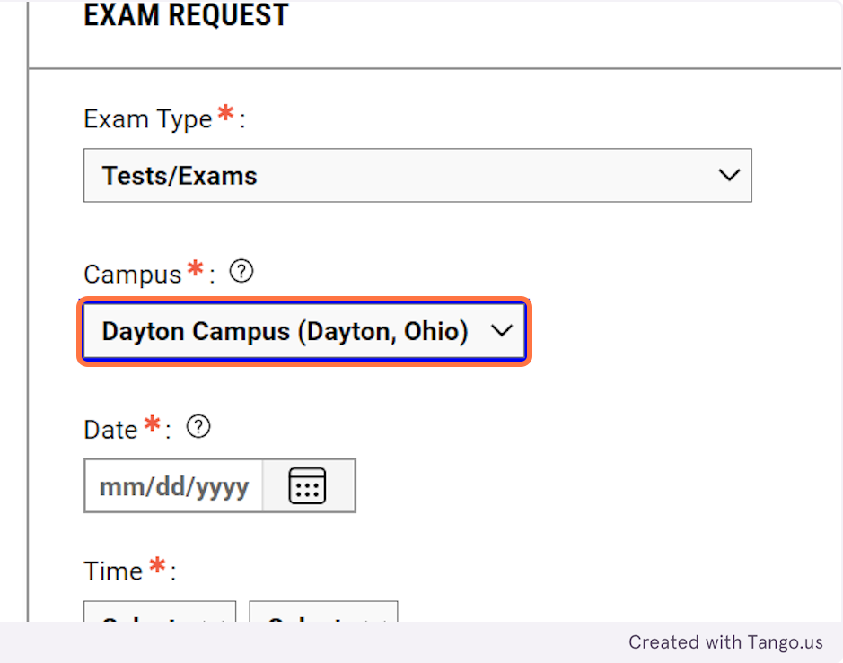
6. Enter the date of your test
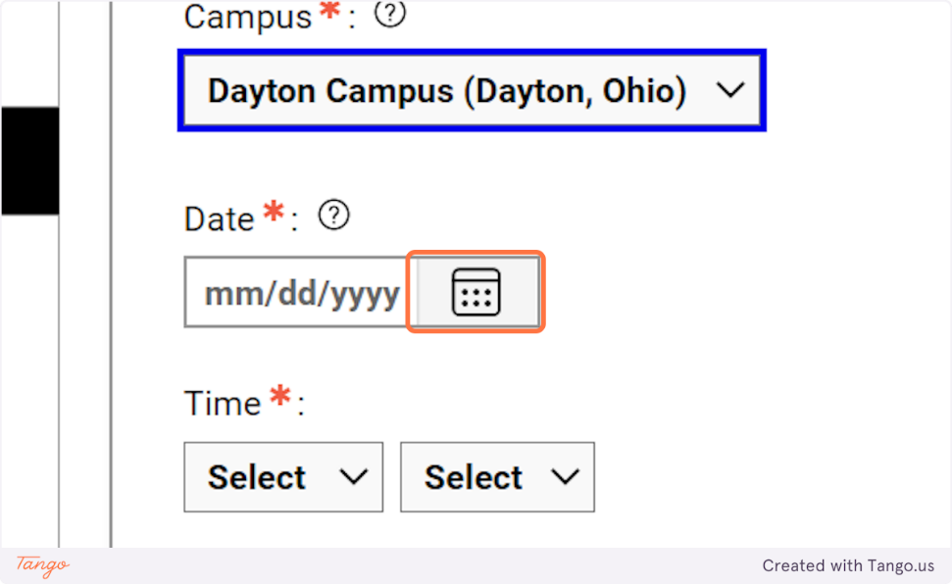
7. Enter the start time for your test.
Tests can start on the hour or half hour, choose the time that is nearest to your class start time.
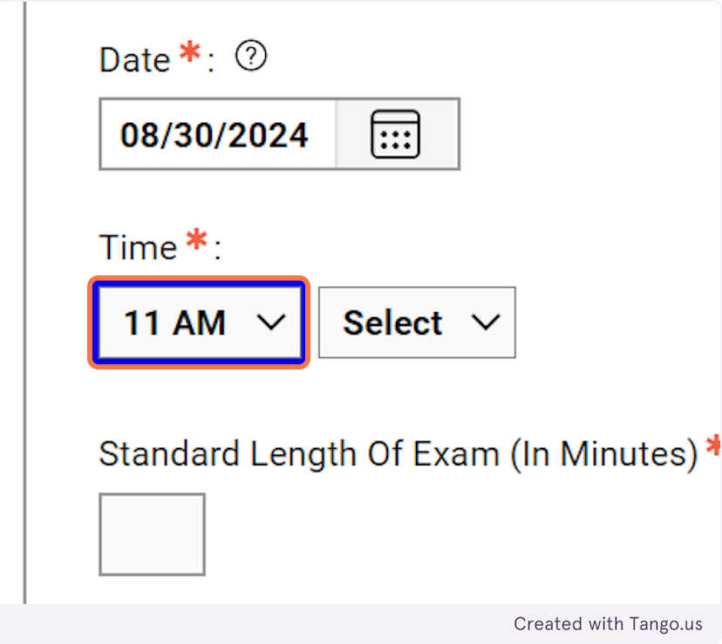
8. Enter the amount of time you class will have for the test in the classroom.
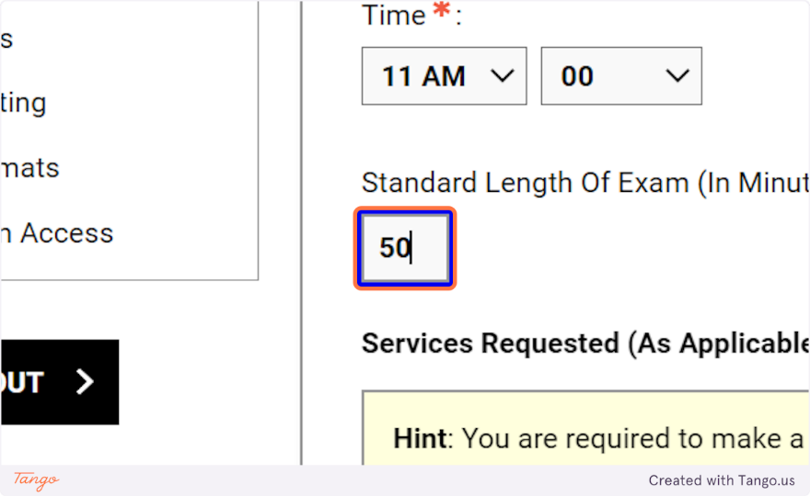
9. Select the accommodations you need for the test.
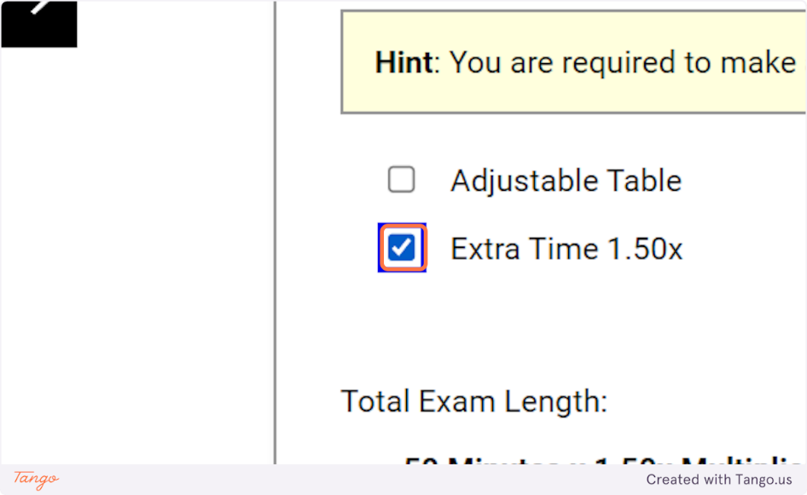
10. If there are additional technologies you will need for the test you can indicate them.
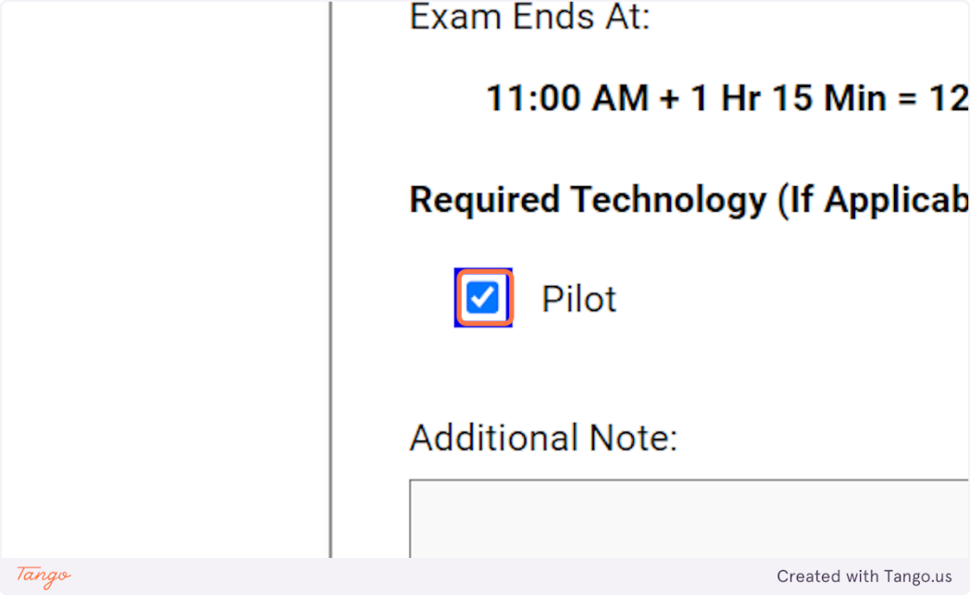
11. Click on ADD EXAM REQUEST
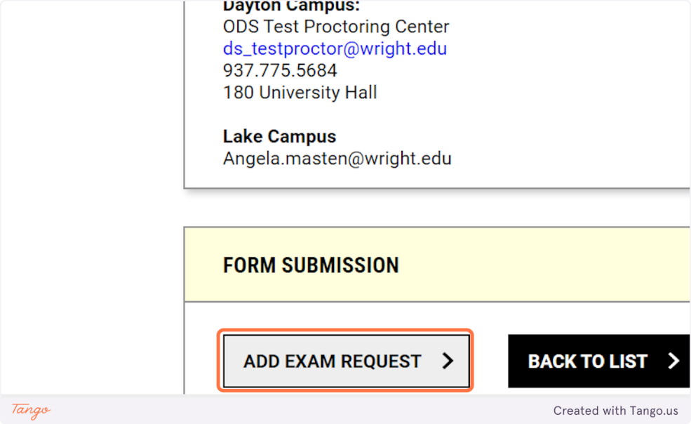

Created with Tango.us

Communication Access- Custom Request
1. Once you are logged into AIM, under Accommodations click on Communication Access.
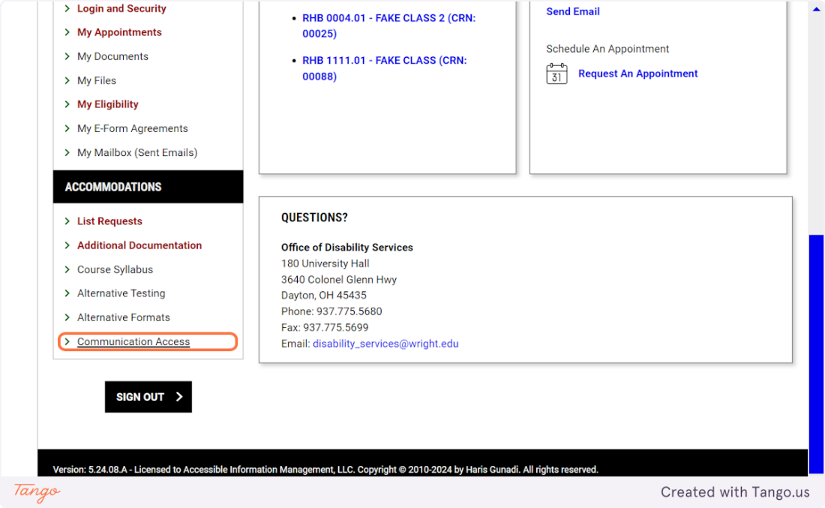
2. Click on CUSTOM REQUESTS
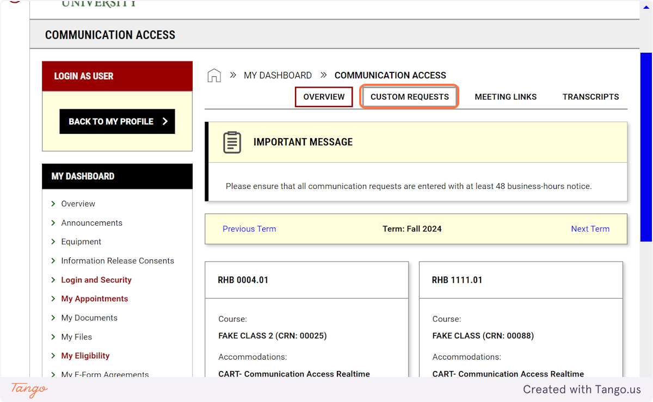
3. Select the course if applicable (tutoring, instructor meetings) or Non-Class Related Request for all other university activities.
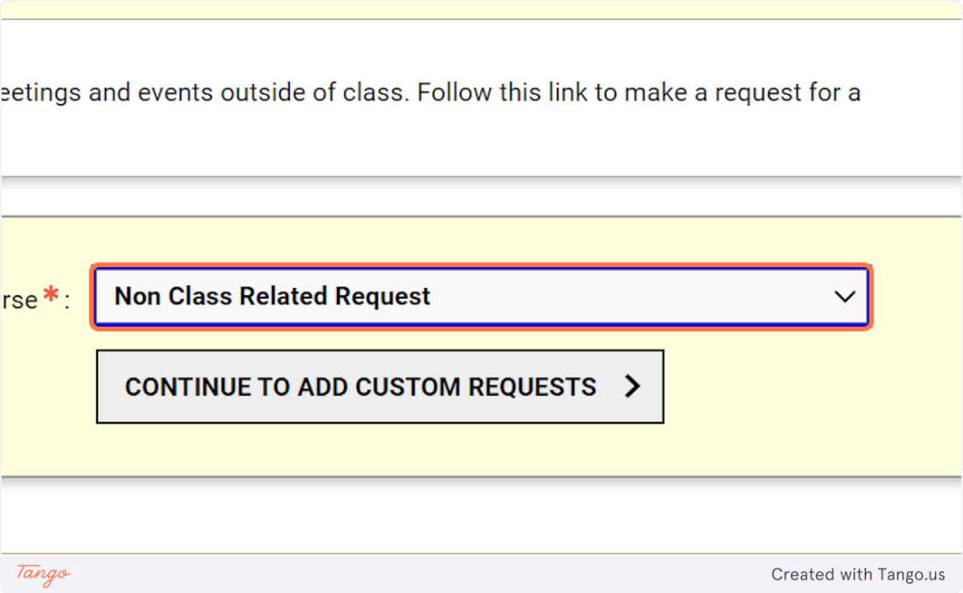
4. Click on CONTINUE TO ADD CUSTOM REQUESTS
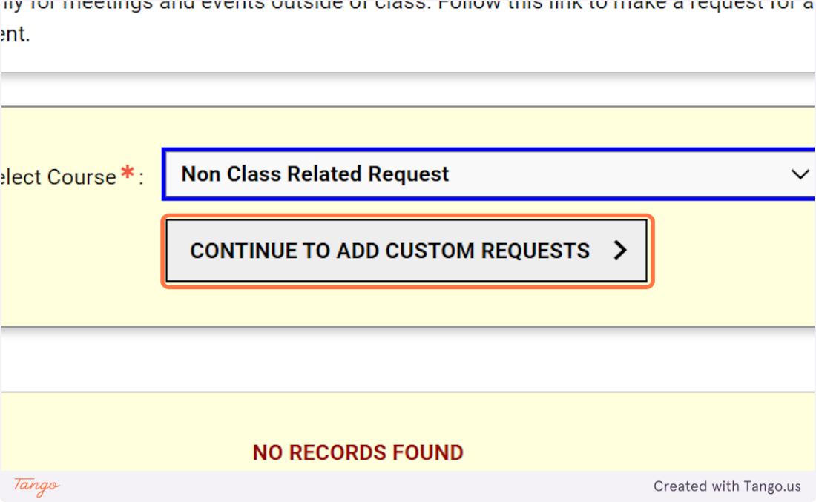
5. Enter the event title
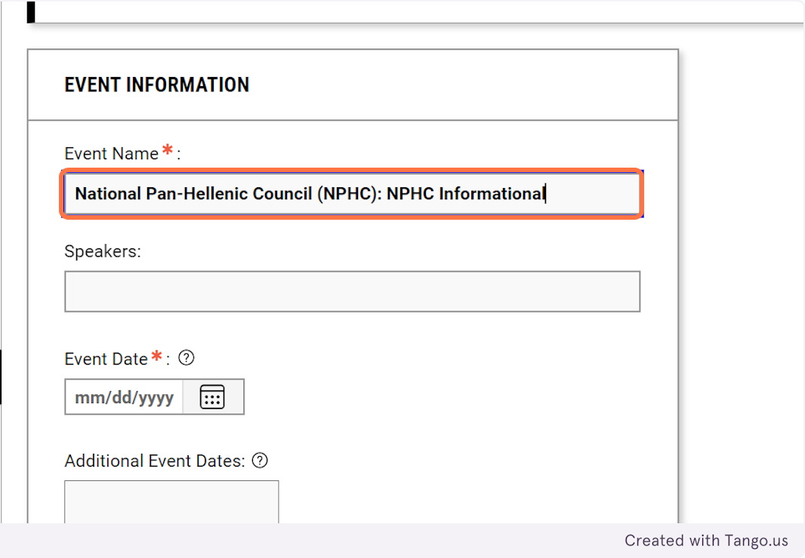
6. Enter the information you know about the speakers
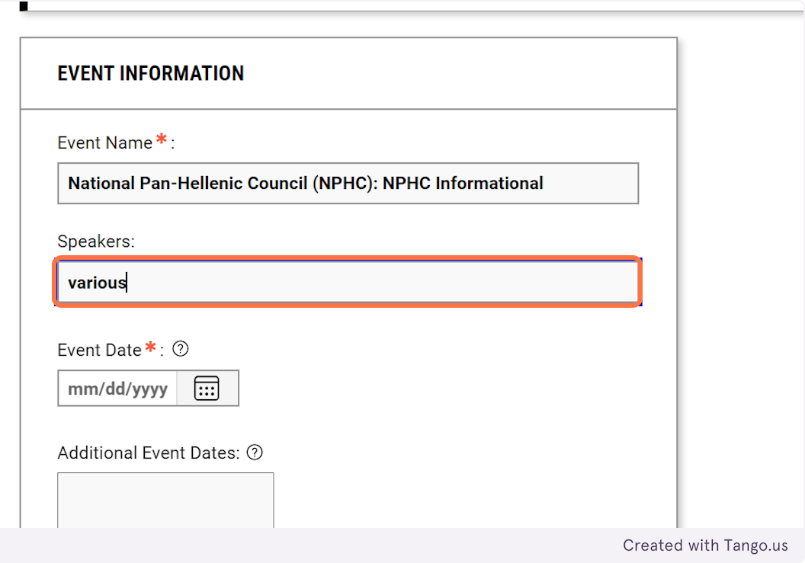
7. Enter the date of the event
If it is a recurring event, like a student organization meeting, you can list recurring dates as well.
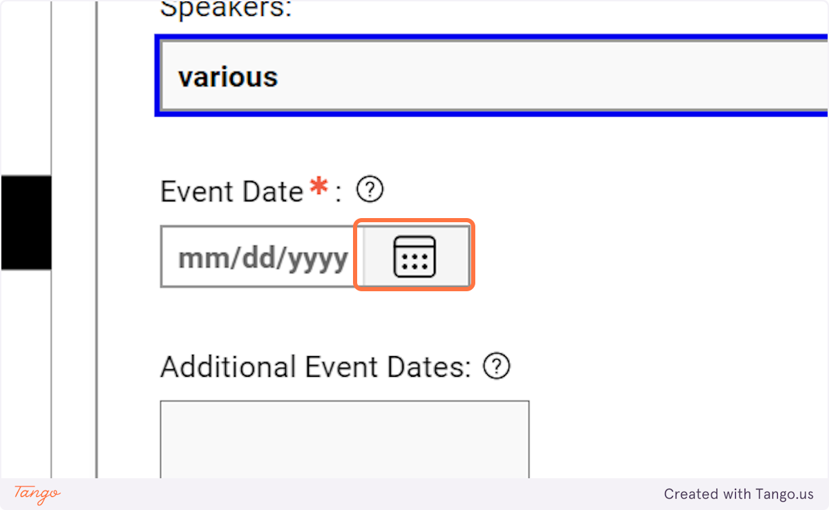
8. Enter the start time.
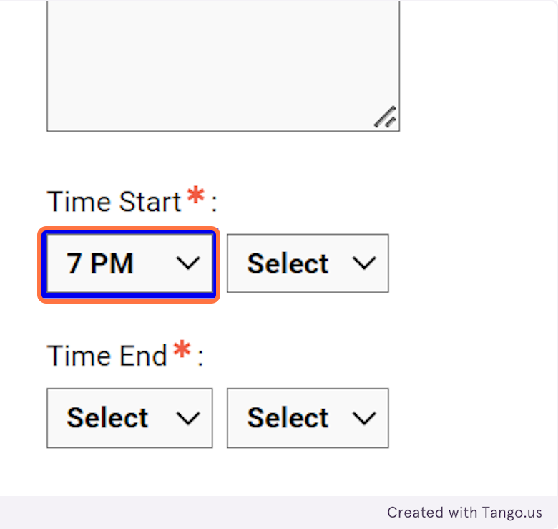
9. Enter the End Time.
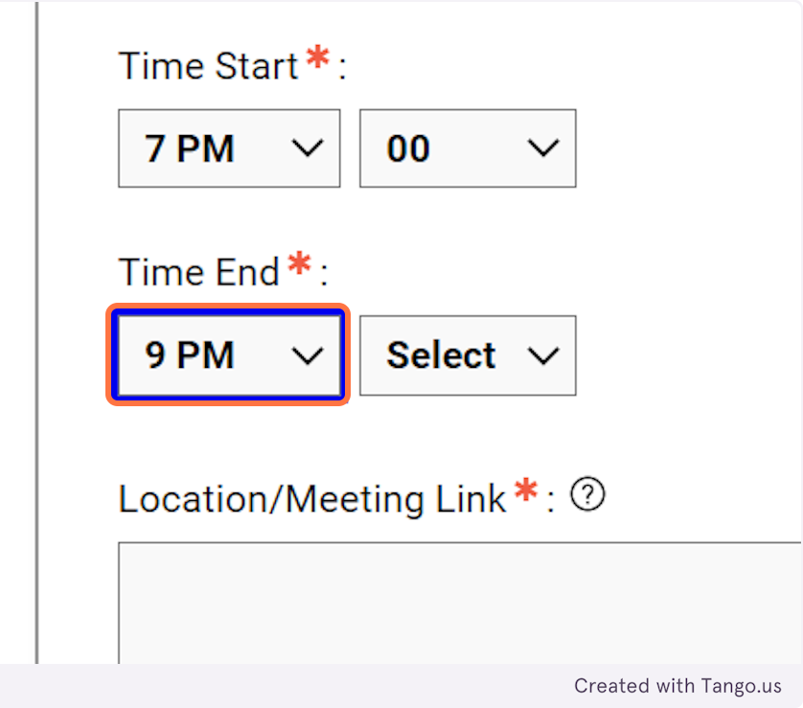
10. Enter the meeting location or link if it is virtual.
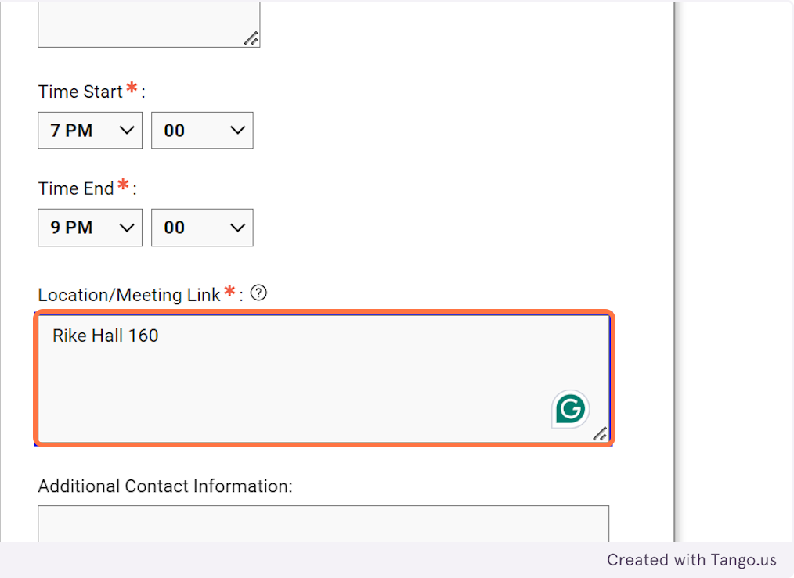
11. Please provide contact information should we need to connect with them directly.
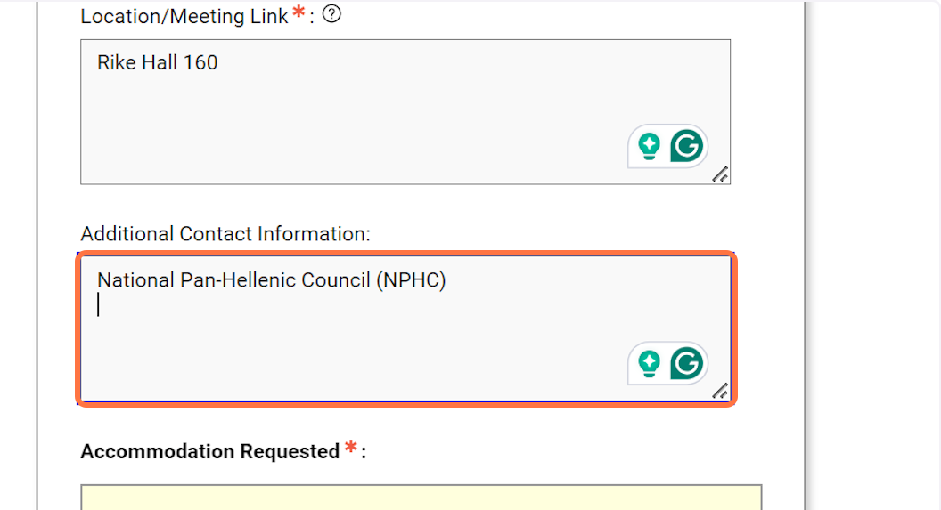
12. Choose the accommodation you need for the event.
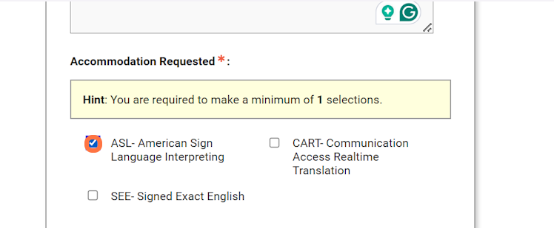
13. List any media, materials, or format that you know will be associated with the event.
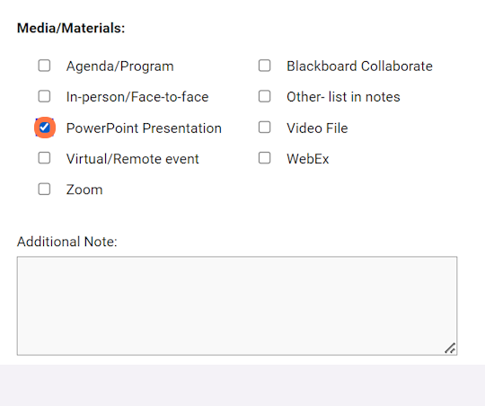
14. Enter the best way for us to communicate with you.
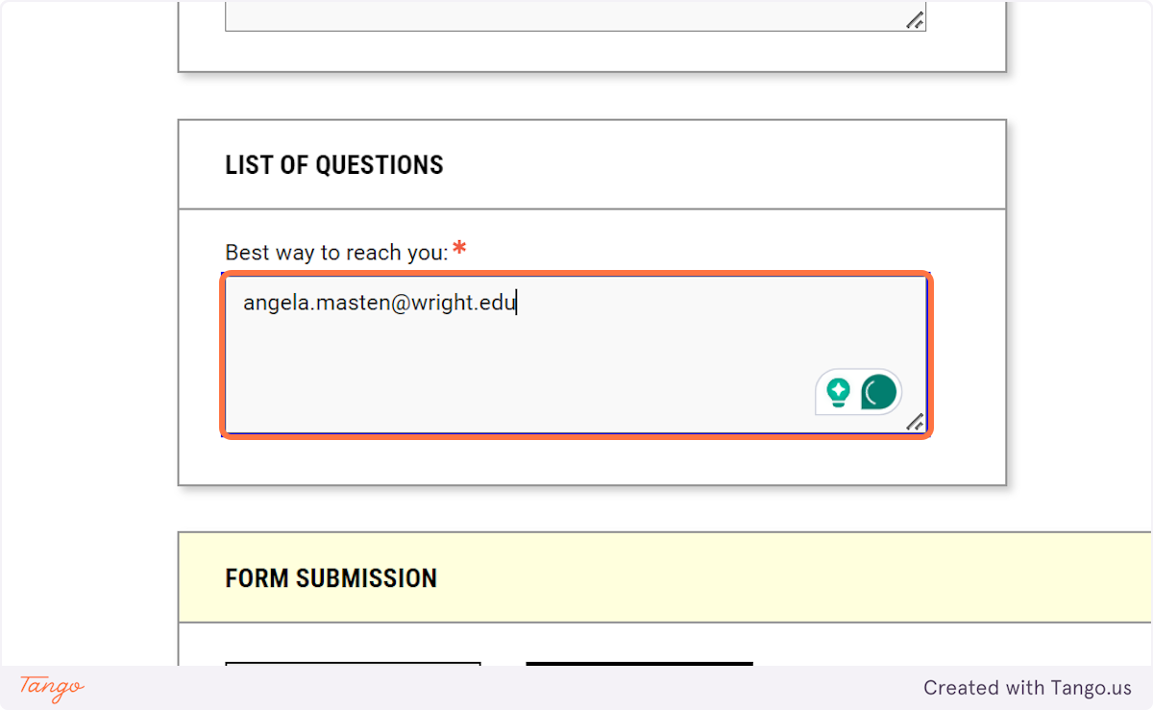
15. Click on ADD NEW EVENT
.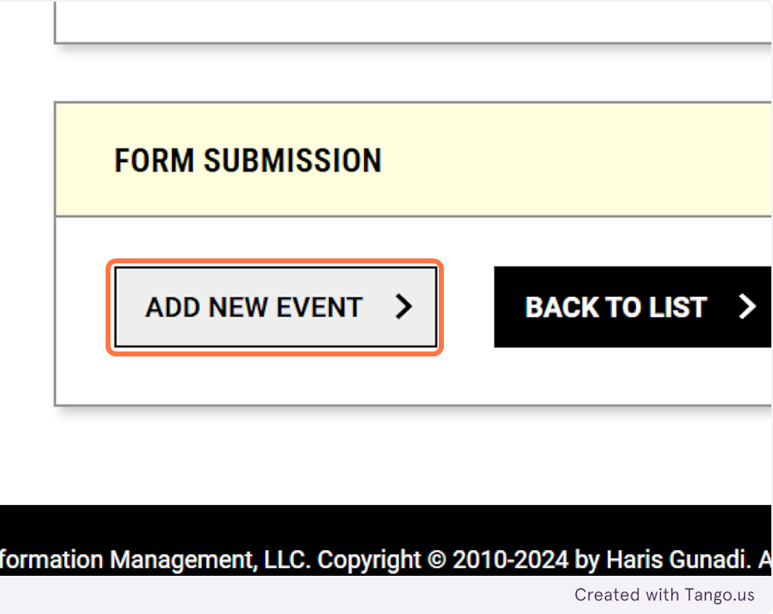
16. Your request will populate on the Custom Request page.
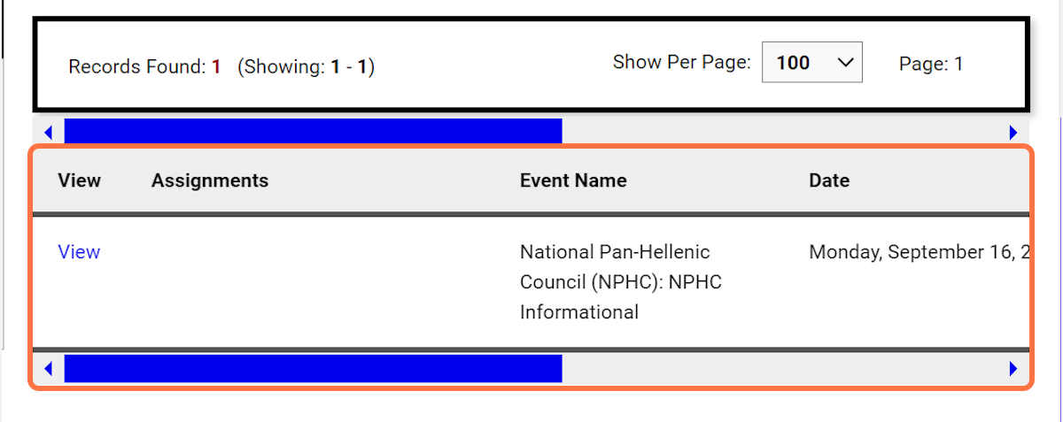

Created with Tango.us

Alternative Format
1. Click on Alternative Formats
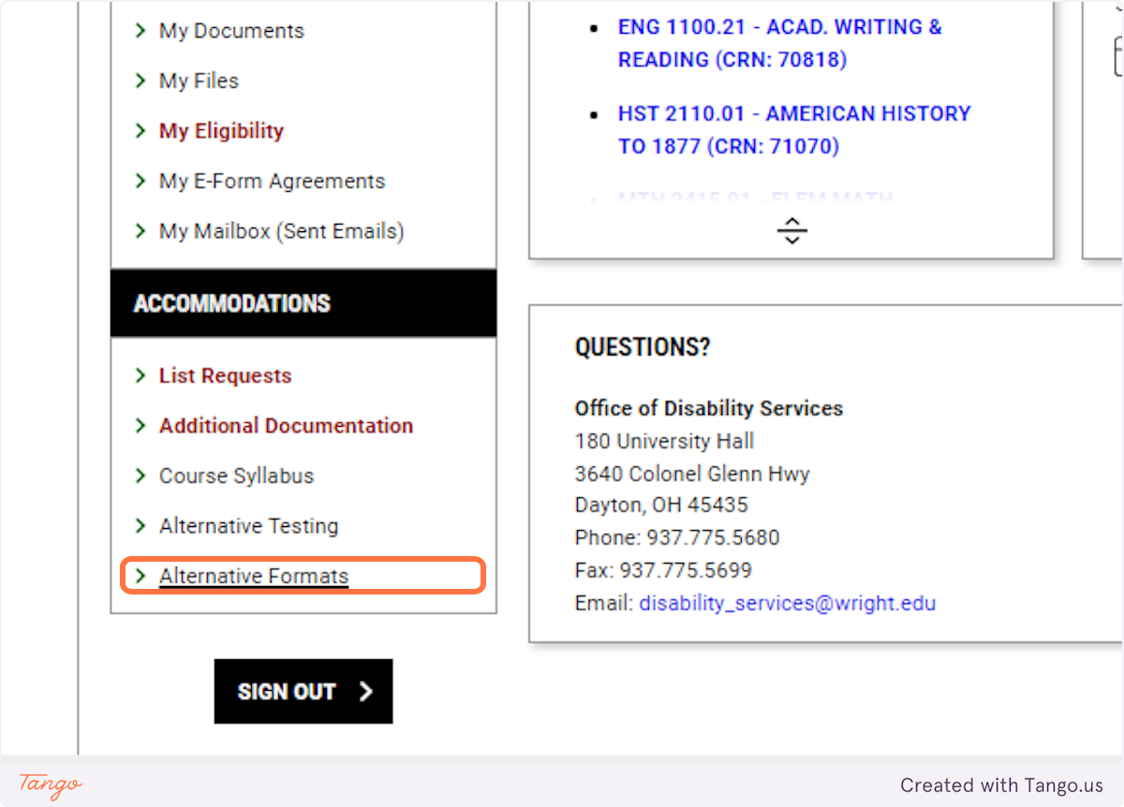
2. Click on DOWNLOAD BOOKS
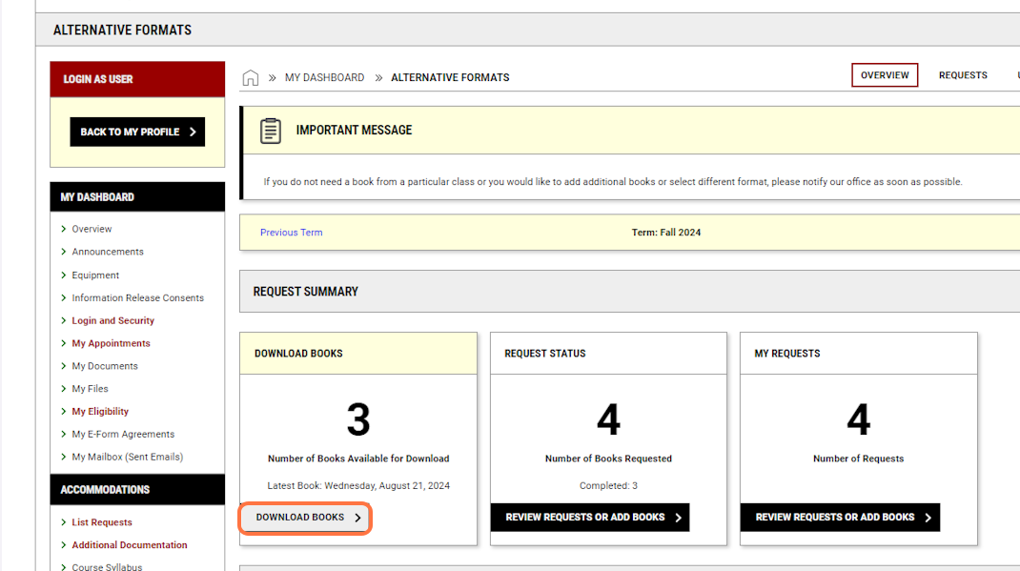
3. Click on Download
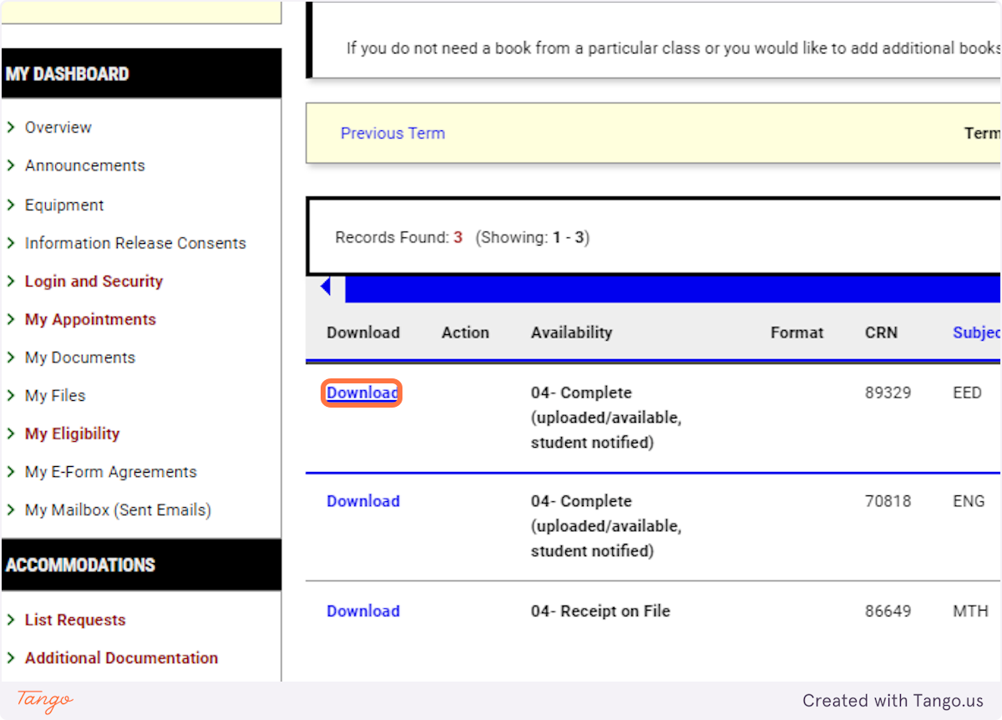
4. The download link will take you to the OneDrive file with your materials. You can download them to your device or access them via the link.
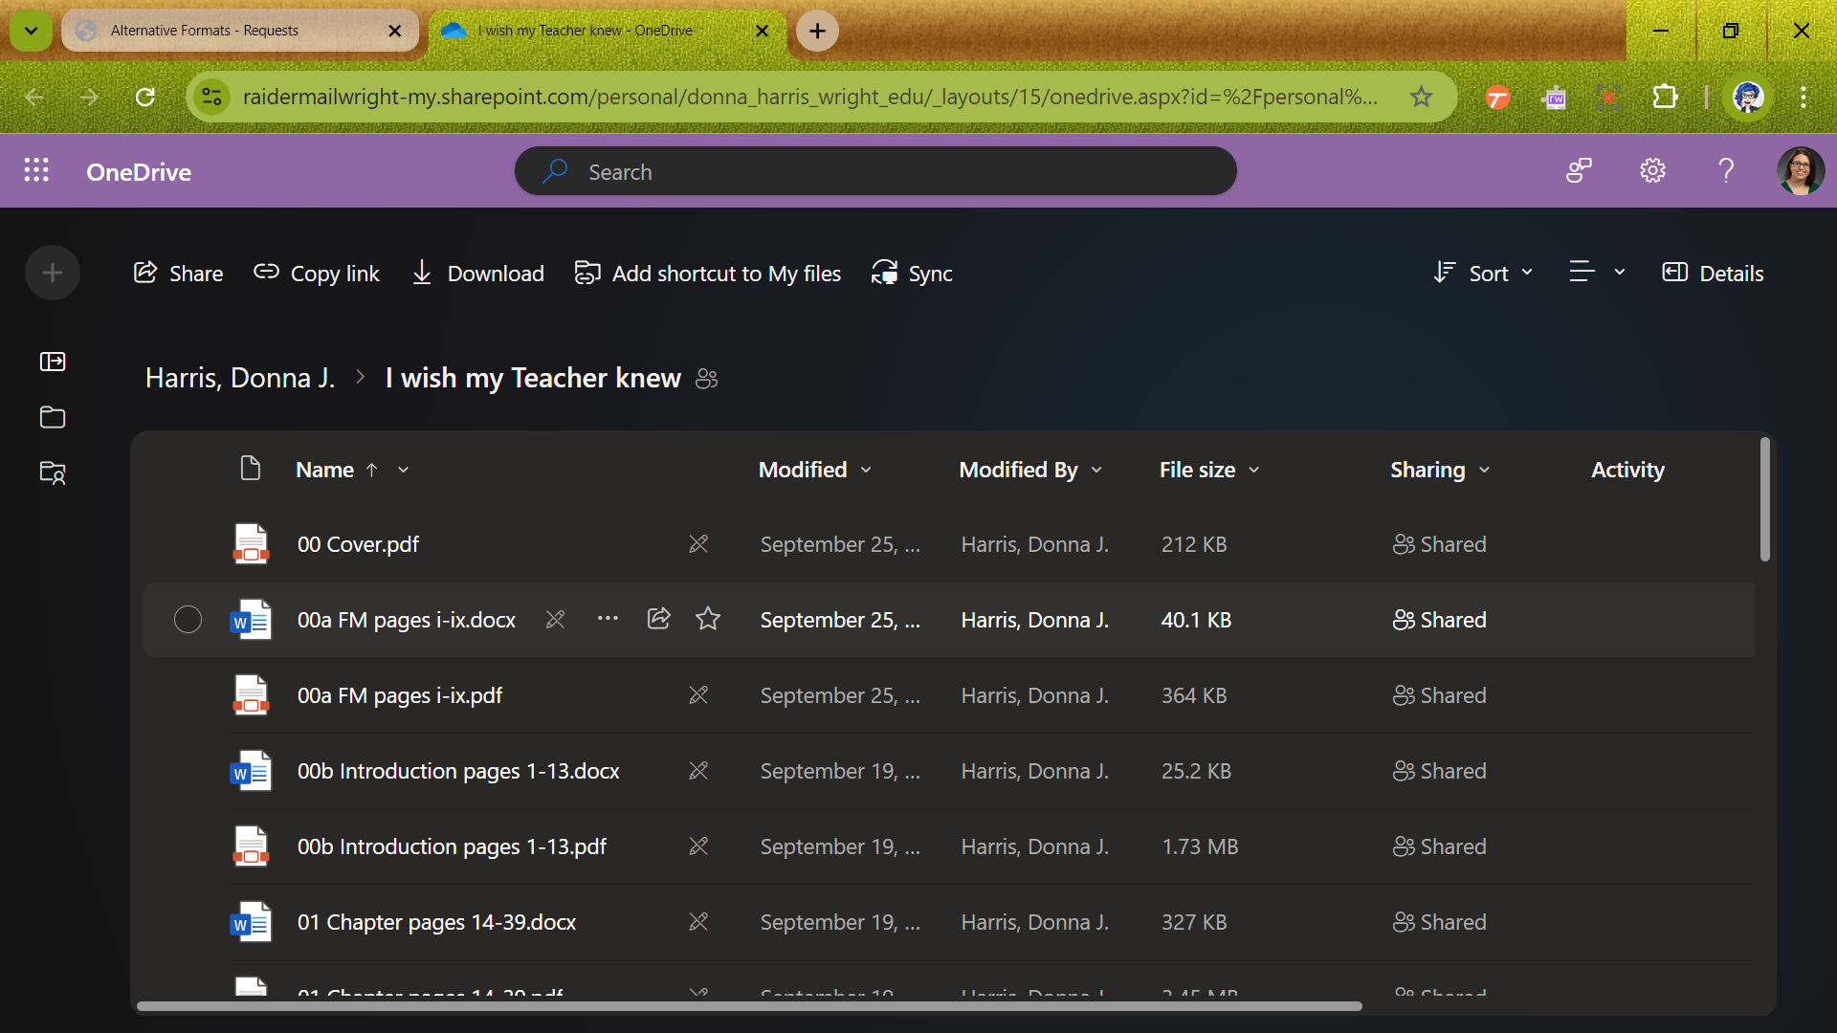

Created with Tango.us

Request an Appointment
1. Click on My Appointments
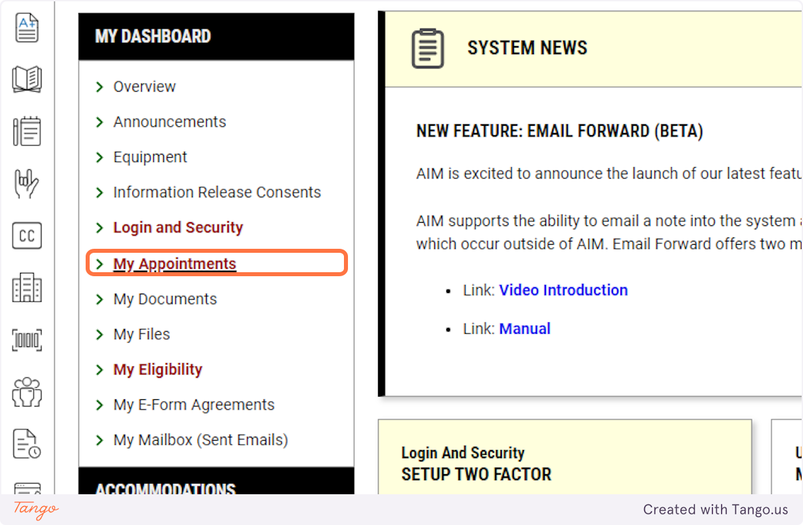
2. Click on REQUEST AN APPOINTMENT
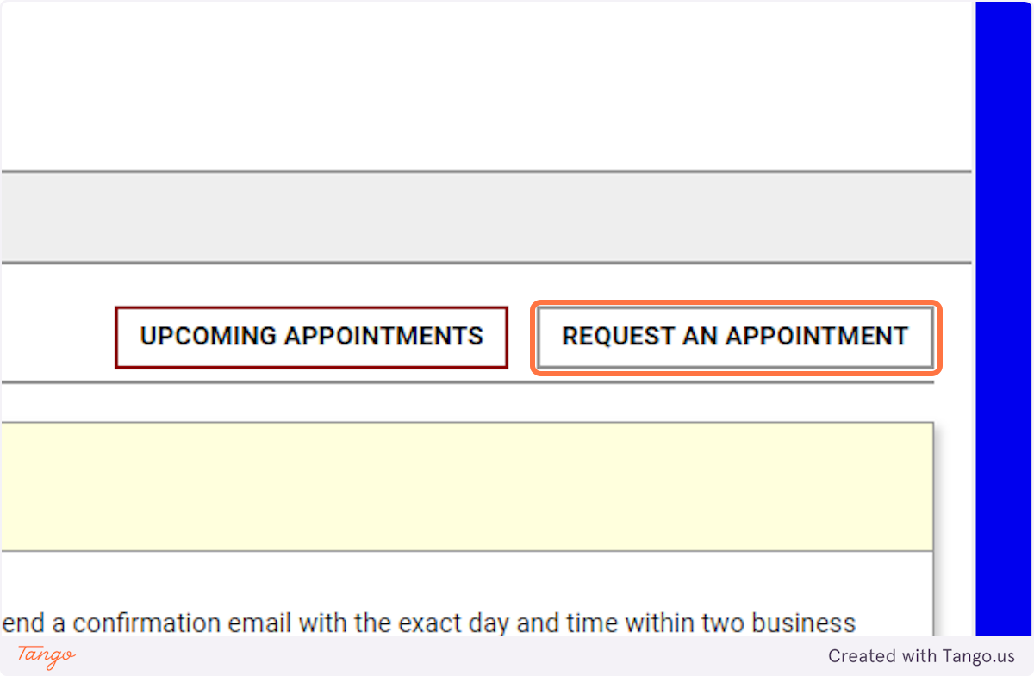
3. Select your campus.
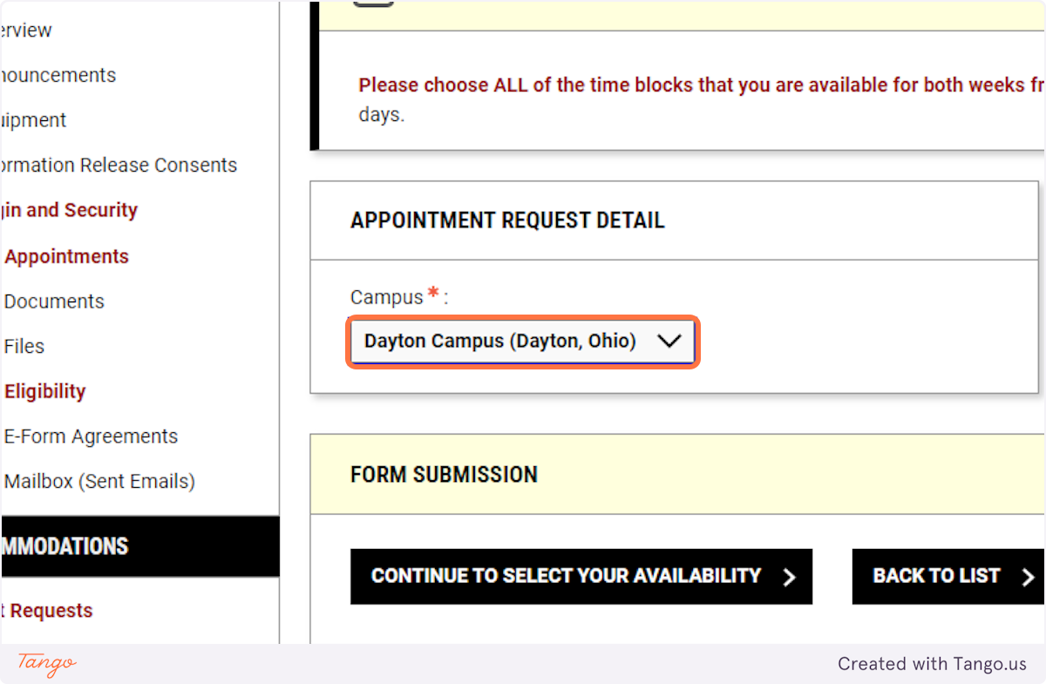
4. Click on CONTINUE TO SELECT YOUR AVAILABILITY
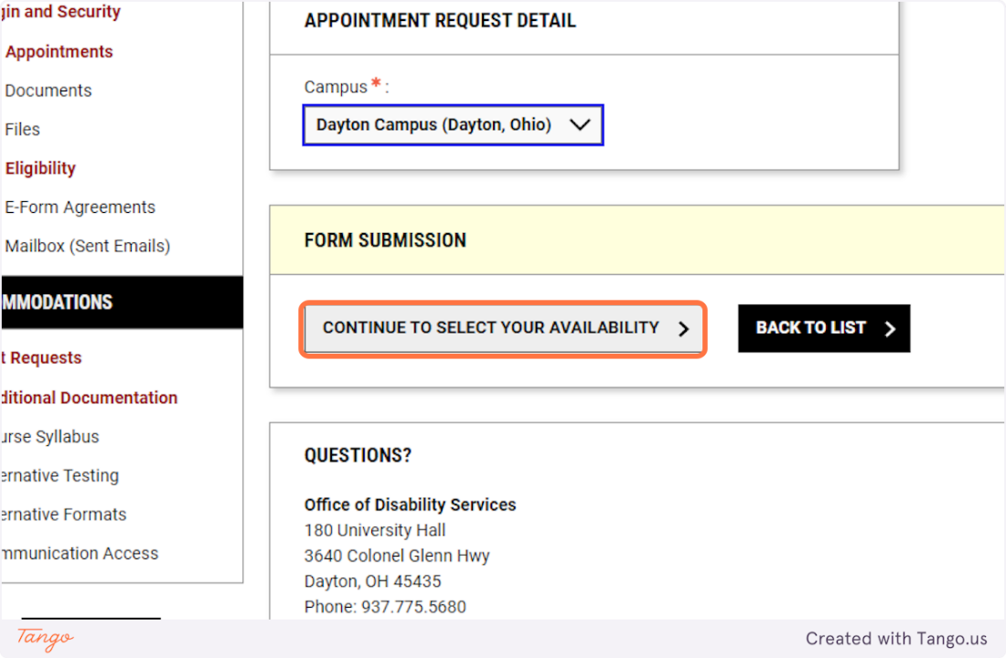
5. If you need accommodations for the appointment, be sure to include them in your request.
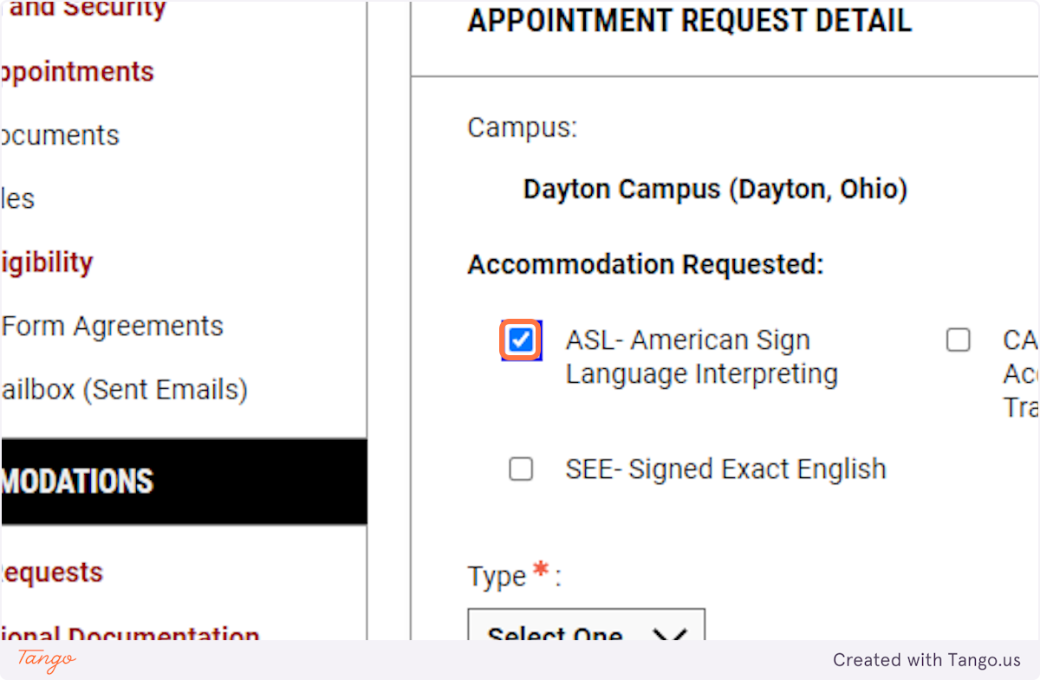
6. Select your format preference: In-person or Webex.
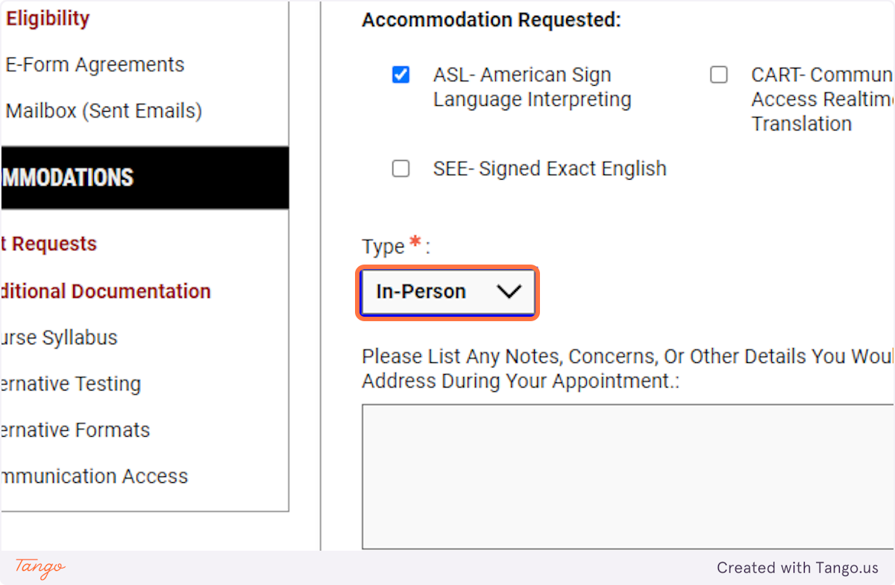
7. Enter any information or questions you have for the appointment.
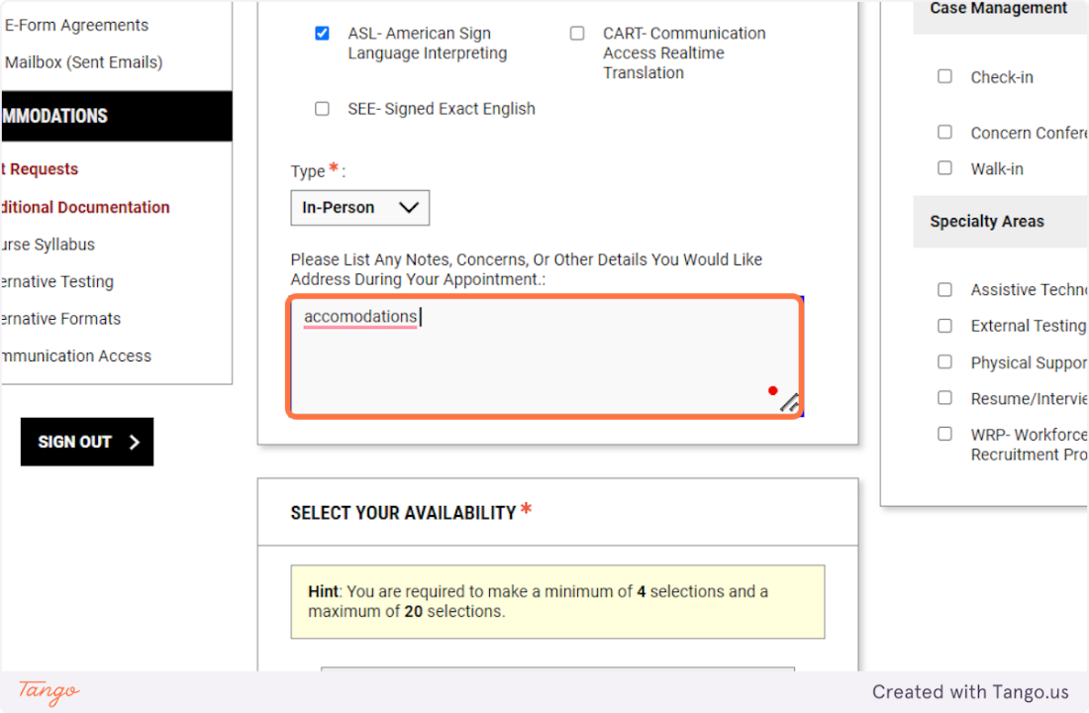
8. Choose a minimum of 4 availability windows, but as many as you like.
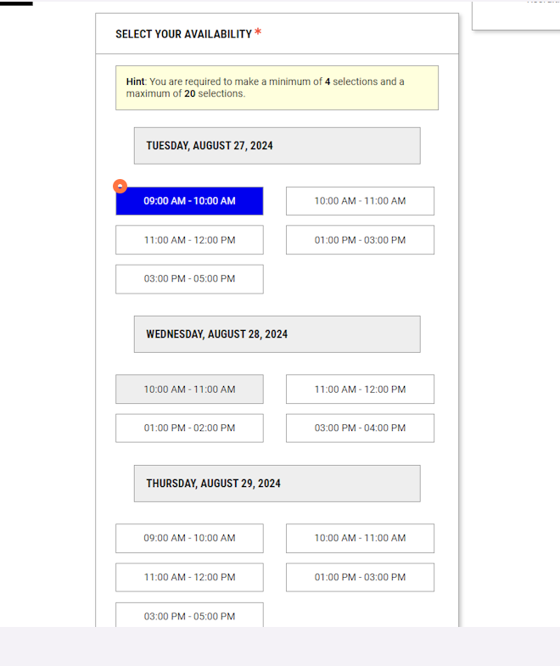
9. In the appointment purpose, choose at least one option.
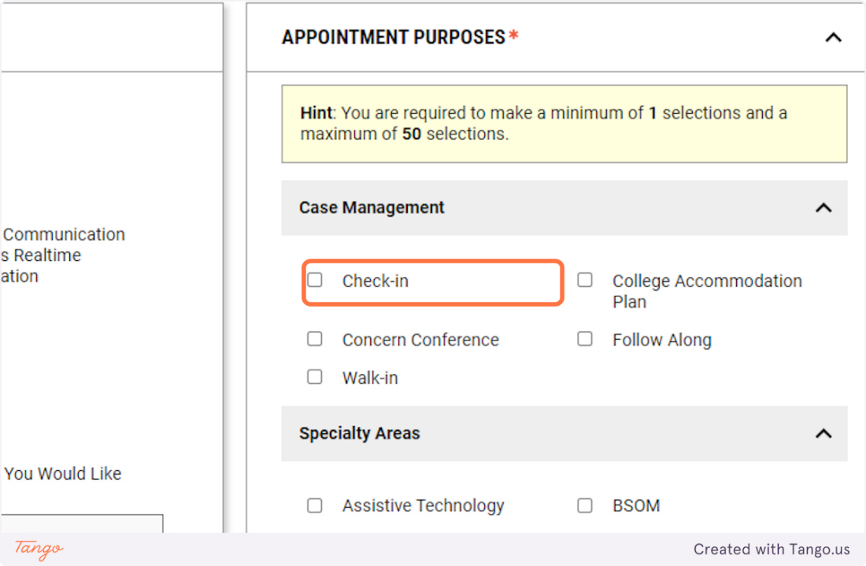
10. Click on ADD APPOINTMENT REQUEST
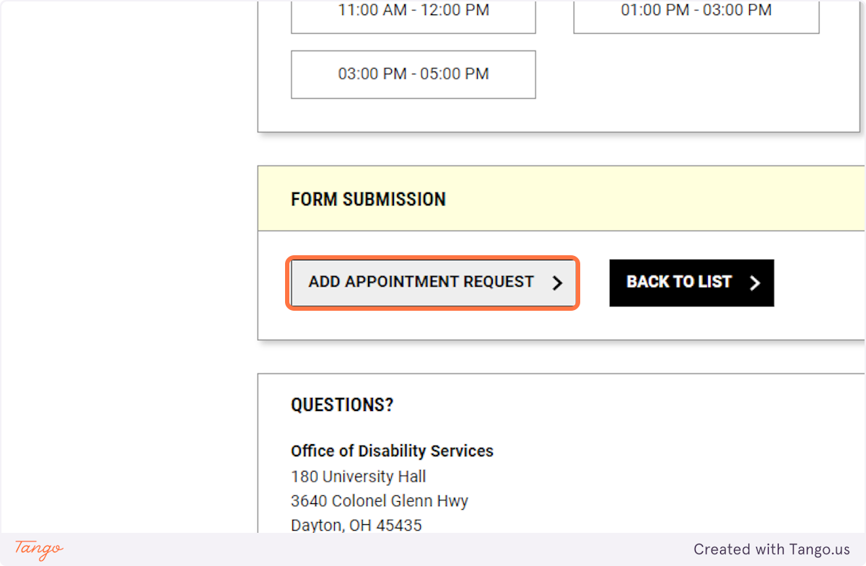

Created with Tango.us

