Stakeholder Summit
The Wright Path to 2025
Day 2 March 21, 2018
Opportunities

On day two, while the summit participants listened to the aspirational stories shared by each group, they wrote down opportunities that supported the aspirations presented. These opportunities were then discussed at each table and the top three opportunities were presented to the entire room. After all opportunities were shared, they were organized into themes for discussion. Some themes were given additional details and some new themes were identified during a discussion by university leadership. After all discussion concluded, 17 opportunity areas for additional discussion and description were identified.

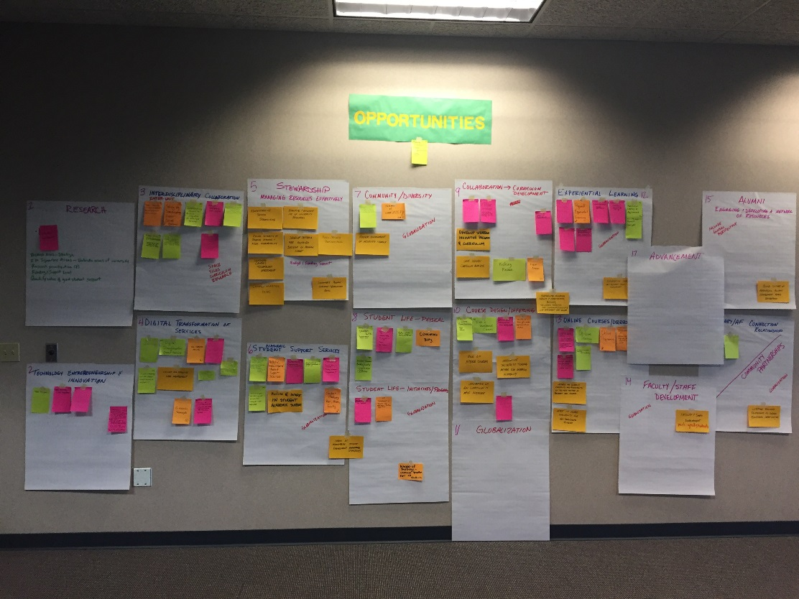

- Research
  - Student involvement
    - Research areas need to be strategic
    - Identify signature areas- umbrella areas for the university
    - Research prioritization ($)
    - Funding and support level
    - Quantify value of graduate student support

- Technology Entrepreneurship and innovation
  - Tech transfer
  - Display technology in new ways/areas
  - Autonomous systems research
  - Create an innovation team that encourages creative approaches in the classroom, lab and the way we do business. Assess and fund pilots and short-term ideas with expected results. Evaluate for long term adoption. Assessment could use Shark Tank approach.

- Interdisciplinary/Inter-Unit Collaboration
  - Innovation reading outlook; get your silo to work with partners you normally don’t work with for a common goal.
  - Solving the big interdisciplinary problem: Opioid Epidemic
  - Interdisciplinary summit to discuss integration of Arts and Sciences
  - Encourage interdisciplinary work and projects
  - Art and Sciences collaboration and faculty development
  - Cross Unit collaboration- breakdown silos; necessary for all aspirations to happen
  - Expand collaboration, programming and event space that fosters innovation and community connection.
  - Community impact needs center- connect experts, faculty, students and community partners
  - Space, silos, curriculum, research

- Digital Transformation of Services
  - Elimination of paper
  - All services online
  - WSU transforms digital enrollment
  - Invest in technology and the staff or contract resources to use/repair it
  - Efficient and effective data management
  - Co-curricular transcripts
  - Data driven scholarship/resource allocated to fill under capacity programs, grow high demand programs and drive net revenue
  - Strategic enrollment management practices- recruitment with an eye toward retention
  - Integrated non-academic event participation tracking system

- Stewardship: Managing Resources Effectively
  - Administrative services streamlining
  - Effective and efficient use of university resources
  - Ensure diversity of revenue streams and fiscal sustainability
  - Develop criteria for go/no go decision on program support
  - Public-private partnerships
  - Continual campus technology investment
  - Campus master plan
  - Budget and funding support
  - Sustainable program completion and graduation rates
- Academic Student Support Services
  - Holistic student services to attract a diverse student body
    - Wrap around services
    - Online access
    - Evening services (classes, disability services, dining)
    - Holistic and integrated student support services
    - Paw prints on community – freshman to senior- professional development for students
    - Coordination of student experience/guidance
    - Recruit alumni as mentors
      - Training of volunteers
      - Compensation?
    - Continue to grow the advising role towards the navigator idea expressed
    - Refine and invest in student academic support
    - Student mentoring; peer, alumni, faculty
    - Invest in meaningful student engagement strategies

- Community/Diversity
  - Training for increased diversity with faculty, staff and students with a focus on those responsible for recruitment.
  - Statement of community
  - Foster environment of inclusivity and family
  - Globalization

- Student life
  - Physical:
    - Invest in student life – housing centric student space
    - Focus on student life
      - Commons building
      - All you care to eat
      - Dorms
      - Rec center
    - 24 hour all you can eat dining
    - Commons buildings
    - Student commons building/center
      - Connect to dorms
      - Dining
      - Activities
  - Initiatives/Programs
    - Invest in student life initiatives
    - Invest in student life experiences, facilities upgrades
    - Invest in meaningful student engagement strategies
    - Wright of passage- common tradition for all students
    - Globalization
- Collaboration- Curriculum Development
  - Cross collaboration for curriculum involvement (STEAM)
  - Implement inter-disciplinary 1st year courses
    - Negotiate faculty time in contracts
    - Raise funds to supplement TAs and professors who are teaching
  - Signature areas of excellence
  - Develop strategic innovative program and curriculum
  - Data driven curriculum analysis
  - Kicking Kaizen

- Course Design/Offerings
  - Flexible class opportunities (online, night, weekends)
  - Evening and weekend classes
  - Invest in course development and course delivery methods
  - Invest in meaningful academic experiences for all students
  - Role of hybrid courses
  - Innovative delivery of teaching methods for increased flexibility
  - Innovation of how curriculum is made accessible
  - Instructional methods to reach the most students

- Globalization

- Experiential Learning
  - Required experiential learning
  - Expand experiential learning opportunities
  - Experiential learning/transition to “real life”
  - Experiential learning as requirement
  - In-through and beyond concept
  - Workforce development/experiential learning
  - Guaranteed or required experiential education opportunities (tailored to individual) for student’s goals, transfer/departmental requirements- Wayne Stark can champion this
  - Experiential learning and relevant skills development
  - Globalization

- Online Courses/Degrees
  - Implement online degrees and class time options
    - 24/7 tech support
    - Faculty developing funds for courses
    - Evening and weekend student affairs support to suit needs of students
  - Online learning
  - Universal design for online learning
  - Online programming
  - Investment in online classes, expansion and tech upgrades campus wide.
  - Increase the diversity, flexibility, and accessibility of delivery methods of programs and courses
  - Invest in course availability for non-traditional students

- Faculty/Staff development
  - Globalization
  - Include grad students

- Alumni: Engaging and Developing a network of resources
  - Include global perspective
  - Build culture of meaningful engagement across enterprise

- Military/AF connection/Relationship
  - Request to perform a needs assessment for Air Force degree creation/completion program
  - WPAFB active duty tuition discount
  - Community partnerships
  - Globalization

- Advancement

