Stakeholder Summit
The Wright Path to 2025
Day 2 March 21, 2018
Aspirations

During the opportunities and possibilities discussion, the participants were asked as a group to brainstorm a newspaper article about Wright State University in the future. They were asked to include a headline, bullets, hashtags or tweets and create a visual as well.

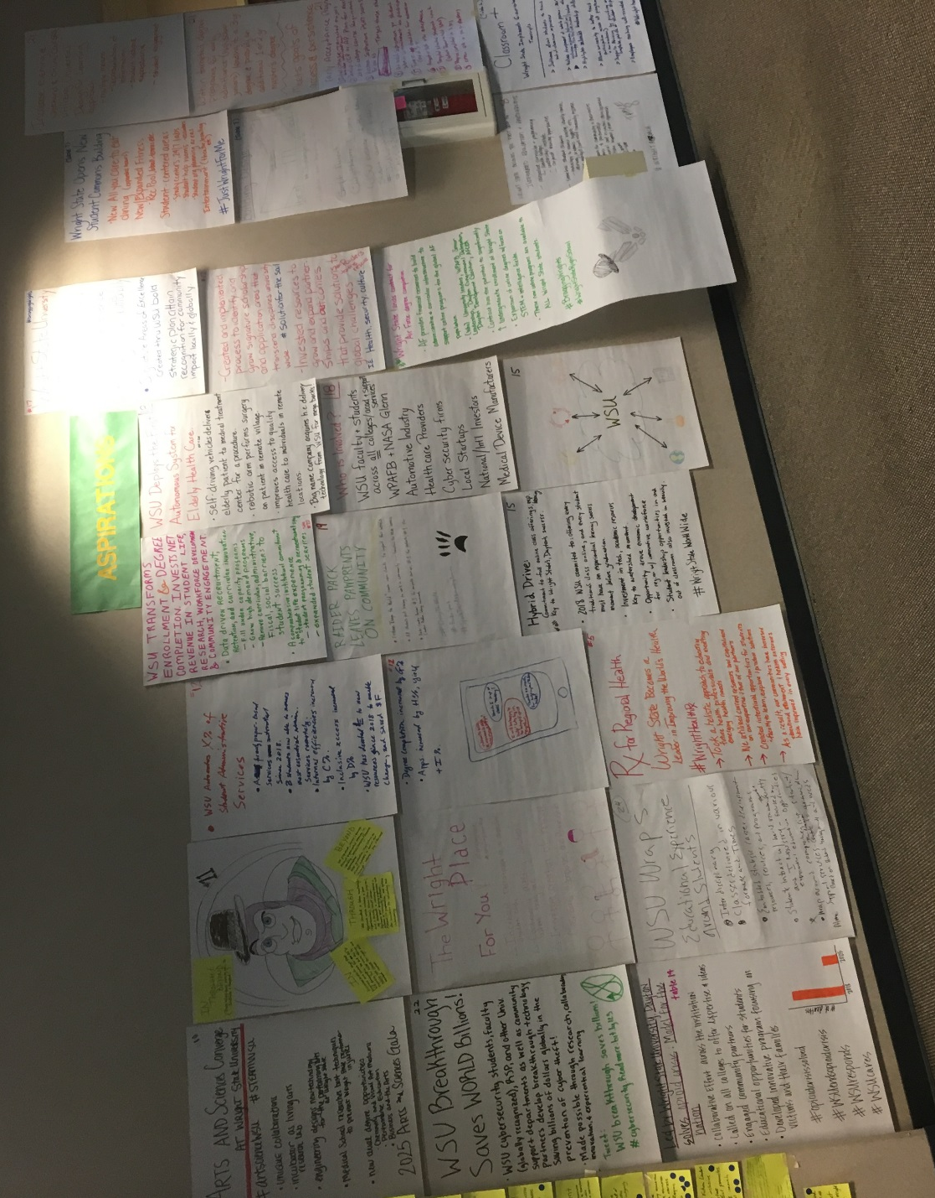

- Soaring Students (table 2)
  - WSU Graduation Rate Rise above National Average
  - Comprehensive Approach
  - Student Success Coordinators/Navigators
    - Handles internal and external
    - Career direction
    - Choosing a major
    - Adaptable for different needs
    - Support system
  - #Soarin4

- Kicking “Kaizen” to a New Level (table 3)
  - Regular and continuous development for new academic programs implemented through annual competitive presentations backed by Market analysis
    - Academic Program Pitch Competition
    - Review of existing program viability
    - Resource realignment
    - Post-graduation strategies
    - Community and data driven
  - #KickingKaizen
  - #MakingtheWrightPitch

- Wright State University – The Leader in Workforce Development (drew Wright Brothers’ plane in top left) (table 4)
  - Students Flock to WSU to Participate in Innovative Programs
  - WSU now leads the state in student participation in experiential learning
  - Since 2019, students have been encouraged to get involved in off-campus experiences and since 2022 experiential learning has been a requirement for graduation
  - This initiative has increased enrollment by 20% and generated additional external – increasing by 30%
  - All colleges are involved which includes training the students for their experiential learning experience
  - Outcomes
    - 40% increased placement of graduates in high demand health care jobs
    - Median starting salaries of graduates in the tech sector have increased by 60%
    - Graduation rates hit all time high
    - Donations to the university have increased dramatically
    - Annual impact on the Midwest economy has reached 2 billion
  - #bestintheMidwest

- Rx for Regional Health (table 5)
  - Wright State becomes a leader in improving the world’s health
  - Took a holistic approach to educating future health professionals and meeting emerging health needs
  - We utilized current resources and capitalized on our expertise and that of our partners
  - Created intentional opportunities for students and faculty to learn, explore and produce solutions
  - As a result, our communities have increased educational attainment and health outcomes have improved in every setting
  - #WrightHealthRx

- Classroom + and Wright State Implements Co-Curricular Transcript (table 6)
  - Software allows students to track out-of-classroom experience
  - Values development of whole person – 360 degree education
    - Inclusive exposure, education, knowledge, skills, attitudes, values
  - Highlights valuable leadership skills
  - Allows University to better track student participation across all programs (academic and non-academic)
  - Support advising by providing more complete picture of student experience
  - Employers seeking well rounded student
  - #WrightHereWrightNow
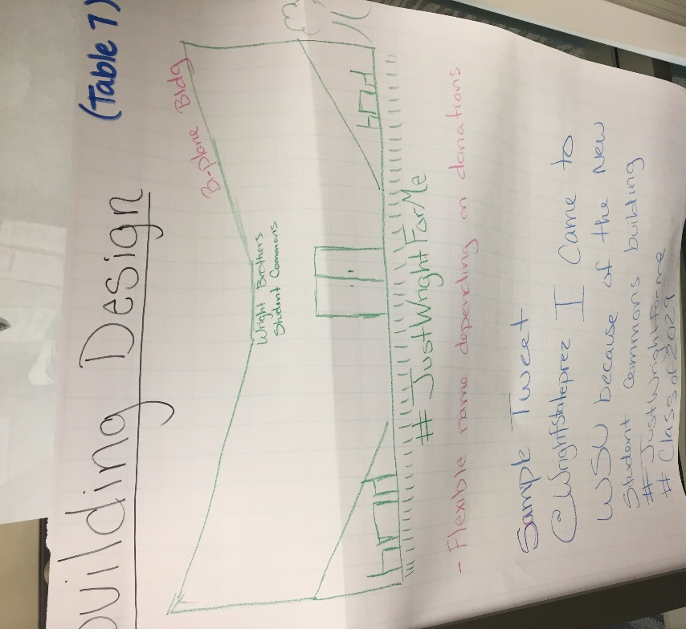
- Wright State Opens New Student Commons Building (table 7)
  - New all you care to eat dining (expanded hours)
  - New/Expanded fitness
    - Rec Pool, basketball, tennis, etc.
  - Student-centered areas
    - Study centers, 24/7 labs
    - Student help rooms – ID centers
    - Student org planning areas
  - Entertainment (theater, bowling, etc.)
  - #JustWrightForMe
  - Building Design
    - Sample tweet: @Wrightstateprez I came to WSU because of the new student commons building #justwrightforme #class of 2029

- Wright State Becomes the First Choice for Integrated Education and Partnerships (table 8)
  - Integrated curriculum and programming
    - Health College
    - Leadership Institute
    - Corporate training opportunities
  - Seamless student support
    - Technology to connect housing, identity centers, advising, academic support, etc.
    - Case managed/coordinated community response
  - Seamless support for community and business
    - Team response to partnership
    - Entrepreneurial and economic development
    - Social issue support/team approach
    - #WrightApproach

- Arts and Sciences Converge at Wright State University (table 10)
  - #artscienceWSU #STEAMWSU
  - Unique collaboration
  - Incubator as living arts research lab
  - Engineering designs new technology for the performing arts at Wright State
  - Medical School research best techniques to prevent Wright State performer injuries
  - New dual degree opportunities
    - Chemistry and visual art medium
    - Performance education
    - Business and the arts
  - 2025 Arts and Sciences Gala

- In, Through, Beyond (table 11)
  - In
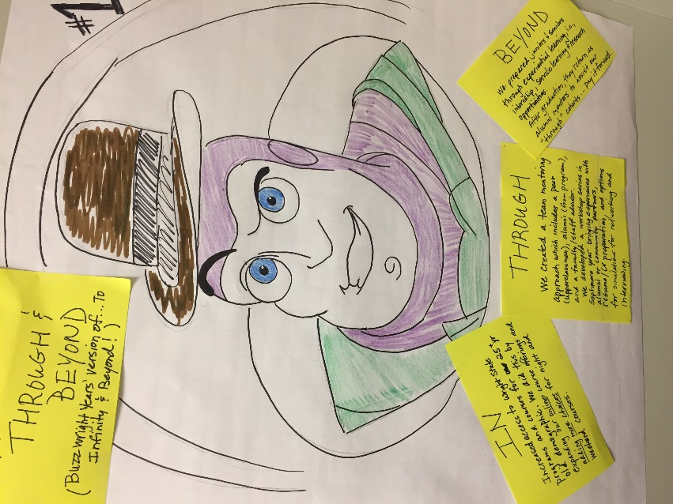
    - Increased access to Wright State programs and courses for 25+ years old demographic. We did this by expanding our online course offerings and adding more choices for night and weekend courses.
  - Through
    - WE created a team mentoring approach which includes a peer (upperclassmen), alumni (from program), and a faculty/staff advisor. We developed a workshop series in sophomore year bringing experiences with alumni or community partners, resume/cv preparation, and options for simulations for networking and interviewing
  - Beyond
    - We prepared juniors and seniors through experiential learning, ie internship, service learning and research opportunities. After graduation, they return as alumni mentors to assist our “through” cohorts- pay it forward.

- WSU Automates X% of Student Administrative Services (table 12)
  - A formerly paper-based services automated since 2018
  - B students now able to access most essential admin services remotely
  - Internal efficiencies increased by C%
  - Inclusive access increased by D%
  - WSU has devoted E to new resources since 2018 to enable change, and saved $F.
  - Degree completion increased by G%
  - Apps increased by H%, yield +I%
  - Drew IPhone with text bubbles that read:
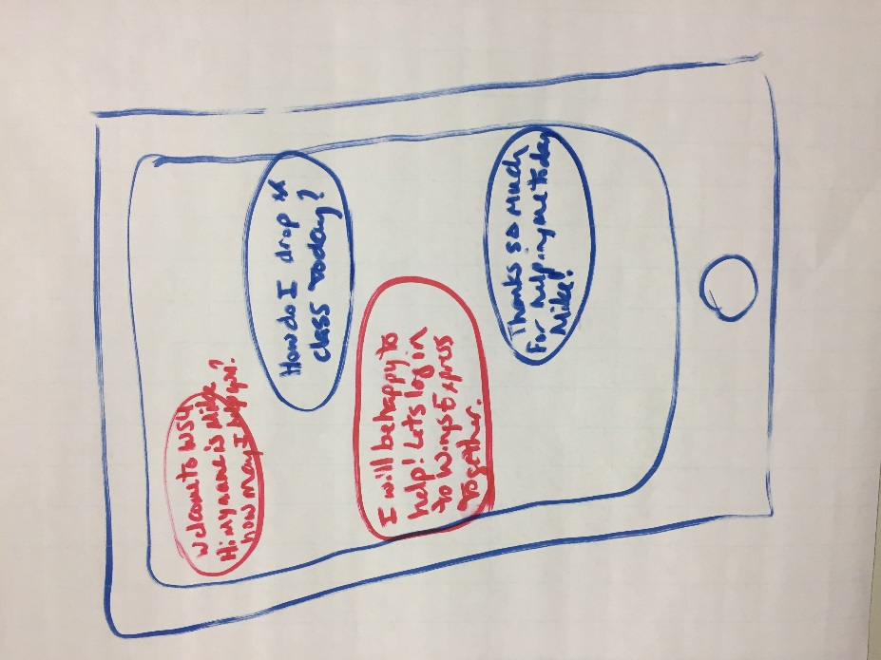

- Led by Wright State University, Dayton solves opioid crisis. Model for the nation. (table 14)
  - Collaborative effort across the institution
  - Called on all colleges to offer expertise and ideas
  - Engaged community partners
  - Educational opportunities for students
  - Developed innovative program focusing on vicitims and their families
  - #OpioidCrisisSolved #WSUEndsOpiodCrisis #WSUResponds #WSUCares

- Hybrid Drive (Table 15)
  - Commitment to full online class offerings (for all), esp. learning. – Key to Wright State’s Dayton success
  - 2018 WSU committed to offering every traditional class online, and every student must have an experiential learning success moment before graduation
  - Investment in tech, academic resources key to watershed moment
  - Opportunity drove economic development for region with innovative workforce
  - Student leadership opportunities in and out of classroom also invested in heavily.
  - #WrightStateWorldWide
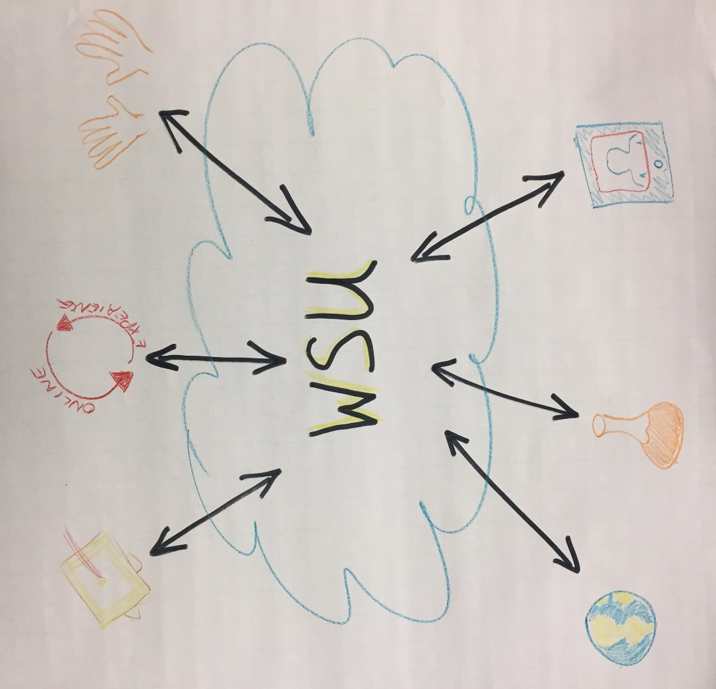

- Wright State Lands Contract for Air Force Degree Completion (table 16)
  - AF provides financial resources to build administrative and curricular infrastructure to support online programs for the global AF population
  - (Who) University leaders, WPAFB Senior Leadership, Dayton Congressional Delegation, Dayton Development Coalition, AFCEA
  - Contract has the potential to significantly increase undergraduate enrollment at Wright State
  - Expansion of online degrees with focus on STEM and intelligence fields
  - These new online programs are available to ALL Wright State students
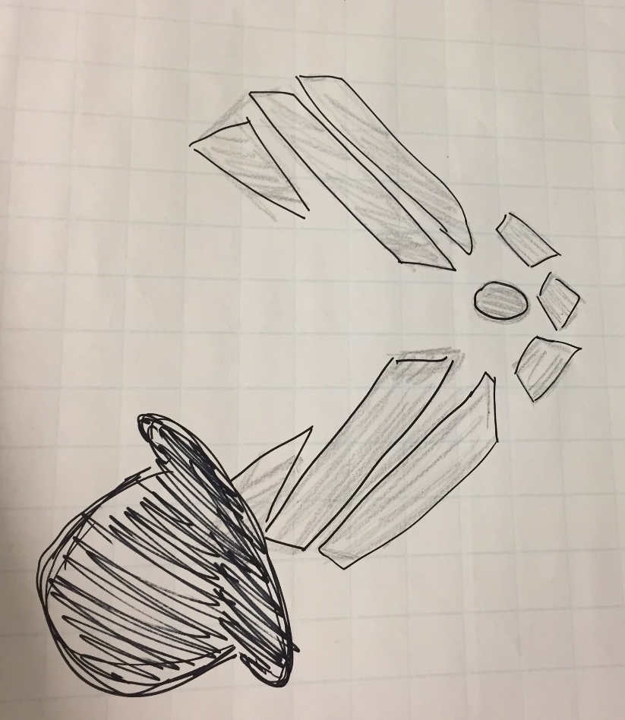
  - #BraggingWrights #WrightStateRightSchool

- Wright State University Student Area of Excellence Recognized Nationally (table 17)
  - Signature Areas of Excellence created through WSU bold strategic plan attain recognition for community impact locally and globally
  - Created and implemented process to identify and grow signature scholarship and application areas that transcend disciplines university wide.
  - Invested resources to grow and expand partnerships and outcomes that provide solutions to global challenges (i.e. health, security, culture…)
  - #SolutionsfortheSoul #RaidertotheRescue

- WSU Deploys the First Autonomous System for Elderly Health Care (table 18)
  - Self-driving vehicles deliver elderly patient to medical treatment center for procedure
  - Robotic arm performs surgery on patient in remote village
  - Improves access to quality health care to individuals in remote locations
  - Big Name Company acquires health care delivery technology from WSU for mega bucks!
  - Who is Involved?
    - WSU faculty and students across all colleges/academics and support services
    - WPAFB and NASA Glenn
    - Automotive Industry
    - Health care Providers
    - Cyber security firms
    - Local startups
    - National/International Investors
    - Medical Device Manufacturers

- Raider Pack Leaves Paw Prints on Community (table 19)
  - Freshman “change the world” course inspires students to impact their WORLD
  - All students put learning to work in community- transition to REAL WORLD
  - Raider country become #1 for nonprofit startups, #1 for patents, #1 for creative problem solving community
  - #ChangeTheWorld #RaiderSpark #SparkTrainReinventingTomorrow

- WSU Transforms Enrollment and Degree Completion. Invests Net Revenue in Student Life, Research, Workforce Development and Community Engagement (table 20)
  - Data driven recruitment, retention and curriculum innovation
    - Fill under capacity programs
    - Grow high demand programs
    - Remove curriculum, administrative, fiscal, social barriers to student success
  - A comprehensive institutional commitment to the student life experience
    - Student programming and recreational space
    - Expanded student services

- Increase Evening and Weekend and Online Courses Utilizing Universal Design for Learning Approach (table 21)
  - Multiple means
    - Representation of information
    - Student action and expression
    - Student engagement
  - Within targeted degree programs for early admittance (high school juniors) leading to a three year degree and possibly an additional one or two year master’s degree
  - Meets goals of access and persistence

- WSU Breakthrough saves WORLD Billions! (table 22)
  - WSU cybersecurity students, faculty (globally recognized), RSP, and other WSU support departments develop breakthrough technology saving billions of dollars globally in the prevention of cyber theft!
  - Made possible through research, collaboration, innovation and experimental learning.
  - Tweet: WSU breakthrough saves billions! #cybersecurity Readmore bit.ly123

- The Wright Place for You! (table 23)
  - #wrightplace #wrightplace4u
  - Increased recruitment of a diversified student body
  - Continuously meeting students where they are
  - Increased creation of inclusive classrooms, campuses and communities

- WSU Wraps Educational Experience around Students (table 24)
  - Interdisciplinary
  - Classes delivered in various formats and times
  - Embedded strategies career development resources, services, and programs
  - Student interactions with world renowned research faculty and industry- focused on experiential learning opportunities
  - Wrap around comprehensive student support services pre-admission based on students background and needs

