Stakeholder Summit
The Wright Path to 2025
Day One March 20, 2018
Values

On day one the participants were shown a video of the vision, mission and values community dialogue sessions that had taken place before the summit. They were also given a Community Dialogue Analysis packet with themes identified from those sessions. Each table was asked as a group to identify their top three values of the 14 identified from the dialogues. Ultimately, the summit participant’s top three values fell into 10 themes. The values and the tables’ thoughts and ideas are presented below by most to least mentioned.

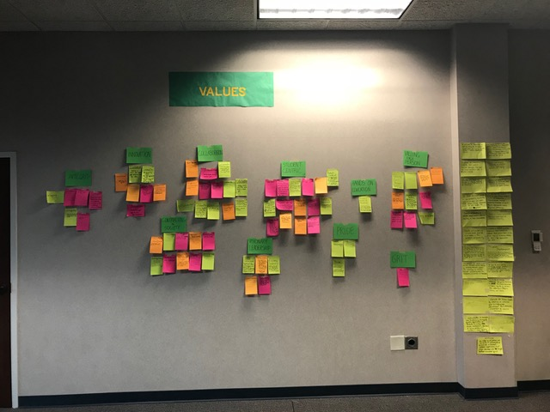

- Student Centric (15)
  - Student success is our top priority.
    - Commitment to all aspects of student education and personal growth
    - Success of our students and alumni defines our success
  - All plans and goals are driven with the education of and service to students at the core
  - Understanding student needs and meeting them where they are in order to guide and mentor them to have a successful educational experience
  - Personalized support, valuing each person, reaching their goals and dreams, empowering students, appreciation of each person and contribution, respect diversity, recognizing breadth of student talents
  - Keeping current, former and future student needs at the front of what we do
  - We place students at the tip of the spear for teaching, scholarship and service. We believe this has become our tradition, our point of pride.
  - A comprehensive educational environment that empowers students through peers and professional interaction.
  - Focused education preparing graduates with maximum employability to service not only immediate community needs, but also future challenges on a global and economic scale.
  - Why we exist. Providing services before, during and after.
  - Providing our students the resources and support they need to succeed
  - Helping students grow and transform both inside the classroom and beyond
  - We value student-centric teaching and learning which is enable the development of knowledge and skills and experiences that our grads need to become productive members of society
  - Meet the needs of our current students through a customer service lens. Retention!
  - Putting student experience at center of all decisions, initiatives etc.
  - Supporting our core group with resources. Supporting students academically, financially and emotionally.
- Collaboration (13)
  - Holistic organization- collaboration across units and levels, improved information flow.
  - Focusing on all relationships, internal and external; working together for a common goal
  - We: work as a team; commitment to common goal; building trust
  - Working together towards a common goal; nurturing stakeholder relationship; to produce new ways of knowledge.
  - Working together towards a common goal by embarking the value and diversity of all individuals
  - Working together with all partners to define and achieve common goals.
  - Teamwork; partnership; strength through relationships; openness
  - Aligning resources with strong social capital toward a common goal
  - Shared governance; common goal; internal and external
  - Working together to impact the university, the community and the world
  - Work that is communal, cooperative, draws upon individual and collective strength and expertise and addresses collective needs.
  - Teamwork to work toward common goals.
  - Consideration of ways in which 2 or more individuals or groups can interact so as to produce a desired outcome
- Valuing each person (10)
  - People first- investing in a lasting legacy
  - Inclusion- all members are welcome and feel included. They are appropriately supported.
  - Meeting out community where they are and where they went to go with an individualistic approach
  - Respect and invest in every person, celebrate inclusiveness, maximize potential
  - Working with people as individuals by meeting people “where they are” with respect and support (inclusive)
  - We are a community that welcomes, accepts, and includes people representing the breadth of society.
  - Developing thrust with groups, operating with integrity, service with and between groups
  - Creating a climate of safety, trust and personal strengths
  - Embracing diversity, creating an inclusive environment, and being respectful to all campus constituents
  - Respect, inclusivity, belonging
- Contributing to society (10)
  - Helping students grow academically and personally. Investing in all people of WSU.
  - Personal and professional development. Learning new skills, gaining self-respect and awareness, thinking critically.
  - Affecting positive social change and creating agents of change to benefit society.
  - Applies to all across the institution, student faculty and staff. Fostering constant community.
  - Leadership in the community learning from each other
  - Community service, creating trust, advocating for causes. Building connections that impact the community.
  - Changing lives for the better, changing society, engaging the community, changing families/generations, scholarship and research.
  - WSU is the 4 year public research University for the Region. Regions successes and needs must be interwoven with our successes and needs.
  - Through education, curation of knowledge, community service and problem solving, we add value to society. By being students, alumni, fac/staff of Wright State, members of society- their responsibilities extend beyond themselves.
  - Provide a positive impact on society leading to the application of resources for a positive resolution.
- Innovation (6)
  - Creative problem solving; importance of entrepreneurial spirit
  - Creating a culture that accepts advances and shares new ideas
  - We dream big ideas; we take appropriate risks; we are open to ideas- all for betterment of students, faculty and staff
  - Flexibility- willingness and ability to adapt or change as needs require; increased flexibility feeds innovation
  - In keeping with the spirit of our namesake, new and dynamic programs taking risks, learning from mistakes, nimble, responsive to changes.
  - New ways to do business; creativity and change; bold risk taking or that fear of failure
- Integrity (6)
  - Transparency; trust, honesty, good character
  - Trust; honesty; transparency; ethical behavior at all levels
  - Do the right thing
  - Doing the right thing even when it is difficult and on one is watching; modeling for students
  - Doing the right/ethical thing and providing transparency of your actions
  - Being honest and transparent
- Visionary Leadership (5)
  - Leadership focused on service to the organization within an acknowledged value system that is persistently opportunistic, creative, collaborative, and goal-directed.
  - Accountability, look forward with optimism, collaboration, relationship building
    - Be a model in a forward thinking way!
    - Clarity of who we are!
  - Setting the tone for excellence and integrity to develop creative thinkers and innovative leaders.
  - Being proactive; looking to the future; keeping their “eyes on the prize” with integrity
  - Setting a strategic bold, and courageous course for the future that inspires, enables and rewards innovation
- Pride (3)
  - Feeling of satisfaction from one’s accomplishments
  - Recognition central to everything (research, teaching, programming, athletics)
  - A willingness to identify as a part of the university
    - A desire to support and build the university based on that identity
- Grit (1) – Ability to thrive and overcome obstacles in the face of the unknown in an increasingly complex world. Resilient leadership.
- Hands on Education (1)
  - Experiential Learning to prepare students for the future
    - We are a 4 year public institution with the distinction of small class sizes and higher contact rates between faculty and students

