INTRODUCTION

The Wright State University Institutional Review Board (IRB) Office has developed a new human subjects (HS) module in InfoED as part of its transition to a paperless IRB submission and review process. All new IRB studies that are submitted using the new system must be done via the Initial Review Form. It is important to understand that this one form replaces the current paper petitions (e.g., Full, SEBR, Chart and Blood). All forms within the HSR Module (Initial Review, Amendment, Reportable Event, Miscellaneous and Continuing Review) are “smart” forms that add/remove questions based on your responses. Therefore, it is important that you answer every available question to avoid submitting an incomplete form.

Implementation of this new system will be in a step-wise fashion. New/updated information and guidance about the module can be found on the IRB website at: http://www.wright.edu/research/compliance/human-subjects. It is recommended that you check the website regularly for any new/updated information.

LOGGING IN TO INFOED

**Before you start make sure to disable any popup blockers for the site in your browser. Popup blockers will cause errors in the review process.**

Open a browser and go to https://rspgateway.wright.edu.

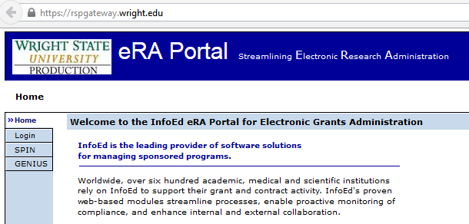

Click Login and the Central Authentication Service (CAS) page appears. Login in again with your Wright State w-number and password.

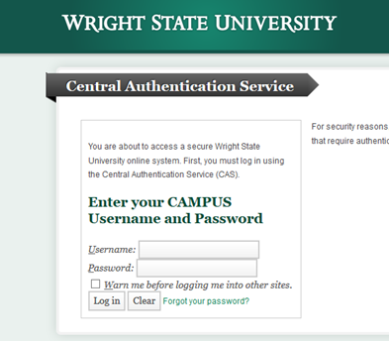
Now, you should see the InfoEd home page.

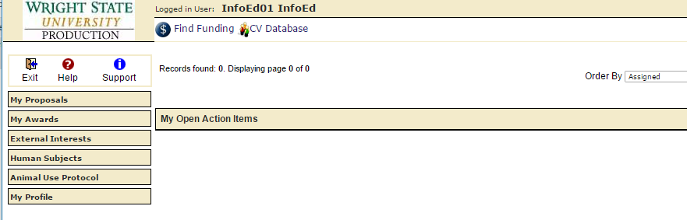

Note: If you want to access InfoED from an off-campus location, you will need to login through Client VPN (VPN) first. For instructions on setting up VPN on your computer or on logging in to InfoED using VPN go to: https://infoed.wsri.com/content/vpn-client.

REVIEWING SUBMISSIONS VIA THE REVIEWER DASHBOARD
As a member of the Wright State University IRB you will be asked to review IRB submissions using the Reviewer Dashboard in InfoED when you are either a designated reviewer for an expedited study or the Designated Reviewer for a full board study.
In addition, the IRB Chair or designee will use the module to give final approval to full board studies and/or other items under his/her purview.
This section contains instructions and screen shots to help you learn how to review submissions in the HS module. Look for the blue arrows in screen shots to help you navigate each step.

- Log into InfoEd either using the instructions above or click the link in the email notification that you were sent notifying you of the pending review task. Note: if you are off-campus you will need to be logged into VPN for the email link to work.

Example of Email Notification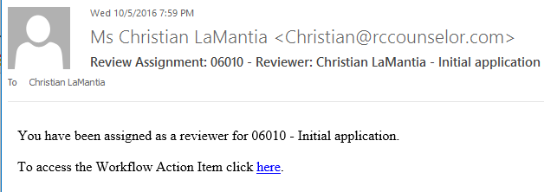
- Once you are logged into InfoEd, click on My Action Items, then click Open. This will you show a list of items that need to be addressed. Those items that are labeled “Review Required” and contain a red “Reviewer” are items that require your review. Click on the folder icon next to “Review Required” to open the item.

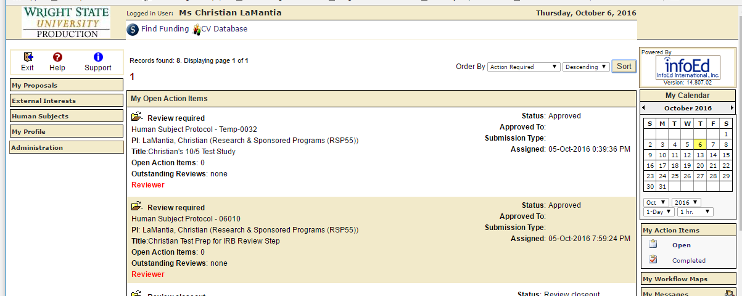
Note: If you are also a PI, your IRB items will be mixed with your own HS study items in the Open Action Items.

- This will open what is called the “Reviewer Dashboard” for the study. Each submission will include one eForm (Initial Review, Amendment, Reportable Event, Miscellaneous, or Continuing Review) and one or more Word, Excel or PDF documents.

- To conduct a review, you should open and review each document under “Form Name/Category.” You can record your comments/findings/recommendations/revisions in three different ways:

Reviewer Dashboard
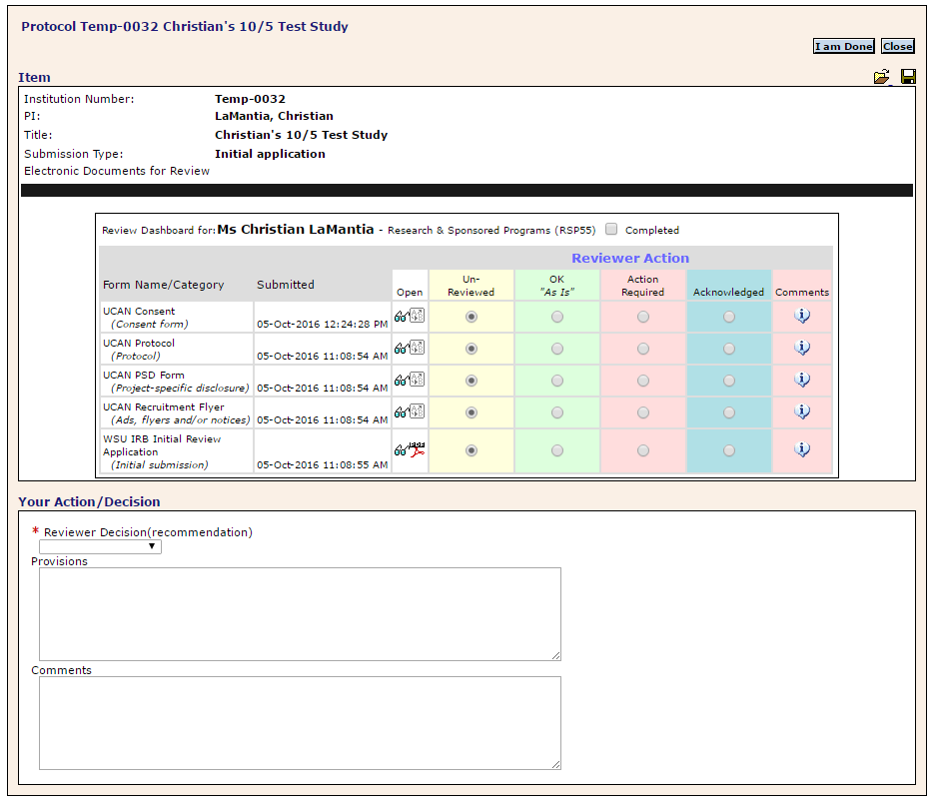

#1 Commenting Via eForm
- Upon opening the Initial Review Application (or Amendment, Continuing Review forms), you will see that each question has a pencil icon beside it (see below).

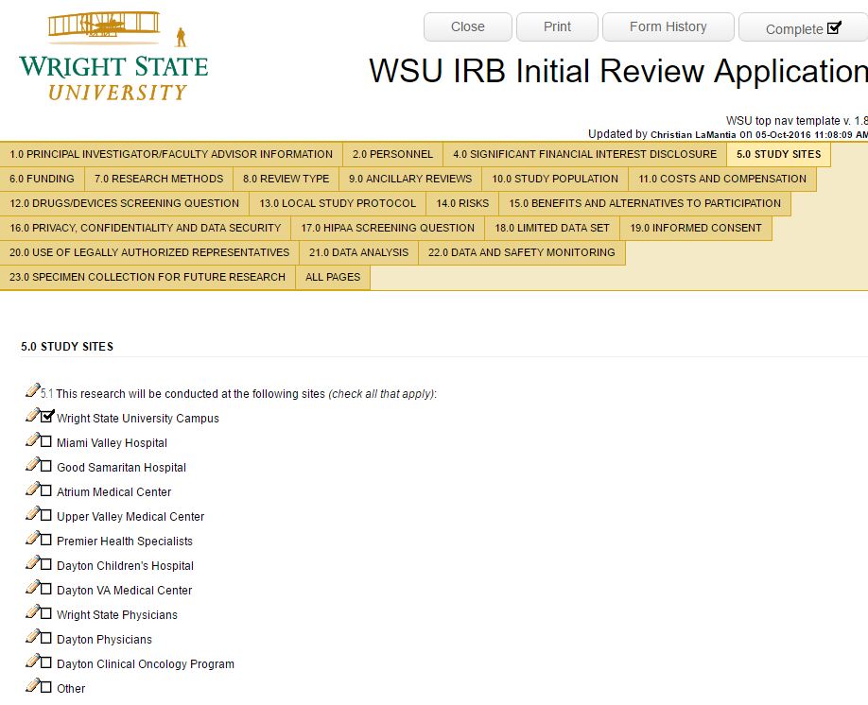
- To request a revision or make a comment within the eForm, simply click the pencil and a “Review Comments” window will appear (see left screen shot below). Type your comment/revision in the “New Comment Box” within the window. Then click Add. This will move your comment to “Existing Comments Box” (see right screen shot below). Click Close button when you are finished. The PI and IRB Office will be able to see your comments by hovering over the yellow exclamation icon.

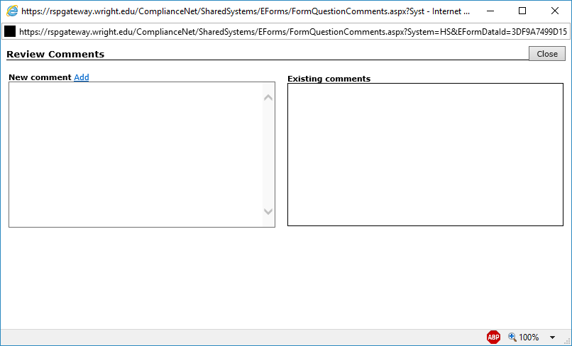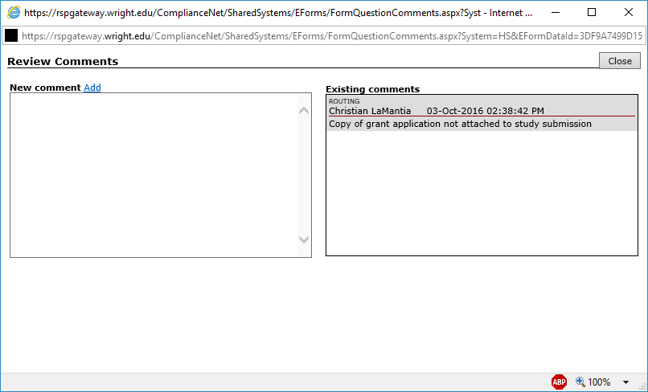

#2 Commenting Via “i” Bubble
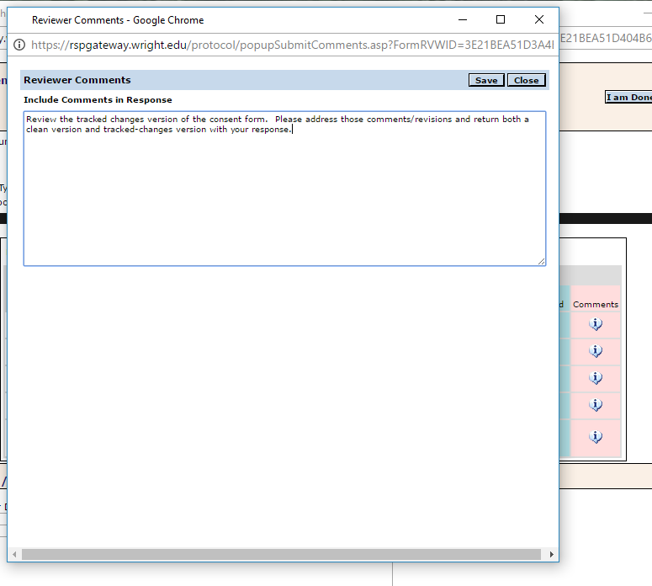
- Simply click the bubble beside the document on the Reviewer Dashboard, you want to add comments to. This will open the comment window above. Type in your comment and click Save, then Close to complete the process.
#3 Tracked Changes and Comments in Word and Excel
- On the Reviewer Dashboard, under the “Open” header, click the glasses icon to open the document on your desktop. Make tracked changes or comments using the regular Word and Excel review options. Save the document to your desktop – adding your initials and date to end of file name.
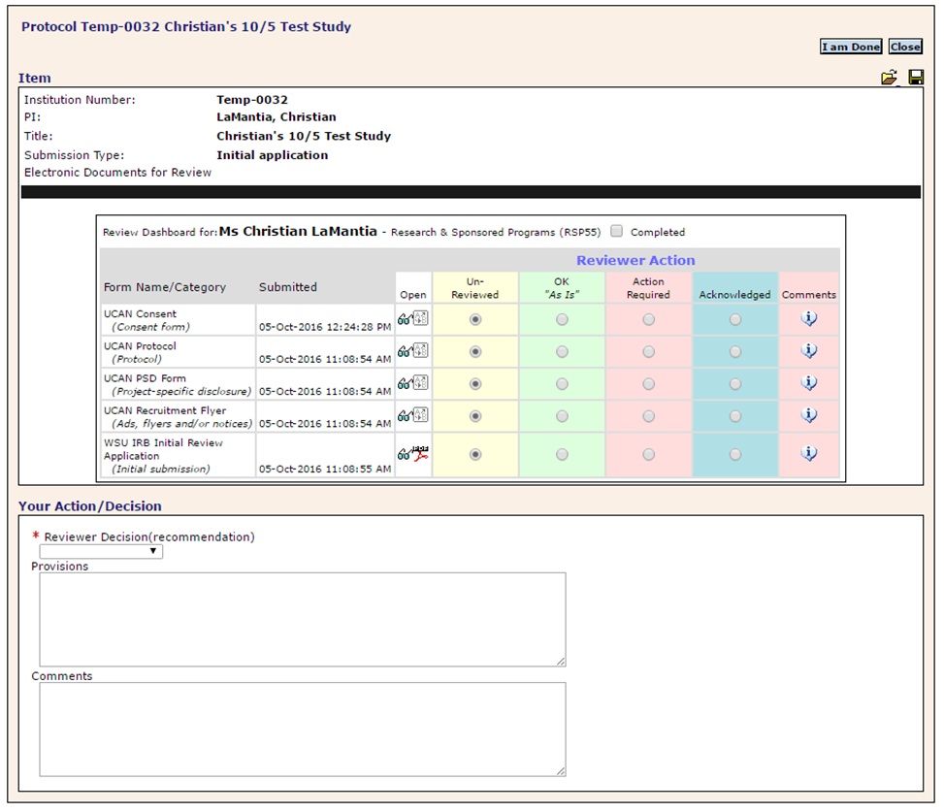

- Then click on the folder icon in the upper right-hand corner of the Reviewer Dashboard (below Close button) to open the window below. Click the square upload icon next to the item you want to update (beside the glasses icon) to pop up an upload box. Select your edited file from your desktop to upload.
Click SAVE and then DONE on the upper left corner of the “Review Detail” page to close it and go back to Reviewer Dashboard (see page 4 of 8).
Review Detail Page
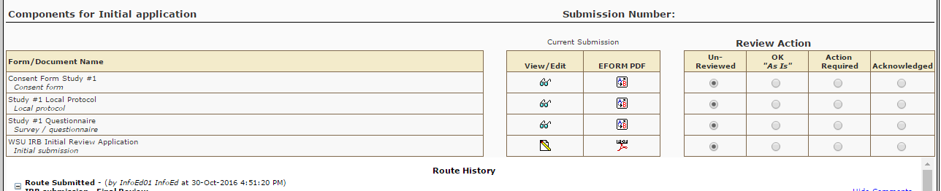

When you have completed your review of all the submission documents, take the following steps via the Reviewer Dashboard:
- For each document in the submission, indicate “OK,” “Action Required,” or “Acknowledged” on the Reviewers Action box (see page 4 of 8 for screen shot).

- Select the appropriate overall Reviewer Decision/Recommendation from the drop-down box (e.g. Full, Expedited, Exempt, etc…)

- Summarize major issues in the “Provisions” box.

- Be sure to note any tracked change documents you attached as well as any other issues you want to communicate to the IRB Office in the “Comments” box

- Click the Complete checkbox above “Reviewer Action” header.

- Lastly, click the Save icon in the upper right hand of the Reviewer Dashboard - then click I am Done button.

Helpful Tips and Notes
Remember to click the Save icon frequently. If you cannot complete the review in one sitting, just click Save icon, then click Close button instead of “I am Done” button. This will save your work until you log in again. Clicking the “I am Done” button forwards the submission to the IRB Office within the electronic route.
Please note that the IRB office will compile your comments/requested revisions and communicate them to the PI via a “Revisions Required” letter, when applicable.

