WSU IRB Member Guidance – Reviewing Full Board Submissions in InfoED
This guidance document contains instructions on how to use the Human Subjects Module to access and review full board study submissions. It also contains information about Reviewer responsibilities and about how to provide comments/proposed restrictions to the IRB Office as either a Reviewer or Non-Reviewer.
InfoED Reviewer Notification and Review Requirements
In the current paper review system, a Reviewer is listed on the agenda and then expected to review an assigned submission once he/she receives the meeting packet. However, in InfoED Reviewers for full board items will be assigned throughout the month as items are received. This will allow reviewers to have more time to conduct their reviews, ask questions of PI/study team, and to even determine that a submission is not ready for a convened review before the actual meeting.
At least one week before the scheduled full board meeting, you will receive an email from the IRB office that contains a PDF of the agenda. If you are off-site, make sure that you connect your VPN first or the hyperlinks in the agenda will not work. Open the PDF and then click on the “link” for the agenda item you want to review. See example below, link is highlighted.
New Protocols for Full Board Review

- IRB #: 000 Temp-0006 Monday, March 20, 2017
PI name: InfoEd01 InfoEd,
Study title: TEST David's AGENDA TEST.
Sponsor(s):
Wittenberg University
Administration for Community Living/DHHS
U. S. Department of Energy
Reviewers(s):
Blacklidge, Jodi
LaMantia, Christian
Link: Development Submission Page

This will first pop-up the browser page containing the sign-in for InfoED. Enter your username and password and then click “Log In.” This will bring you to the electronic folder containing all the items for that submission (also called “Components for Submission X” table).
IRB members are responsible for reviewing all items on an agenda (paper and InfoED) on which they will vote in accordance with the regulations. This has not changed.
Recording and Sharing Assigned Reviewer Comments/Proposed Restrictions
For all submissions, a Reviewer should follow the instructions outlined in the guidance entitled “InfoED IRB Member Review Guidance” found on the IRB Member Toolbox website at http://www.wright.edu/research/compliance/institutional-review-board-member-toolbox These instructions include how to review using the “Reviewer Dashboard.”
Note that for InfoED studies Reviewers must still bring their comments/concerns with them to the meeting (just as you do for current paper packet). The IRB staff will not be able to “show” those comments in Reviewer Dashboard on the screen during the discussion of the study at the full board meeting.
Per the Reviewer Dashboard instructions, Reviewers can record their comments/request for revisions in the “Provisions” box of the Reviewer Dashboard, as well as, create tracked-changed versions of informed consent or other study documents within the submission itself.
If you have determined that an agenda item is approvable with no further changes, it is important that you indicate that it is “approved” on your Reviewer Dashboard at the time of your review before the meeting so that the IRB Office can move forward with the approval of the item without sending it to you again after the meeting. It is also important for you to note “No Changes, No Concerns” in provision box for those items, as well. For example, many continuing review submissions may be able to be approved as is.
Recording and Sharing “Non-Reviewer” Comments/Proposed Restrictions
All IRB members can comment and request changes for agenda items even if they are not the Assigned Reviewer for that item. Your comments during the meeting will be recorded as usual, however, if you have substantive comments it would facilitate communication within InfoED if you provide them to the IRB office in an electronic format (e.g. email, Word summary, tracked- changed version) before or soon after the meeting. This will greatly decrease the time it will take for the IRB Office to communicate decisions and requests for revisions to investigators.
What will IRB Members “See” During the Meeting?
For each electronic agenda item, the IRB Office will be projecting either the Informed Consent form or application form (e.g., Initial, Continuing, Amendment, etc.…) during the discussion of that item. If, for example, a Reviewer, submitted a detailed tracked-changed version of the informed consent before the meeting, the IRB Office could project that to facilitate discussion. During the discussion at the meeting, IRB Members can request that the IRB Office show other items in the submission to facilitate discussion – however, it is not necessary to “see” every page during the meeting.
IRB Members who are already comfortable with navigating the electronic system, may choose to bring their laptops to the meeting and can navigate through the agenda items within the system just like they would a paper packet.
IRB Members who are not yet comfortable with navigating the electronic system during the meeting, may choose to print out a key component of the agenda item (e.g., informed consent or initial review form). This print out can contain their notes/concerns and or just be a reminder of what the study is about to facilitate the Member’s discussion during the meeting.
Here is an example of how an IRB Member could prepare the electronic items for a full board meeting as he/she is getting used to balancing paper and electronic documents:
- Print out copy of electronic agenda
- Navigate and review agenda items using electronic agenda links.
- Make minor notes on the paper agenda for items in which you are not Reviewer and/or bring print out of specific docs as needed for those items
- Bring detailed notes regarding items in which you are an Assigned Reviewer, as applicable.
There are many ways to review and document full board items within the system. It is expected that IRB Members will need several months of experience to find the “system” that works best for him/her.
**Remember that you can navigate from Reviewer Dashboard to the core submission by clicking on folder icon in upper right corner of Reviewer Dashboard.**
Reviewing Investigator’s Responses – How to see modifications required letter for submission
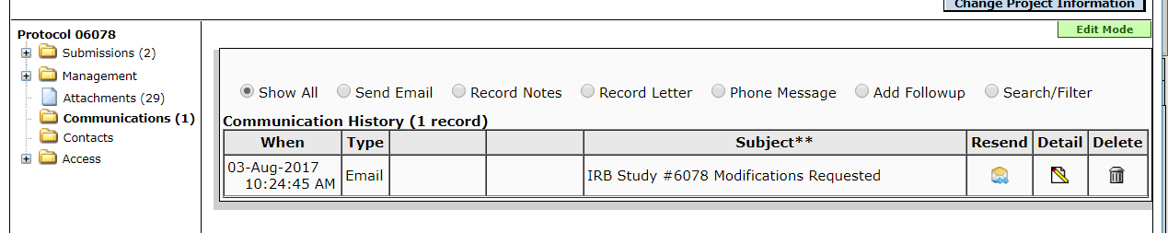
To see communications, like revision requests to the investigator, simply click on the Communications link on the left of the submission screen and it will bring up list of prior communications. Simply click on “Detail” to view.

How to See Other Member’s Comments for a Submission
Use the left-hand menu to navigate to either “Full Board” or “Member Review” General. Under “Assigned Reviewers” click “Show Details/Hide Details” button to see comments of the reviewer that have been submitted.
