WSU IRB Member Expedited Review Guidance
Definition
The WSU Institutional Review Board (IRB) uses an expedited review process to review studies that meet the expedited categories adopted by the Department of Health and Human Services (DHHS) and the Food and Drug Administration (FDA), and that involve no greater than “minimal risk.” Expedited review procedures can also be utilized for the review of minor revisions submitted for previously approved research during the period for which approval is authorized.
The expedited review process can be carried out by the Chair of the IRB or one or more experienced reviewers designated by the Chair from among voting members of the IRB. Federal regulations also dictate that when an IRB uses expedited review procedures, there must be a mechanism in place for advising all the members of the IRB of the research procedures approved under this review process.
Authority of an Expedited Reviewer
The expedited reviewer is responsible for ensuring that all the information requested in the Initial Review application is provided. The expedited reviewer make the final determination as to whether research activities meet the expedited review criteria as outlined in the section of this document titled, Definition of Minimal Risk and Guidance to PI and Reviewers.
The expedited reviewer also determines whether the research meets the federal criteria for approval as outlined in 45 CFR 46.111, 21 CFR 56.111, and 38 CFR 16.111. (See Criteria for IRB approval: Reviewer Checklist.)
The expedited reviewer has the authority to approve a study or request additional information. The expedited reviewer does not have the authority to disapprove a study.
Informed Consent
Expedited reviewers ensure that the investigator conducts the informed consent process and obtains documentation of informed consent, as specified in 45 CFR 46.116 and 117, 21 CFR 50.25, and 38 CFR 16.116 and 117, unless the IRB waives the requirements in accord with federal regulations. When children are involved as research subjects, the expedited reviewer is also charged with ensuring that there are adequate provisions for obtaining assent from these children.
Vulnerable Subject Populations
Federal regulations do not specify whether any certain populations should be globally excluded from a study for it to be eligible for expedited review. The expedited reviewer gives special consideration to protecting the welfare of vulnerable subjects such as children, prisoners, fetuses/neonates, pregnant women, and decisionally challenged/impaired persons. The expedited reviewer also recognizes that additional populations such as students may qualify as vulnerable populations and need safeguards in place for their protection during study participation.
Definition of Minimal Risk and Reviewer Guidance
Expedited procedures can only be used to review a study if the only involvement of human subjects fits one or more of the categories specified in the federal regulations and if all the procedures present no greater than “minimal risk.” The IRB reviewer confirms that all the research activities fit in one or more of the expedited categories. If the research includes activities that do not fit in the categories, the study is not eligible for expedited review even if the research involves “minimal risk.”
The Department of Health and Human Services defines minimal risk to mean “the probability and magnitude of harm or discomfort anticipated in the research are not greater in and of themselves than those ordinarily encountered in daily life or during the performance of routine physical or psychological examinations or tests” [45 CFR 46.102(2)(i)].
Investigators are asked to provide a risk assessment, but it is the IRB reviewer’s responsibility to determine whether the research meets the federal definition.
The IRB reviewer must consider two questions:
♦ Is the probability of the harm or discomfort anticipated in the proposed research greater than that encountered ordinarily in daily life or during the performance of routine physical or psychological examinations or tests?
♦ Is the magnitude of the harm or discomfort greater than that encountered ordinarily in the daily life or during the performance of routine physical or psychological examinations or tests?
If the answer is “yes” to either of these questions, then the research does not meet the definition of minimal risk.
Federal Expedited Review Applicability and Categories
(A) Research activities that (1) present no more than minimal risk to human subjects, and (2) involve only procedures listed in one or more of the following categories, may be reviewed by the IRB through the expedited review procedure authorized by 45 CFR 46.110 and 21 CFR 56.110. The activities listed should not be deemed to be of minimal risk simply because they are included on this list. Inclusion on this list merely means that the activity is eligible for review through the expedited review procedure when the specific circumstances of the proposed research involve no more than minimal risk to human subjects.
(B) The categories in this list apply regardless of the age of subjects, except as noted.
(C) The expedited review procedure may not be used where identification of the subjects and/or their responses would reasonably place them at risk of criminal or civil liability or be damaging to the subjects’ financial standing, employability, insurability, reputation, or be stigmatizing, unless reasonable and appropriate protections will be implemented so that risks related to invasion of privacy and breach of confidentiality are no greater than minimal.
(D) The expedited review procedure may not be used for classified research involving human subjects.
(E) IRBs are reminded that the standard requirements for informed consent (or its waiver, alteration, or exception) apply regardless of the type of review—expedited or convened—utilized by the IRB. (F) Categories one (1) through seven (7) pertain to both initial and continuing IRB review.

Expedited Research Categories
- Clinical studies of drugs and medical devices only when condition (a) or (b) is met.
  - Research on drugs for which an investigational new drug application (21 CFR Part 312) is not required. (Note: Research on marketed drugs that significantly increases the risks or decreases the acceptability of the risks associated with the use of the product is not eligible for expedited review.)
  - Research on medical devices for which (i) an investigational device exemption application (21 CFR Part 812) is not required; or (ii) the medical device is cleared/approved for marketing and the medical device is being used in accordance with its cleared/approved labeling.

- Collection of blood samples by finger stick, heel stick, ear stick, or venipuncture as follows:
  - From healthy, nonpregnant adults who weigh at least 110 pounds. For these subjects, the amounts drawn may not exceed 550 ml in an 8-week period and collection may not occur more frequently than 2 times per week; or
  - From other adults and children1 considering the age, weight, and health of the subjects, the collection procedure, the amount of blood to be collected, and the frequency with which it will be collected. For these subjects, the amount drawn may not exceed the lesser of 50 ml or 3 ml per kg in an 8-week period and collection may not occur more frequently than 2 times per week.

- Prospective collection of biological specimens for research purposes by noninvasive means. Examples: (a) Hair and nail clippings in a nondisfiguring manner; (b) deciduous teeth at time of exfoliation or if routine patient care indicates a need for extraction; (c) permanent teeth if routine patient care indicates a need for extraction; (d) excreta and external secretions (including sweat); (e) uncannulated saliva collected either in an unstimulated fashion or stimulated by chewing gumbase or wax or by applying a dilute citric solution to the tongue; (f) placenta removed at delivery; (g) amniotic fluid obtained at the time of rupture of the membrane prior to or during labor; (h) supra- and subgingival dental plaque and calculus, provided the collection procedure is not more invasive than routine prophylactic scaling of the teeth and the process is accomplished in accordance with accepted prophylactic techniques; (i) mucosal and skin cells collected by buccal scraping or swab, skin swab, or mouth washings; (j) sputum collected after saline mist nebulization.

- Collection of data through noninvasive procedures (not involving general anesthesia or sedation) routinely employed in clinical practice, excluding procedures involving x-rays or microwaves. Where medical devices are employed, they must be cleared/approved for marketing. (Studies intended to evaluate the safety and effectiveness of the medical device are not generally eligible for expedited review, including studies of cleared medical devices for new indications.) Examples: (a) Physical sensors that are applied either to the surface of the body or at a distance and do not involve input of significant amounts of energy into the subject or an invasion of the subject’s privacy; (b) weighing or testing sensory acuity; (c) magnetic resonance imaging; (d) electrocardiography, electroencephalography, thermography, detection of naturally occurring radioactivity, electroretinography, ultrasound, diagnostic infrared imaging, doppler blood flow, and echocardiography; (e) moderate exercise, muscular strength testing, body composition assessment, and flexibility testing where appropriate given the age, weight, and health of the individual.

- Research involving materials (data, documents, records, or specimens) that have been collected or will be collected solely for non-research purposes (such as medical treatment or diagnosis). (Note: Some research in this category may be exempt from the HHS regulations for the protection of human subjects. 45 CFR 46.101(b)(4). This listing refers only to research that is not exempt.)

- Collection of data from voice, video, digital, or image recordings made for research purposes.

- Research on individual or group characteristics or behavior (including, but not limited to, research on perception, cognition, motivation, identity, language, communication, cultural beliefs or practices, and social behavior) or research employing survey, interview, oral history, focus group, program evaluation, human factors evaluation, or quality assurance methodologies. (Note: Some research in this category may be exempt from the HHS regulations for the protection of human subjects 45 CFR 46.101 (b)(2) and (b)(3). This listing refers only to research that is not exempt.)

- Continuing review of research previously approved by the convened IRB as follows:
  - Where (i) the research is permanently closed to the enrollment of new subjects; (ii) all subjects have completed all research-related interventions; and (iii) the research remains active only for long-term follow-up of subjects; or
  - Where no subjects have been enrolled and no additional risks have been identified; or
  - Where the remaining research activities are limited to data analysis.

- Continuing review of research, not conducted under an investigational new drug application or investigational device exemption where categories two (2) through eight (8) do not apply but the IRB has determined and documented at a convened meeting that the research involves no greater than minimal risk and no additional risks have been identified.
Minor Modifications Submitted for Previously Approved Research
Investigators must report to the IRB any proposed changes in IRB-approved research, including proposed changes in informed consent documents. No changes may be initiated without approval of the IRB, except where necessary to eliminate apparent immediate hazards to subjects.
In accordance with 45 CFR 46.110(b) (2), 38 CFR 16.110(b) and 21 CFR 56.110, IRBs may utilize expedited procedures to review a proposed change to previously approved research if it represents a minor change to be implemented during the previously authorized approval period.
A minor modification is one which, in the judgment of the IRB reviewer, makes no substantial alteration in:
(1) The level of risk to subjects;
(2) The research design or methodology;
(3) The subject population;
(4) The qualifications of the research team;
(5) The facilities available to support the safe conduct of the research;
(6) Any other factor which would warrant review of the proposed changes by the convened IRB.
Examples of minor modifications include but are not limited to:
- Changes in study research personnel;
- Adding a blood draw to a research study;
- Decreasing the amount of a blood drawn or the frequency of blood drawn;
- Adding research site(s) to a research study (assuming they are of a similar nature to those
- previously approved by the IRB);
- Adding a standardized test instrument to a research study;
- Modifying the subject recruitment plan;
- Adding a standard quality of life questionnaire;
- Extending the time period of the study to include follow-up with the research participants
- (with no additional invasive measures such as blood withdrawals);
- Changing the principal investigator (assuming the proposed PI has similar credentials to
- the previously approved P.I.);
- Deletion of questions in a questionnaire;
- Adding “non-sensitive” questions (questions that would not appear to invoke
- psychological injury) to a questionnaire;
- Changing telephone numbers or contact persons on the consent form
- Changing the dates of time for initiating a study;
- Modifications in an already approved subject recruitment flyer;
- Changes in project title;
- Adjusting incentives (so long as these do not appear coercive).
Expedited Reviewer Responsibilities
IRB members will be assigned as expedited reviewers for submissions based on the Reviewer Schedule maintained by the IRB Office. All expedited reviews must be conducted within 7 days of receipt. A reviewer must notify the IRB Office ASAP if he/she will be unable to complete the review within 7 days so that the item can be reassigned reviewer. However, it is expected that reviewers will be available to conduct timely reviews during their assigned review period.
Documenting Expedited Review in Human Subjects Module
Expedited reviewers will receive an email notifying them that they have been assigned a submission for review. These review items are also listed in a reviewer’s Open Action Item’s tab in InfoED as “Review Required. Opening via the link in the email or the open action item will open the following Reviewer’s Dashboard:

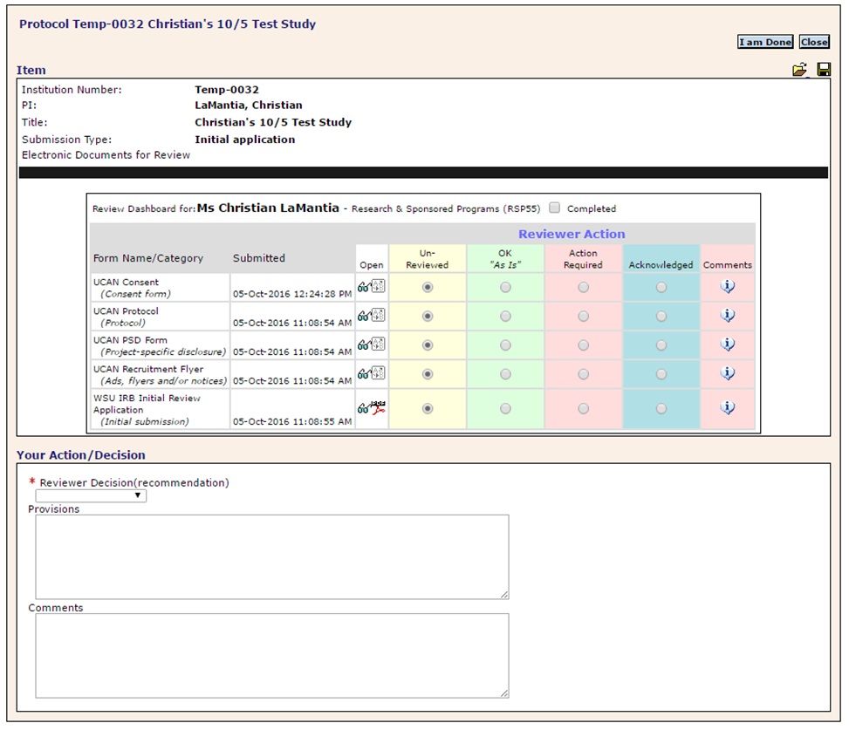
In the Provisions Box, the expedited reviewer should indicate which expedited category or categories (1-9 or minor modification) apply to the research under review. The reviewer must also list all required findings in Provisions Box when applicable:
- Waiver of Consent
- Waiver of Signature/Oral Consent
- Waiver of Authorization
- Children - 45 CFR 46.404-406
- Pregnant Women - 45 CFR 46.204-207
- Prisoners – 45 CFR 46.306(a)(2) (i-iv)
- Non-Significant Risk Device Determination
Requested revisions should be indicated in the Comments Box of the Reviewer Dashboard or via means described in “WSU IRB Member InfoED Guidance” so that the request can easily be included in revisions required letter drafted by the IRB Office.

