PI Guideline Appendix: Space Planning and Scheduling
This document serves as an example for PIs and laboratory members when developing a plan for the safe use of laboratory space and occupation thereof. To limit the exposure and spread of the virus, it is extremely important to practice physical distancing. This includes maintaining a minimum of 6 ft distance between individuals and 10 ft where prolonged co-occupancy will occur in the laboratory and office spaces (see Fig. 1), as well as minimizing the number of individuals present on campus. PIs are encouraged to clarify the new norms and behavioral expectations following these guidelines, and to educate all lab members that it is completely acceptable to politely tell other people (including the PI!) to step back a few steps if the required physical distance is not maintained. Also remember to wear masks at all times while on campus.
AVOID
10 ft
6 ft
Figure 1. Approximate time-separation guidelines for individuals working with cloth or surgical masks. The goal is to minimize integrated “exposure” which depends on both separation and duration. PIs are advised to arrange laboratory workflow to avoid interactions that fall in the red shaded region (adapted from https://www.cdc.gov/coronavirus/2019-ncov/php/public-health-recommendations.html, April 25 2020).
Laboratory space, including work areas and work flow:
PIs will be distributed floorplans of their laboratory spaces. It is advised that these are used to design work areas and plan for work flow. Examples include:
- Review the layout of benches, workstations, and devices within the laboratory.
- Designate foot-traffic lanes, including the laboratory entrance region, access to the sink, etc.. Use one-way traffic between benches wherever possible.
- Designate specific workstations on lab benches, with maximum physical separation, at least 10 ft apart; researchers should not be facing each other on work benches. Ideally, every researcher has their own, separate bench. If a physical separation of work benches is not possible, creating a physical barrier, such as acrylic “cubicles” around work areas, could be an option. Please consult details with EH&S.
- Remove or label chairs to provide separation between researchers when they are at the workbench.
- Using tape on the floor, mark out 10 ft regions on lab benches.
- Designate any no-occupancy or limited-occupancy areas. Post signage indicating their occupancy levels in appropriate locations.
- Put up signs in the laboratory reminding researchers to maintain a safe distance and regularly wash their hands (available from EH&S/link).
- Place markers on the floor to identify 10 ft separations for shared equipment, fume hoods, storage cabinets, sinks, etc.
- Schedule access to shared instruments, microscopes, etc. to reduce overlaps (see section below).
It is recommended to physically mark spaces in the laboratory using tape and/or print and post a copy of the marked floorplan at the laboratory entrance. Examples are shown in Fig. 2.
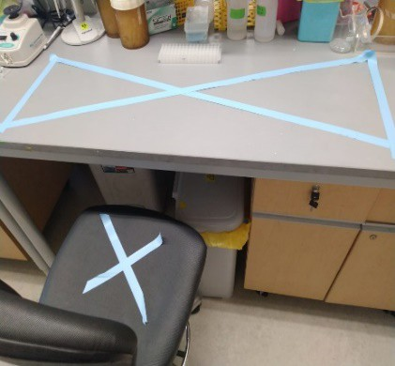  Labels for out-of-bound bench area and chair | 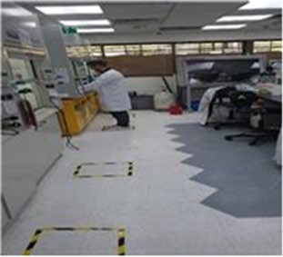  Floor labels where users should work | 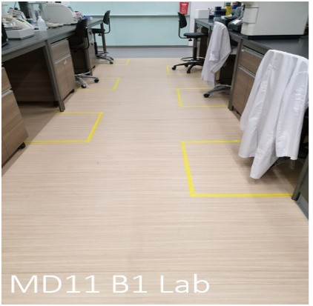  Floor labels for chairs / standing work
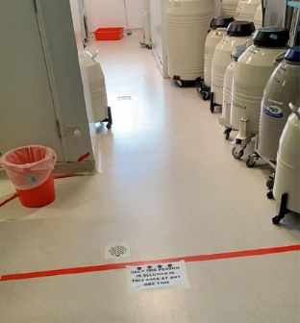  Floor label indicating a constricted space that others should not enter if someone is inside | 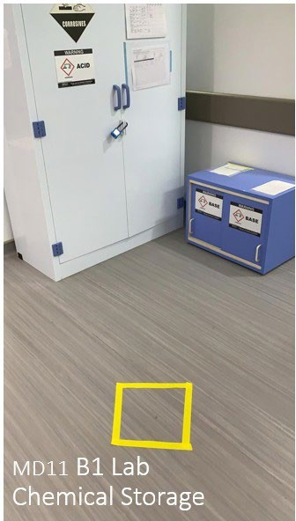  Floor labels for waiting when another user is at the shelf | 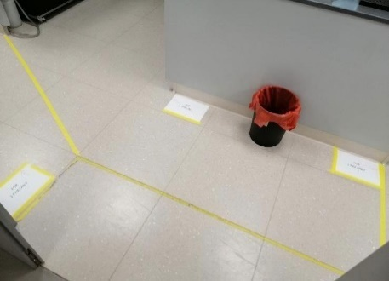  Floor labels to indicate separate work areas
Figure 2. Examples of marking out work areas and work flow (adapted from Harvard Return Plan).

Organizing lab occupation and use:
For level 3 (Orange), the goal is to have an on-campus research activity of ~ 20-30%. This will enable better tracking of people, policies, instrument usage, cleaning, physical distancing, and the possible spread of virus. Level 3 is meant as a test/transition phase which will provide feedback for changing to the next level.
It is recommended that research groups set up an online communication tool for general lab space usage as well as shared equipment, such as an online calendar, google doc with fillable table, etc., or define a-priori specified shift schedule for specific researchers, so that a maximum level of physical distancing can be maintained and overlap/waiting is minimized. It is important to implement a downtime / blocked period for the use of common equipment (min. 15 minutes) to prevent physical encounter of the two individuals, and to allow for proper disinfection of the equipment.
When designing a work plan, it is advised to keep the following in mind: Should an individual be tested positive for SARS-CoV-2, every person who has shared the same space at the same time will be required to quarantine for up to 14 days. A possible solution could be to form 2 or 3 distinct “teams” which work on alternate days or alternate shifts with no temporal overlap. Using this strategy, a whole lab might not necessarily have to go out of commission all at once (details would need to be discussed with health safety specialists).
Allowable personnel:
The following tables give an overview of allowable and non-allowable on-campus research participation for different groups of researchers. Please note that during the initial ramp-up on-campus activities are voluntary for trainees. For all levels, physical distancing is required. The difference between level 2 and level 3 is the percentage of on-campus research activity.
Example: If, for example, a lab has 9 full time researchers, normally working 40 hours per week in the lab (= 360 hr total), then a 30% research activity (for Orange Level 3) would be ≈108 hr / week of total research activity in the laboratory. This could be achieved by:
- having 3 people work 36 hr / week each
- having 6 people work 18 hr / week each
- having all 9 people work 12 hr / week each
As mentioned above, forming “teams” of people with non-overlapping shifts could prevent an entire laboratory shut-down in case of SARS-CoV-2-positive testing of one lab member. All scheduling must follow the guideline of physical distancing, and minimize occupation, i.e., the number of individuals present in the laboratory space at any given point in time. For most laboratory spaces, the goal should be to have a maximum of 3 researchers present at any given time.
 | Faculty |  | Staff |  | Post-graduate trainees
Level 4 (Red) | If essential, can come to campus |  | If essential, can come to campus |  | If essential, can come to campus; need approval by Chair/Dean
Levels 3 & 2 (Orange, Yellow) | Can come to campus if needed |  | Can come to campus if requested and scheduled by PI |  | Can come to campus for research if requested and scheduled by PI
Level 1 (Green) | Can come to campus |  | Can come to campus |  | Can come to campus for research
 | PhD / DSc graduate students | Masters students |  | Undergraduate students |  | High school students
Level 4 (Red) | If essential, can come to campus; need approval by Chair/Dean | Cannot be essential; cannot come to campus |  | Cannot be essential; cannot come to campus |  | Cannot be essential; cannot come to campus
Levels 3 & 2 (Orange, Yellow) | Non-essential can come to campus for research as scheduled by PI. Deans can decide to impose restrictions. | Can come to campus if requested and scheduled by PI |  | Cannot come to campus; exceptions may be requested by PI and need to be approved by Chair / Dean |  | Cannot come to campus
Level 1 (Green) | Can come to campus for research | Can come to campus if requested and scheduled by PI |  | Can come to campus if requested and scheduled by PI |  | Cannot come to campus

