Instructions to complete the UCIE Faculty Program Application

STEP 1:
- Please Go to the link: http://studyabroad.wright.edu/?go=FacAmbassadorApp
- Click on the green APPLY NOW button.
- You will be asked to log in with three options.
Choose the first option: I have a Campus username and password. Click Submit.
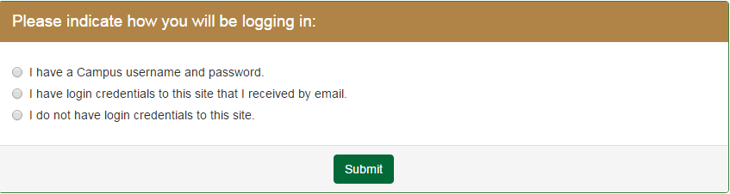
  - Login with your campus W-number and campus password.

- Update your personal details like phone number.
- Please select the TERM in which you plan to offer the class

- Select your program’s estimated travel dates under ARRIVAL DATE and DEPARTURE DATE. We understand this may only be an estimate at this time and could change.
- Select the LOCATION as the city you are visiting during the above dates. If your destination is not there, choose “Other” and notify the UCIE at megan.trickler@wright.edu to have it added.
- Click ADD ITINERARY. (You will notice your city added with dates under ‘Current Itinerary’).
- You can add in more than one location with respective dates depending on your Itinerary.
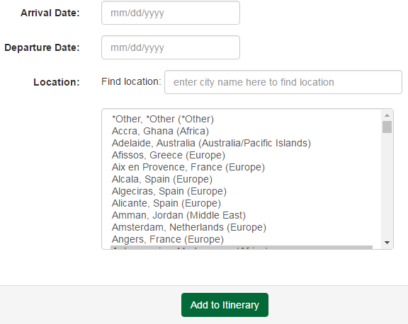
- When you have your itinerary complete, scroll down and click the APPLY button.

STEP 2:
- You will be directed to the Program Application Page.
- You will need to complete all sections on the right hand side of the page.
- Under Application Questionnaires, click on each of the 4 links to complete.
  - Program Information: Answer questions 1 to 12 and click Submit.
  - Program Itinerary: Complete questions 1 & 2, including downloading a copy of your estimated itinerary and click Submit. We understand this may be an estimate at this time and subject to change.
  - Course Information: Answer questions 1 to 6, including downloading a brief description of your program, a syllabus is not required. Click Submit.
  - Cost Information: Answer questions 1 to 3.
    - Click on the green link that say: Budget Planning Worksheet. Complete the budget to the best of your ability, we understand some line items will be estimated at this early stage and changes will occur as the planning process continues. Please don’t hesitate to contact the UCIE with any questions on this. When you are finished, you can upload this document in section 3 by clicking on the yellow folder icon.
    - Once complete, click Submit.

STEP 3:
- The Recommendations section is a tool to allow your department Chair and Dean to officially approve your application electronically. When you activate this they will ONLY see a brief email request to approve/deny the program and a comment section. They will NOT see your program application. Please present a copy of your program itinerary, course information and budget planning sheet to discuss your proposed program with the approvers BEFORE you activate this electronic recommendation feature. Once they complete the directions in their email and hit “send”, a check mark will appear next to their name in your application portal.

- Click on Request Electronic Recommendation to receive the 2 required recommendations.
- Use the “Directory Lookup” to search for your Chair and Dean’s name, click on their name and then click Next.
- You will be taken to the “Recommender Information” page. If you wish to add a message you may do so in either of the boxes below. Click Save.

FINAL CHECK:
- Make sure the individual “check boxes” under three sections “Signature Documents”, “Application Questionnaire(s)”, and “Recommendations” are completed.

