INTRODUCTION

The Wright State University Institutional Review Board (IRB) Office utilizes InfoED Human Subject module for its paperless IRB submission and review process. All forms within the HSR Module (Initial Review, Amendment, Reportable Event, Miscellaneous, HUD Initial, HUD Continuing and Continuing Review/Administrative Update) are “smart” forms that add/remove questions based on investigator responses.

ACCESSING ELECTRONIC SUBMISSION SYSTEM

Before you start using the system make sure to disable any popup blockers for the site in your browser. Popup blockers will make it more difficult to use the system. The system works best in Google Chrome. WSU’s VPN must be active to access the system from outside campus. You can find information on uploading and using the VPN at: http://www.wright.edu/information-technology/security/use-vpn-software-on-your-pc-or-macintosh

To access the electronic submission system (InfoEd) open a browser window (e.g., Google Chrome) and go to https://rspgateway.wright.edu. The Central Authentication Service (CAS) page appears. Login in again with your Wright State w-number and password.

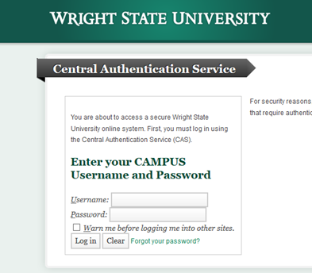

Now, you should see your InfoEd home page which should open to My Action Items – Open. If not navigate there as you can see below. Submissions for which you have been assigned as a reviewer will have the Reviewer notation under the item.

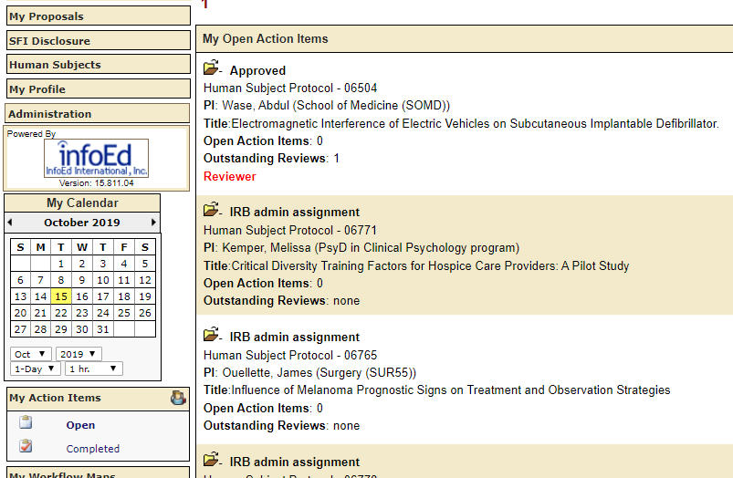

RECEIVING ASSIGNMENTS AND REVIEWING SUBMISSIONS VIA THE REVIEWER DASHBOARD
As a member of the Wright State University IRB you will be asked to review IRB submissions using the Reviewer Dashboard in InfoED when you are either a designated reviewer for an expedited study or the Designated Reviewer for a full board study.
This section contains instructions and screen shots to help you learn how to review submissions using the Reviewer Dashboard. Look for the blue arrows in screen shots to help you navigate each step.

- Log into InfoEd either using the instructions above or click the link in the email notification that you were sent notifying you of the pending review task. Note: if you are off-campus you will need to be logged into VPN for the email link to work.

Example of Email Notification
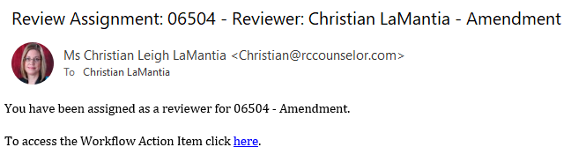
- If you are on campus or your VPN is active, if you click the “here” in the email, the program will ask you to log in. Then it will open right to the Reviewer Dashboard Screen below:

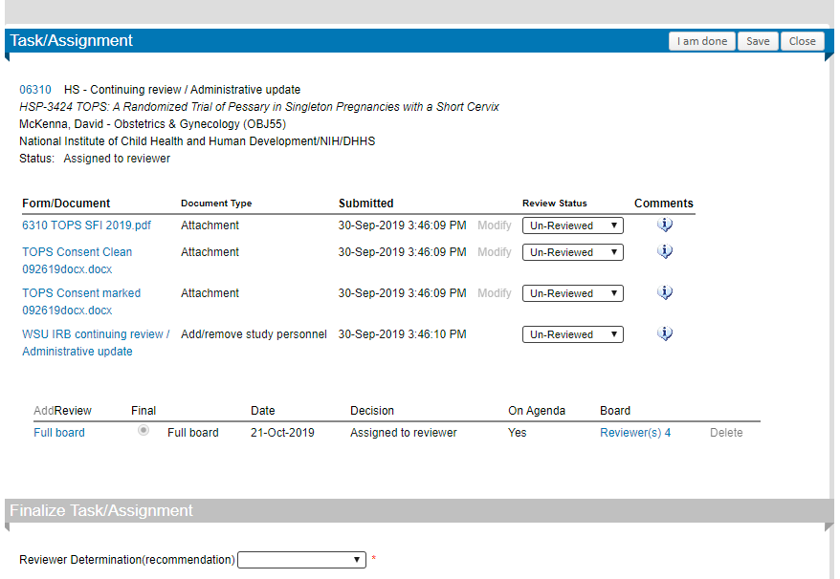
- To conduct a review, you should open and review each document under “Form/Document.” You can record your comments in “Comment” and requested revisions in Provisions box in bottom half of Dashboard. Then complete Review Status for each document. To see other Reviewer comments (if applicable) follow direction in #4.

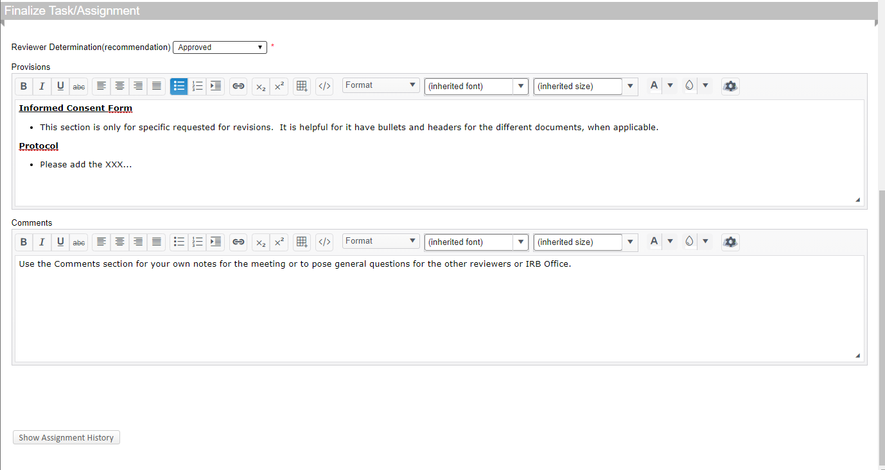
- To see other Reviewer’s comments, click on the type of review near the middle of the screen

WHICH SHOWS THE FOLLOWING
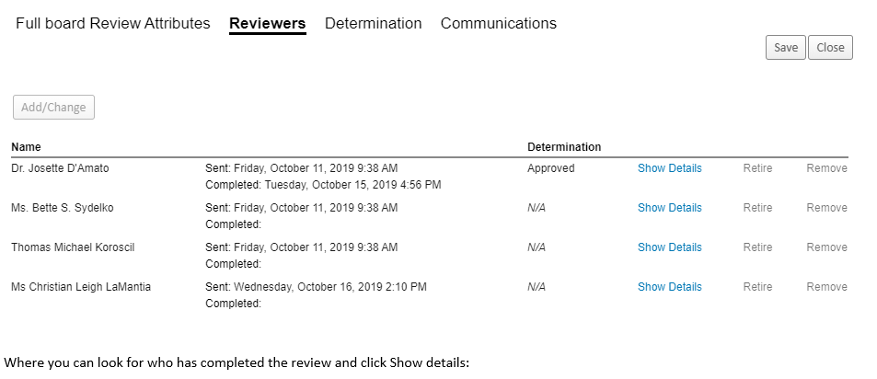

- To complete your review, select the appropriate review determination (see IRB Member Reviewer Instructions for guidance) and then click the SAVE button, then the I am Done button to complete your review and send an alert back to the IRB Office.

**Note that you can gain access to the full file by simply clicking on the number at the top left of the Reviewer Dashboard.**

