Applying for Military Educational Benefits
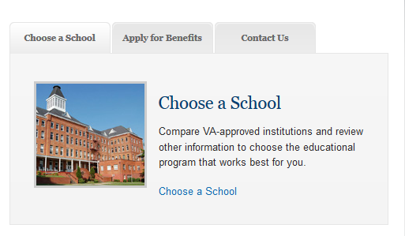
The Veterans Online Application is available at benefits.va.gov/gibill.
First-Time Applicants:
- Click on the “Apply for Benefits” tab.
- Hit “Apply for Benefits” then click the “Apply Online” link.
- You will be taken to a screen with “Which Form do you Need to Use”.
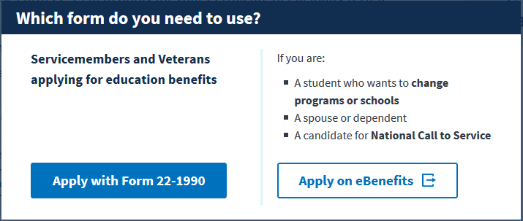
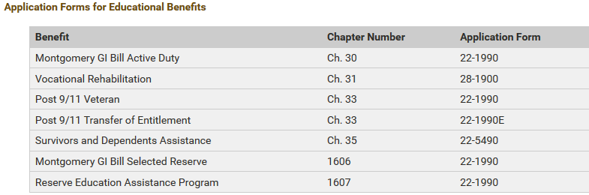
- Servicemembers and veterans (Non Voc-Rehab) will click “Apply with Form 22-1990”. Vocational Rehabilitation, spouses and dependents will click “Apply on eBenefits”.
Servicemembers and Veterans Applying for Benefits Only:
On the “Apply for Education Benefits” homepage click “Start Form 22-1990”. Fill in the requested information and complete the application.
Voc Rehab/Spouse/Dependents Applying for Benefits Only:
- You will be taken to the VONAPP homepage. Click “I Am A New Vonapp User”.
- Read through the information and click “Continue” and “No, Create a Vonapp Account”.
- Be sure to properly fill out all information.
- When prompted to select which educational benefit and the corresponding form, please refer to the above table.
For Transfer Students or Change of Program of Study Only:
- Log in as a previous VONAPP user.
- Select “Change Programs/Place of Training” from the drop-down menu. Be sure you submit the proper address for the campus you plan on attending. If you are transferring to Wright State, you will need submit a new Certificate of Eligibility to the VMC to reflect Wright State as your new institution.
- For Chapters 30, 1606, and Post 9/11, use VA Form 22-1995
- For Chapter 35 benefits, use VA Form 22-5495

