Wright State University
Statistical Consulting Center
Presents:
SAS – Multiple Linear Regression
SAS (Statistical Analysis System) is a software suite developed by SAS Institute for advanced analytics. The Statistical Consulting Center is offering an introductory hands-on tutorial using SAS version 9.4 for Windows. This 2 hour tutorial has no prerequisites and assumes some prior experience with SAS. The tutorial is offered free-of-charge.
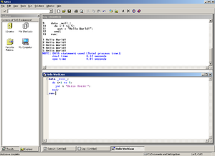
SAS 9 on Microsoft Windows
Topics include:
- Checking Assumptions
- Cleaning and Exploring Data
- Creating Dummy Variables and Interactions
- Model Selection Techniques
- K-fold Cross Validation

Registration is limited to 12 per class and is limited to faculty, staff, and grad students only (no undergrad students at this time). You must be able to log into WINGS using your WSU Username and Password. Please call the SCC and register today for one of these upcoming tutorials. The tutorial will be offered on the following days and times:

May 12, 2017 2pm-4pm
June 2, 2017 10am-12pm

All classes are held in 170 Math & Micro Bldg
To register, or if you have questions,
Call: (937)775-4205 or email jennifer.schmidt@wright.edu

