
The Student Experience in Brief:
Wright State University

Each year the National Survey of Student Engagement (NSSE) asks students at hundreds of colleges and universities to reflect on the time they devote to various learning activities. The topics explored are linked to previous research on student success in college.

The following responses were provided by 1,054 randomly selected Wright State students on the 2011 NSSE survey.

Academic Challenge

To what degree is studying and spending time on academic work emphasized?
79% of First-Year (FY) students felt that this institution placed substantial emphasis on academics.¹

Do faculty hold students to high standards?
61% of FY students frequently worked harder than they thought they could to meet faculty expectations.²

How much time do students spend on homework each week?
35% of FY students spent more than 15 hours per week preparing for class. 24% spent 5 hours or less.

What types of thinking do assignments require?
First-year students reported substantial emphasis on the following activities:
Memorizing facts, ideas, or methods: 67%
Analyzing basic elements of an idea or theory: 72%
Synthesizing and organizing ideas: 65%
Making judgments about value of information: 64%
Applying theories or concepts: 68%

How much writing is expected?
9% of FY students wrote more than 10 papers between 5 and 19 pages and 20% wrote at least one paper more than 20 pages in length.

How much reading is expected during the school year?
31% of FY students read more than 10 assigned books and packs of course readings. 31% read fewer than 5.

Do exams require students to do their best work?
45% of FY students reported that their exams strongly challenged them to do their best work.³

Active Learning

How often are topics from class discussed outside of the classroom?
57% of FY students frequently discussed readings or ideas from coursework outside of class.

Do students work together on projects – inside and outside of class?
49% of FY students frequently worked with other students on projects in class, 35% worked with peers on assignments outside of class.

How often do students make class presentations?
26% of FY students reported that they made frequent presentations in class.

How many students participate in community-based projects in regular courses?
13% of FY students frequently participated in service-learning or community-based projects during a given year. 59% never took part in such activities.

How many students apply their classroom learning to real life through internships or off-campus field experiences?
By their senior year, 40% of students participated in some form of practicum, internship, field experience, co-op, or clinical assignment.

Do students have opportunities to tutor or teach other students?
23% of seniors frequently assisted their fellow students by tutoring or teaching.

Student-Faculty Interaction

Are faculty members accessible and supportive?
44% of FY students said their faculty were available, helpful and sympathetic.

How many students work on research projects with faculty?
By their senior year, 14% of students had done research with a faculty member.

Do students receive prompt feedback on academic performance?
57% of FY students indicated that they frequently received prompt verbal or written feedback from faculty members.

How often do students talk with advisors or faculty members about their career plans?
79% of seniors at least occasionally discussed career plans with faculty.⁴ 21% never talked with faculty members about career plans.

Do students and faculty members work together on committees and projects outside of course work?
37% of FY students at least occasionally spent time with faculty members on activities other than coursework.

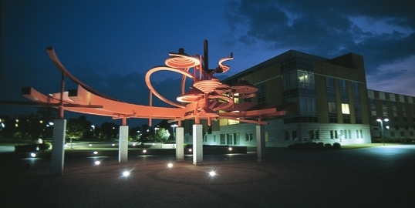

INSERT CAMPUS
PHOTO HERE

Enriching Educational Experiences

What types of honors courses, learning communities, and other distinctive programs are offered?
During their first year, 38% of students participated in a learning community. By their senior year, 13% of students had taken an independent study class.

How often do students interact with peers with different social, political, or religious views?
41% of FY students said they frequently had serious conversations with students who are different from themselves in terms of their religious, political, or
personal beliefs.

How often do students interact with peers from different racial or ethnic backgrounds?
44% of FY students frequently had serious conversations with those of a different race.

How many students study in other countries?
By their senior year, 6% of students had studied abroad.

Do students participate in activities that enhance their spirituality?
31% of FY students frequently engaged in spiritually enhancing activities such as worship, meditation, or prayer.

What percentage of students participate in community service?
By the time they were seniors, 51% of students had participated in community service or volunteer work.

Supportive Campus Environment

How well do students get along with other students?
46% of FY students reported that their peers were friendly, supportive, and helped them feel as if they belonged.

Are students satisfied with their overall educational experience?
82% of FY students reported a favorable image of this institution; 74% of seniors would have chosen this school again if they could start their college career over.

How much time do students devote to co-curricular activities?
7% of FY students spent more than 15 hours a week participating in co-curricular activities. 59% spent no time participating in co-curricular activities.

How well do students get along with administrators and staff?
34% of FY students found the administrative personnel and offices helpful, considerate, and flexible.

To what extent does the school help students deal with their academic and social needs?
74% of FY students felt that this institution had a substantial commitment to their academic success.
40% felt well-supported by the institution regarding their social needs.

A Pocket Guide to Choosing a College is available at nsse.iub.edu/html/pocket_guide.cfm

Notes:
- "Substantial" emphasis is defined by combining the responses of "Very much" and "Quite a bit."
- "Frequently" is defined by combining the responses of "Very often" and "Often."
- "Strongly challenge" is defined by combining responses of "6" and "7" on a one-to-seven point scale where 1 is “Very little” and 7 is “Very much.”
- "Occasionally" is defined by combining the responses of "Very often," "Often," and "Sometimes."

Data source: National Survey of Student Engagement 2011

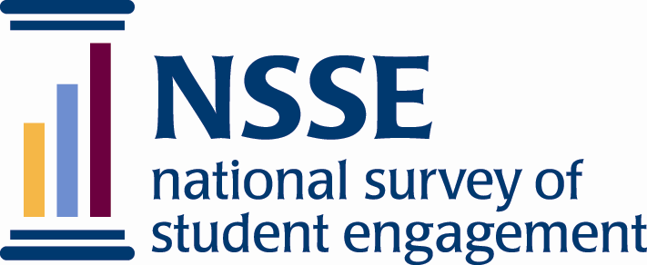

Indiana University Center for Postsecondary Research
1900 East Tenth Street, Suite 419
Bloomington, IN 47406-7512

Phone: 812-856-5824
Fax: 812-856-5150
E-mail: nsse@indiana.edu
Web: www.nsse.iub.edu

IPEDS=206604

