CITI EXPORT CONTROL

https://www.citiprogram.org/ or through RSP’s Website – rsp@wright.edu, “Human/Animal Subjects, Collaborative Institutional Training Initiative (CITI)” on left.

Click “Wright State University Courses”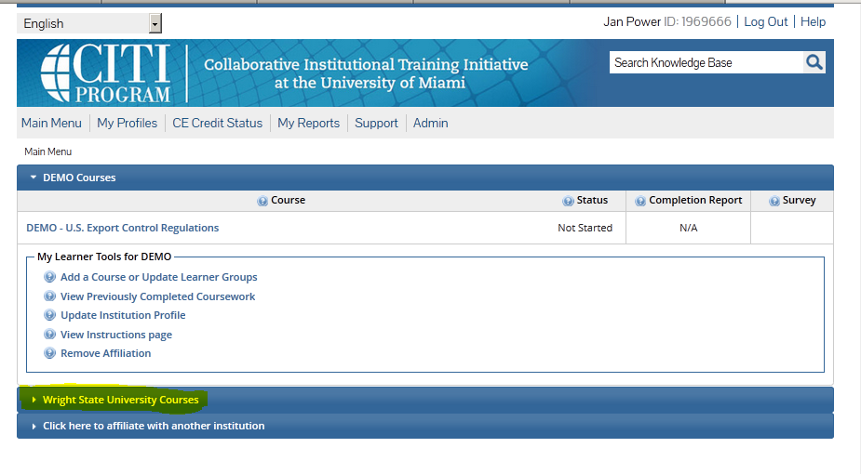
Click “Add a Course or Update Learner Groups”
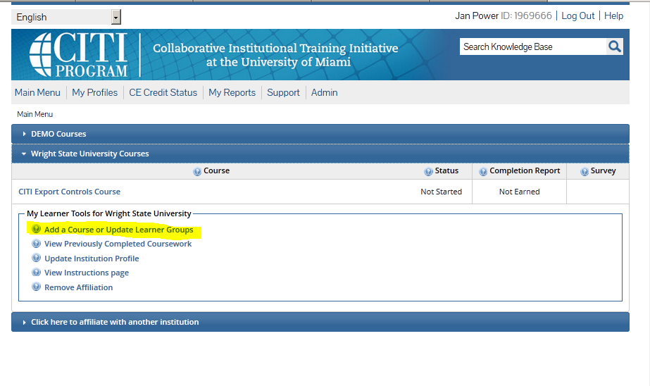

Read information and then click “Continue to question 1 at this time”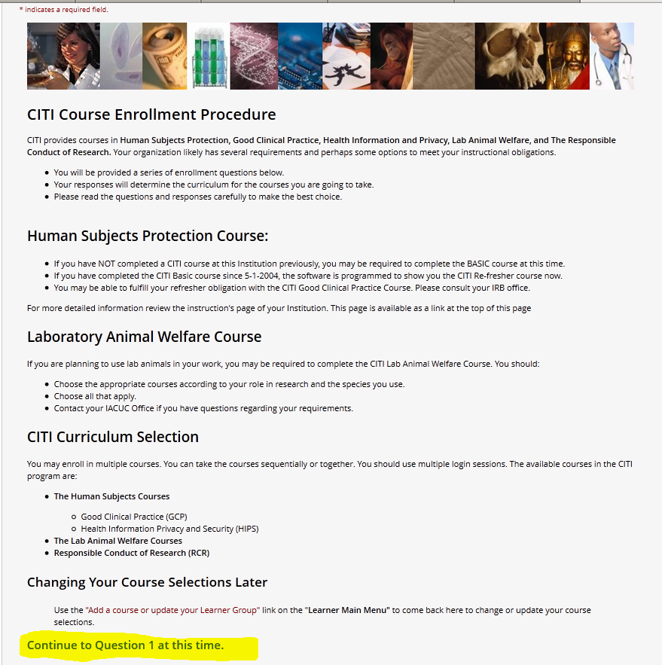

The last question in the series regards EXPORT CONTROL. Click “CITI Export Controls,” then click “Submit.”
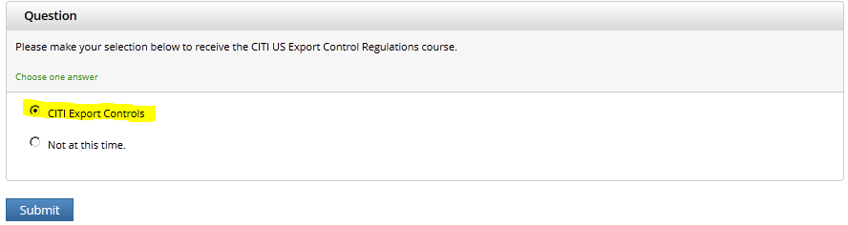

“Your request has been successfully submitted” will show.
Click on “Wright State University Courses”
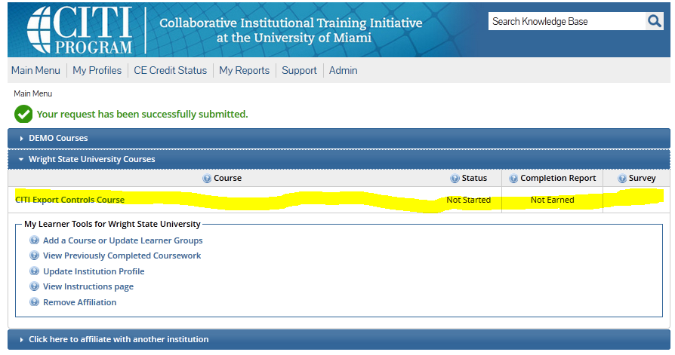

Click on “Complete The Integrity Assurance Statement before beginning the course”
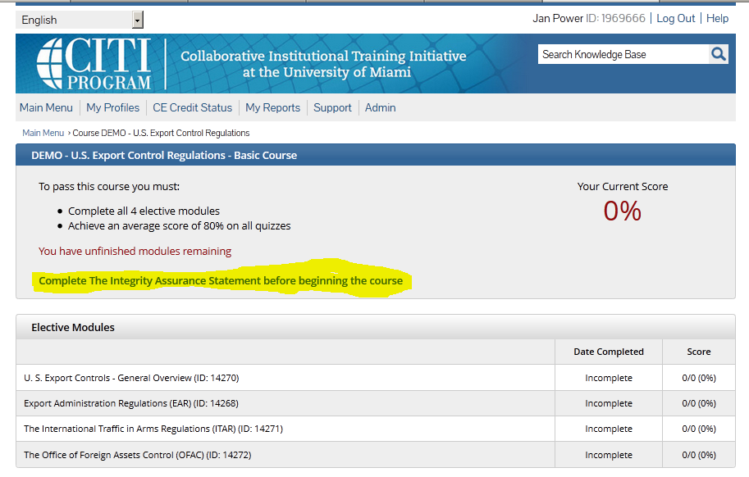

Read the info and click on button to agree or not with statement
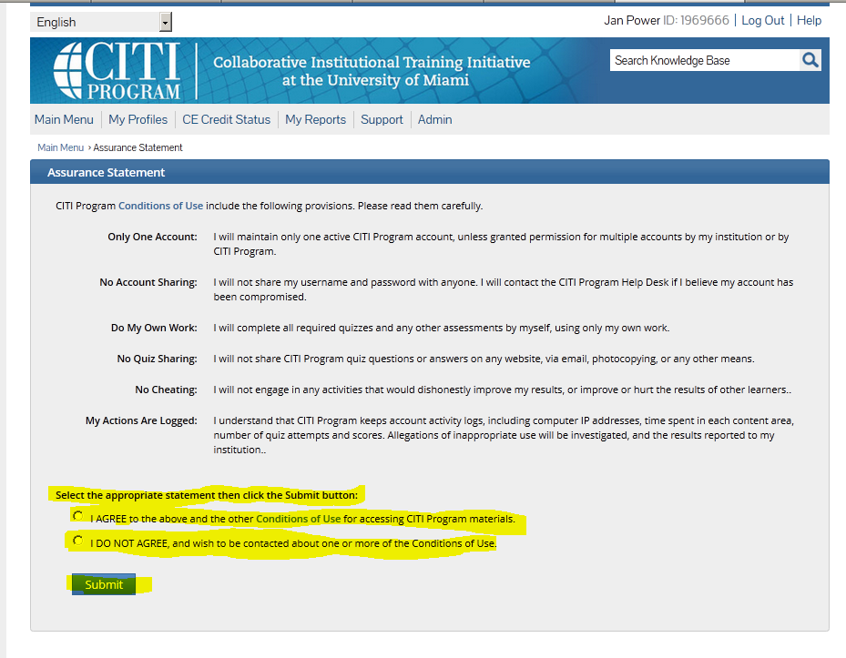

Complete all modules and required quizzes in the course
